Resistance to Apartheid

Political Organisation… |  | …and its armed wing
1. ANC  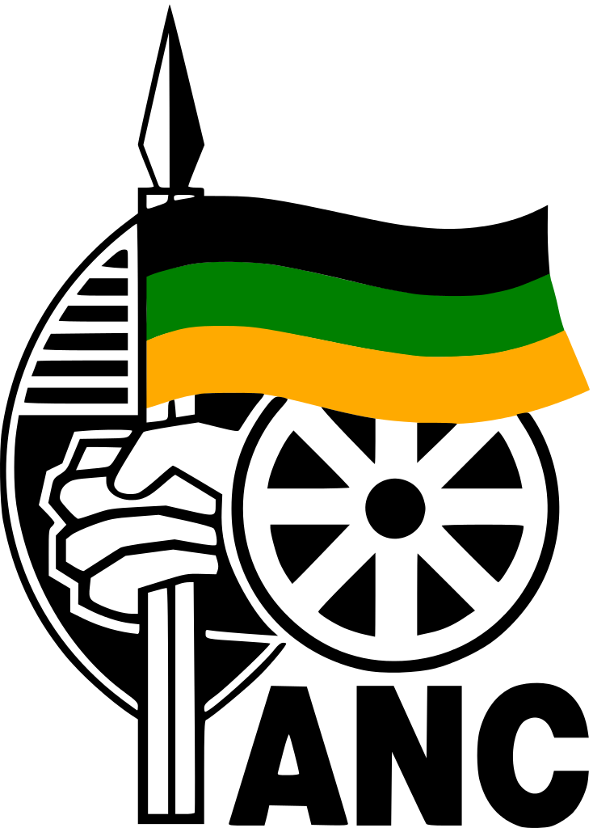 | African National Congress  Date Formed: 1912  Led by: Albert Luthuli (1952-1967) (Deputy: Mandela to 1958, then Tambo)  Objectives: its primary mission was to end apartheid and give voting rights to black and mixed race Africans.  Methods/Actions: The ANC originally attempted to use nonviolent protests to end apartheid, however, the Sharpeville massacre resulted in the deaths of 69 black Africans and contributed to deteriorating relations with the South African government. In April 1960, the ANC was banned. This forced the party to leave South Africa. | MK (Umkhonto we Sizwe – Spear of the Nation)  Date Formed, and Why: After it was banned in 1960, the ANC formed the Umkhonto we Sizwe (Spear of the Nation)  Led by: Co-founded by Nelson Mandela in the wake of the Sharpeville massacre.  Objectives: To fight against apartheid by demanding constitutional reform and increasing political rights.  Methods/Actions: Utilizing guerrilla warfare and sabotage. Its founding represented the conviction in the face of the massacre that the ANC could no longer limit itself to nonviolent protest. MK launched its first attacks against government installations in December 1961. It was then classified as a terrorist organisation by the South African government and the United States, and banned.
2. PAC  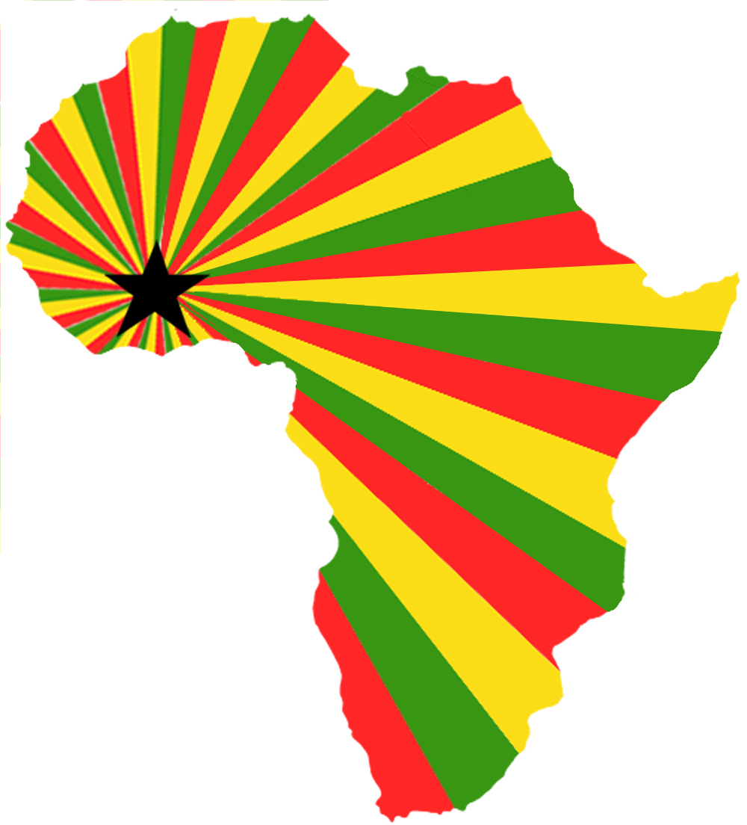 | Pan Africanist Congress  Date Formed: The Pan Africanist Congress is a South African Black Nationalist movement. It was a breakaway group formed by former members of the ANC who felt its adoption of the 1955 Freedom Charter and willingness to work alongside white pressure groups and communists was diluting its focus.  Led by: Robert Sobukwe  Objectives: The PAC followed the idea that the South African Government should be constituted by the African people owing their allegiance only to Africa ("We aim, politically, at government of the Africans by the Africans"). This rejection of white power made them more extreme than the ANC.  Methods/Actions: For Africanists like the PAC, the armed struggle is the primary struggle and they support the principle that political power will never be relinquished and must therefore be seized by force. Their anti-pass law demonstration in Sharpeville precipitated police brutality that radicalised the whole anti-Apartheid movement. | Poqo (Pure)  Date Formed, and Why: Poqo was formed as an armed wing to the Pan Africanist Congress (PAC) during the 1960's. The word 'poqo' means 'pure' or 'alone' in Xhosa and the organisation drew most of it's following from the Western Cape and the Transkei.  Led by: Potlako Leballo. The structure and functioning of the organisation was based on the Communist cell, where members do not know the identity of their fellow members. Any person who disclosed Poqo information was sentenced to death and about ten members of the organisation were executed for betrayal.  Objectives: Its aim was to overthrow the South African government in order to replace it with a socialist African state.  Methods/Actions: and was known for its aggressively violent sabotage campaign. Unlike other resistance organisations of the time, such as uMkhonto we Sizwe, Poqo made no effort to avoid loss of life and was the most anti-White underground movement of its time. Arguably the largest underground grouping of the 1960's, Poqo's strategy intentionally involved killings.  .

Organisation |  | Successes / Failures
SACP  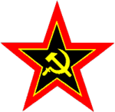 | South African Communist Party (sometimes called CPSA, or SACPO) | Aware that the National party, elected to government in 1948, was about to ban the party, the CPSA decided, by a majority to dissolve itself. A minority felt that the party should organise underground, but the majority apparently argued that this would be unnecessary; that support should be given to the African National Congress (ANC) in the drive to majority rule. After its voluntary dissolution (the only Communist Party ever to do so), the CPSA was declared illegal in 1950.
SAIC | South African Indian Congress | The SAIC was formed in 1923 under prominent SACP member Yusuf Dadoo. The SAIC was set up in reaction to discriminatory legislation affecting Indians and served as an umbrella body for the regional Indian councils. It later cooperated closely with the ANC in the Defiance Campaign joining the Congress Alliance, an anti-apartheid body formed in 1954 that pledged itself to a united liberation struggle. The SAIC was also closely involved in drawing up the Freedom Charter. In the late 1950s it was left virtually powerless by the banning or house arrest of most of its leaders.
SACTU  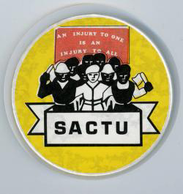 | South African Congress of Trade Unions | SACTU was founded in 1955 by those who were critical of the decision taken by the Trade Union Congress of South Africa (TUCSA) that only registered (non-African) unions could join the congress. Its basic approach was that in South Africa industrial relations could not be divorced from politics and it openly engaged in political activities rather than confining itself to conventional trade union action. This made it an easy target for the authorities. SACTU was closely associated with the ANC* and joined the Congress Alliance* as its trade union wing. Its membership, almost exclusively black, grew rapidly in the aftermath of the Defiance Campaign but many of its leaders were banned and it was forced underground in 1960.
CD | Liberal Party of South Africa | In 1951, a number of people met in Pietermaritzburg to discuss a response to the increasing entrenchment of apartheid by the government. Amongst them were Alan Paton, Peter Brown and Henry Selby Msimang. Sometime in 1953, this group developed formed an organisation known as the Liberal Association which brought together a number of liberal groups.On 9 May 1953, the LA formally constituted itself as the Liberal Party of South Africa (LPSA) when delegates voted to transform the LA into political party.  After its formation the LPSA, pushed for the franchise to be ‘extended gradually on the common roll to all adult persons, without any literacy, income or other qualifications. Later the party changed its position to a universal suffrage. The LPSA was opposed to political participation based on race. Among other demands that the LPSA made to the NP led government was a constitution which would contain a bill of rights, making education available for all, freedom of association whether in political or trade union activities. The party’s position on other issues such as land and the economy were set in the party’s policy document.  Although the party had a predominantly white membership after its formation, this changed over time as more Black people joined and swelled its ranks.  The government responded to the LPSA and its policies by persecuting its members as it viewed the party’s policies as a threat to its apartheid policy. This was because the party had both black and white members in its ranks.  Between March 1961 and April 1966, forty-one leading members of the LPSA were banned under the Suppression of Communism Act. This was despite the fact that they were not members of the Communist Party or supported communism. The banning of members of the LPSA was severe between 1963 and 1964.
FASW | Federation of South African Women | The Federation of South African Women (FEDSAW or FSAW) was launched on 17 April 1954 in Johannesburg as the first attempt to establish a broad-based women’s organisation. The "Women`s Charter", written at the first conference, called for the enfranchisement of men and women of all races; equality of opportunity in employment; equal pay for equal work; equal rights in relation to property, marriage and children; and the removal of all laws and customs that denied women such equality. The Charter further demanded paid maternity leave, childcare for working mothers, and free and compulsory education for all South African children. The demands laid out in the "Women`s Charter" were ultimately incorporated into the "Freedom Charter", adopted by the Congress of the People in Kliptown on June 25-26, 1955. In December 1956, 156 leaders of the Congress Alliance were rounded up and detained, this led to the Treason Trial that went on for four and a half years. During the Treason Trial, FEDSAW women organised support for the treason trialists and their families.

