Year 9 Dragon’s Den Project

Creating a sustainable company/product
1. Product over-view
Company name: | Company logo
Product name:

Product description:

Product Diagram
Please sketch your product below and annotate it with the key features

2. How is your product sustainable?
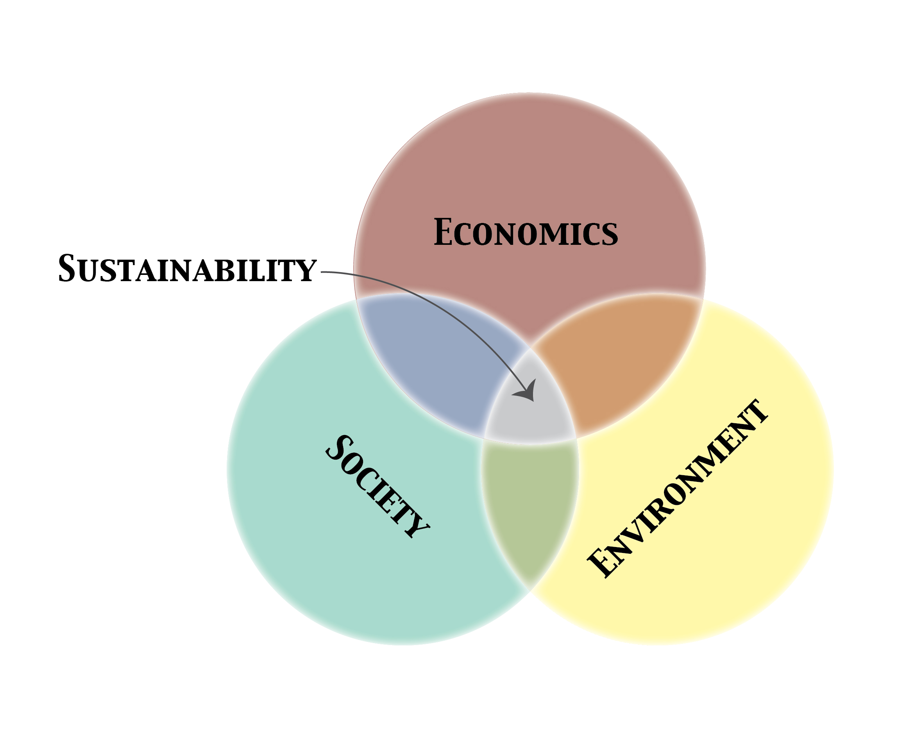
Social | Economic | Environmental

How does your product relate to the Global Goals or the concept of a circular economy?
3. Market research
- Market research is research that is carried out to determine whether there is an interest for your product in the market place.
- To do this you need to design a short survey to find out whether there is an interest/desire for your product, what type of people might buy your product, how much they would be willing to pay for it, any other suggestions they have etc
- Once you have completed your market research, think about how you might need to modify your product to appeal to your target market.

4. Product Production:
Describe the supply chain of your product:
Primary processes – how will you obtain any raw materials used?

Secondary processes – how will your product be manufactured (made)?

Tertiary processes – how will you market, advertise and sell your product?

5. Product Development Costs and Pricing Guide
- Calculate what the pricing should be for its product. An example is included here, in table form, which shows the kinds of elements that should be included in basic pricing estimates.
- Note: The sample pricing estimates below are based upon a product ultimately being sold to the consumer for $2.28.
Production/Development Costs and Pricing Worksheet for One Item (or Unit)
Costs and Expense Items for One Unit | Estimated Amount | Estimated Amount
Cost of Marketing Research/ | $0.20
Basic Cost of Product itself/Product | $0.60
Cost of Product Packaging  (including printing, materials, etc.) | $0.10
Cost of Distribution/Place or Positioning | $0.25
Cost of Advertising/Promotion  (include sales promotion and publicity, could include expense of celebrity endorsements) | $0.40
A. Total Expense of Production  (calculate by adding all costs above) | $1.55
B. Profit Percentage to Product Manufacturer  Each team must decide what percentage of profit they want for each product. | (13%)
C. Profit to Product Manufacturer  (calculate by multiplying A by ___ % -  called "company profit margin") | $0.20
D. Total Cost to Retailers  (Wholesale Price)  (calculate by adding A and B)  This is the wholesale price of the product as it is sold to distributors/retailers. | $1.75
E. Profit Percentage to Retailers  Each team must decide, hypothetically, what a normal retailer 'marks-up' their products in order to make a profit. | (30%)
F. Profit to Retailers  (calculate by multiplying C by ___ % -  called "product markup") | $0.53
G. Total Cost to Consumers  (Retail Price)  (calculate by adding C and D) | $2.28
You could also consider your product's sales goals. Be ready with answers to the following:
- How many potential customers are expected to be interested in this product? ________________
- How many products do you plan on selling in the first six months, or in the first year? ______________
- How much actual profit (income minus expenses; multiply B by the number of products sold) does that mean for your company? _________________

6. SWOT Analysis
Having undertaken all of your research, what to you think are the STRENGTHS, WEAKNESSES, OPPORTUNITIES and THREATS of your product?

Strengths: | Weaknesses:
Opportunities: | Threats:

7. Final Pitch
You will pitch your product to a team of Dragons!
You should include the following in your pitch:

- The name of your product
- A detailed description of your product (including what it is, how it works, the materials it is made from, how much it costs, the target market for your product, how and why it Is sustainable).
- When describing how your product is sustainable remember to think about the ways it is socially, economically and environmentally sustainable. Also think about how you can incorporate links to the global goals and/or the concept of the circular economy
- Provide an annotated diagram of your product and/or model
- End your pitch by providing a convincing summary argument about why the Dragons should choose to invest in your product.
- Be prepared for any questions the Dragons may want to ask you!

Consider what makes a successful pitch - you may watch clips from Dragon’s Den or Shark Tank for inspiration! (see Weebly).

