Year 7
Quick
Evidence
Test

Name: ______________ Tutor Group: _____

Evidence of The Battle of Kadesh, 1285 BC

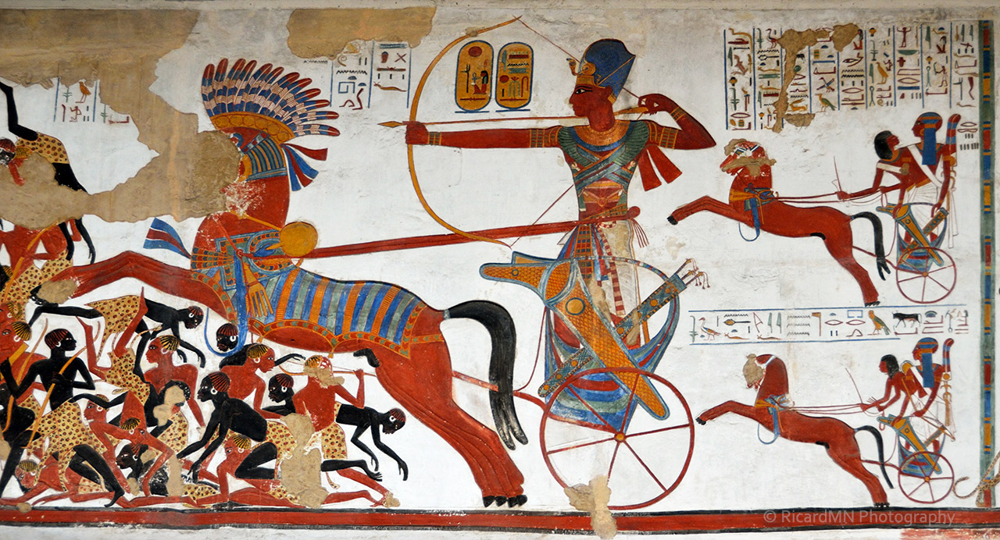
Source A – An Egyptian Tomb painting of the Battle of Kadesh, made around 1284 BC.

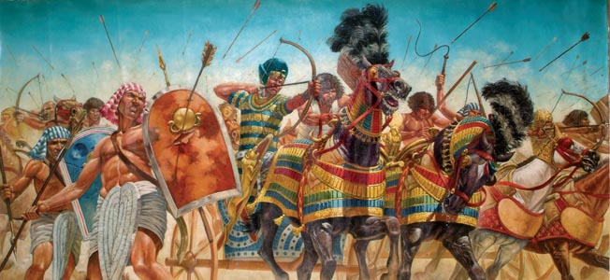
Source B – A modern book illustration of the Battle of Kadesh, made around 2000 AD.

Question 1
Look at both sources and their citations.
Which is a contemporary Egyptian source? Explain why it is contemporary.

Source _____ is a contemporary Egyptian source. [1m]

Reasons why : ____________________________________________________ ______________________________________________________________________________________________________________________________________________________________________________________________________________________________________________________________ [2m]

Question 2
Look at both sources.
Which man in the sources is Ramesses II? What evidence supports this?

In Source A it is __________________________________________. [1m]

Reasons why : ____________________________________________________ ______________________________________________________________________________________________________________________________________________________________________________________________________________________________________________________________ [2m]

In Source B it is __________________________________________. [1m]

Reasons why : ____________________________________________________ ______________________________________________________________________________________________________________________________________________________________________________________________________________________________________________________________ [2m]

Question 3
Look at Source B.
List all the weapons being used at the Battle of Kadesh.
__________________________________________________________________________________________________________________________________
____________________________________________________________________________________________________________________________ [5m]
Question 4
Look at Source A.
How does the source suggest Ramesses II & his Army was outnumbered at the Battle of Kadesh?
_________________________________________________________________
__________________________________________________________________________________________________________________________________
____________________________________________________________________________________________________________________________ [1m]

Question 5
Look at both sources.
In what ways is the content of both sources the same?
_________________________________________________________________
__________________________________________________________________________________________________________________________________
____________________________________________________________________________________________________________________________ [2m]

Question 6
Look at both sources.
In what ways is the content of both sources different?
_________________________________________________________________
__________________________________________________________________________________________________________________________________
____________________________________________________________________________________________________________________________ [2m]

Question 7
Look at both sources.
Why is the content of both sources different?
_________________________________________________________________
__________________________________________________________________________________________________________________________________
____________________________________________________________________________________________________________________________ [1m]

TOTAL ____ / 20
Evidence of Julius Caesar, 100 BC – 44 BC

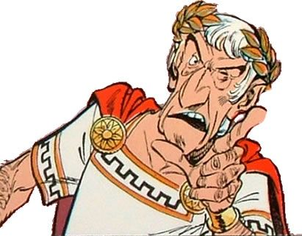
Source C – A book illustration of Julius Caesar, drawn by Albert Uderzo in 1961 AD

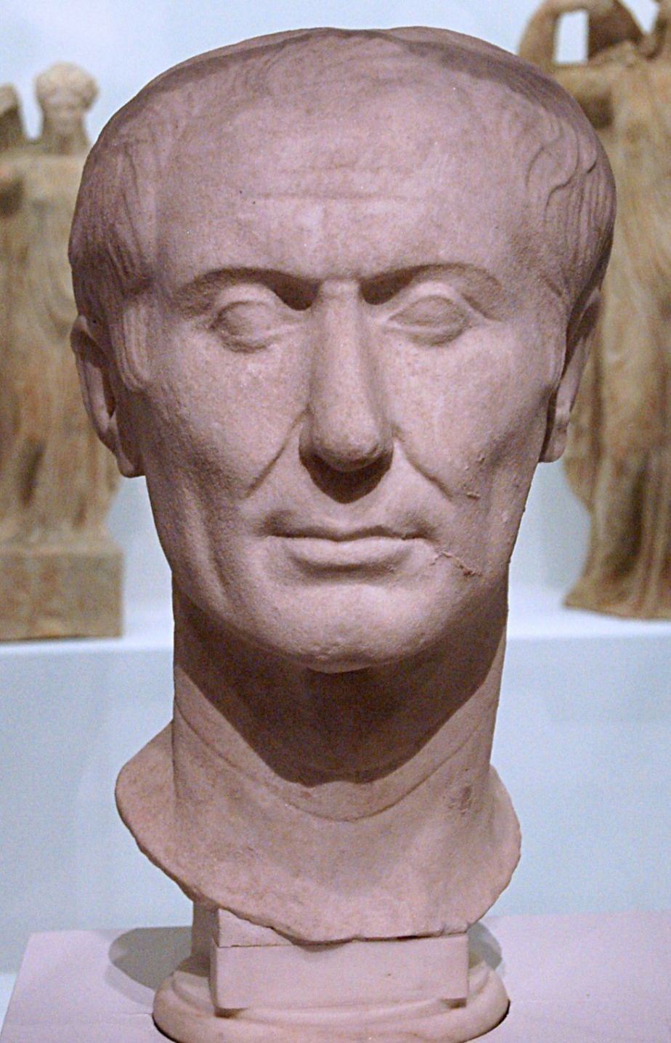
Source D – The Tusculum portrait of Julius Caesar, in marble, made around 45 BC
"Tall of stature with a fair complexion, shapely limbs, a somewhat full face, and keen black eyes. He enjoyed excellent health, except towards the close of his life when he was subject
to sudden fainting fits and disturbances in his sleep.”

Source E – Description of Julius Caesar by Roman historian, Suetonius, around 120 AD
"Julius Caesar – a conqueror, a populist leader, the biggest power-grabber of the lot.
The man who turned Rome from a democracy into a dictatorship. And he would no doubt be
thrilled to know that we still recognize him 2000 years later.”

Source F – Description of Julius Caesar by historian, Mary Beard, in 2018 AD
Question 8
Look at all four sources and their citations.
Which 2 are contemporary Roman sources? Explain why they are contemporary.

Source _____ and Source _____ are contemporary Roman sources. [2m]

Reasons why : ____________________________________________________ _______________________________________________________________________________________________________________________________________________________________________________________________________________________________________________________________________________________________________________________________ [4m]

Question 9
Look at all four sources and their citations.
Which 2 are modern historical sources? Explain why they are modern.

Source _____ and Source _____ are modern historical sources. [2m]

Reasons why : ____________________________________________________ _______________________________________________________________________________________________________________________________________________________________________________________________________________________________________________________________________________________________________________________________ [4m]

Question 10
Look at all four sources.
Which 2 are the best for knowing what Julius Caesar looked like? Explain why.

Source ____ and Source ____ are best for knowing what he looked like. [2m]

Reasons why : ____________________________________________________ _______________________________________________________________________________________________________________________________________________________________________________________________________________________________________________________________________________________________________________________________ [4m]
Question 11
Look at all four sources.
Which 1 is the best for knowing how Julius Caesar ruled? Explain why.

Source ____ is the best for knowing how Julius Caesar ruled. [2m]

Reasons why : ____________________________________________________ __________________________________________________________________________________________________________________________________________________________________________________________________________________________________________________________________________________________________________________________________________________________________________________________________________________________________________________________________________________________________________________________________ [4m]

Question 12
Look at all four sources.
Which 1 is the least useful to historians studying Julius Caesar? Explain why.

Source ____ is the least useful to historians studying Julius Caesar. [2m]

Reasons why : ____________________________________________________ __________________________________________________________________________________________________________________________________________________________________________________________________________________________________________________________________________________________________________________________________________________________________________________________________________________________________________________________________________________________________________________________________ [4m]

TOTAL ____ / 30

