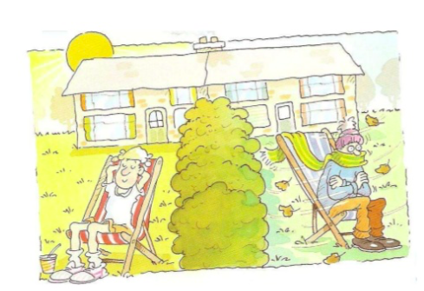Writing an analysis for microclimates assessment

What is an analysis?

Why do we write an analysis?

Success criteria:
- Describe the data you have presented. You should refer to figure numbers and quote the results found.
- You should explain why you got this data. This should link to features of the school site (locational context) that may have influenced the results in that area (link to microclimate theory)
- Are there any anomalies (results that don’t fit the expected pattern)? Why may we have got these unexpected results?
- Use this information to explain the pros and cons of each site for locating an outdoor swimming pool.
- Using the information from your analysis come to an overall conclusion: which site is the best for the outdoor pool at BISH?

Microclimate theory – you should refer to this in your analysis to help you explain your results

When the climate in a small area is different to the general surroundings it is called a microclimate.
There are lots of factors that can affect a microclimate...
Physical features: trees can provide shade, water can provide a cooling effect and hill tops can be windy.
Shelter: trees, hedges, walls and buildings can provide shelter, which means they will be warmer.
Buildings: buildings give off heat that has been stored during the day, they also break up any wind.
Surface: the colour of the ground affects warming.
Aspect: the direction that you/a building is facing is called aspect, facing the south will be warmer.

