Writing a UN Resolution

What: What is a resolution? A resolution is a document that contains all the issues that the committee wants to solve and the proposed solutions to that issue.

Who: Who writes a resolution? Any delegate in the committee can write a resolution, the author of a resolution is called a sponsor.
Most resolutions have multiple sponsors because it takes a group of countries to share good ideas and to come to a consensus.
A resolution has three main parts: the heading, the pre-ambulatory clauses, and the operative clauses.
1. Heading
The heading contains four pieces of information: the committee name, the sponsors, the signatories, and the topic.
The committee name and topic should be self-explanatory. The sponsors are the authors of the resolution. The signatories are other delegates in the committee who do not necessarily agree with the resolution but would like to see it debated. Most conferences require a minimum number or percentage of sponsors and signatories (or a combination of both) before a resolution can be presented.
2. Pre-ambulatory clauses
The pre-ambulatory clauses states all the issues that the committee wants to resolve on this issue. It may state reasons why the committee is working on this issue and highlight previous international actions on the issue. Pre-ambulatory clauses can include:
- Past UN resolutions, treaties, or conventions related to the topic
- Past regional, non-governmental, or national efforts in resolving this topic
- References to the UN Charter or other international frameworks and laws
- Statements made by the Secretary-General or a relevant UN body or agency
- General background info formation or facts about the topic, its significance, and its impact.
Tips for writing a pre-ambulatory clause:
- It’s very simple to write a pre-ambulatory clauses. First, take a statement that you want to write about (perhaps an issue you want to solve or a specific fact from one of the five bullet points above).
- You then take that statement, combine it with an underlined pre-ambulatory phrase, and end it with a comma.
- Here are some example pre-ambulatory phrases from that you can choose from:
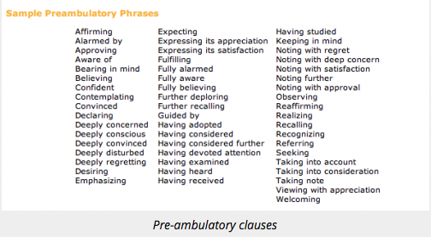
Example pre-ambulatory clause:
For example, my country wants to address the issue of how HIV/AIDS has spread rapidly in sub-Saharan Africa. I pick a pre-ambulatory phrase from above — I’ll use “Alarmed by” — and then I combine it to say:
Alarmed by the 17% increase in HIV/AIDS contraction among sub-Saharan African countries in the past five years,
3. Operative clauses
Operative clauses state the solutions that the sponsors of the resolution proposes to resolve the issues. The operative clauses should address the issues specifically mentioned in the pre-ambulatory clauses above it.
It’s very simple to write an operative clause. First, take a solution that you want to include in the resolution. You then take that solution, combine it with an underlined operative phrase, and end it with a semicolon (the last operative clause ends with a full-stop). Here are some example operative phrase that you can choose from:
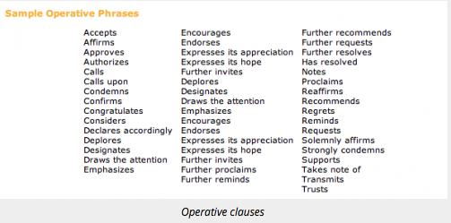

For example, my first solution is to distribute low-cost medicines for HIV/AIDS to sub-Saharan African countries. I pick an operative phrase from above — I’ll use “Calls upon” — and then I combine it and number it to say:
- Calls upon the developed countries and major pharmaceutical countries to provide low-cost, generic medicines for HIV/AIDS to sub-Saharan African countries;

Amendments
Approved draft resolutions are modified through amendments. An amendment is a written statement that adds, deletes or changes an operative clause in a draft resolution. The amendment process is used to strengthen consensus on a resolution by allowing delegates to change the operative clauses.

Template for resolution writing:
- Heading
Committee name: (name of the country putting the ideas forward) ______________________
The sponsors: (others who also back the resolution/agree with it)
_________________________________________________________________________________________________________________________________________________________________________________________________________________________________
The signatories: (others who want to see the issue debated – don’t have to agree with it)
_________________________________________________________________________________________________________________________________________________________________________________________________________________________________
- Pre-ambulatory clause (this is the issue that needs solving – there is a specific way to write this – see guide)
__________________________________________________________________________________________________________________________________________________________________________________________________________________________________________________________________________________________________________________________________________________________________________________________________________________________________________________________________

- Operative clause (this is a suggestion for solving issue – there is a specific way to write this – see guide)
__________________________________________________________________________________________________________________________________________________________________________________________________________________________________________________________________________________________________________________________________________________________________________________________________________________________________________________________________

