Writing a Diary Account from the Oregon Trail…

Now that you have completed the simulation you will now write an authentic account of the westward migration demonstrating your knowledge of the people, reasons for migration, challenges of the trail and hopes of those that undertook the journey. You must demonstrate your skills of historical writing, by writing in the authentic first-person voice of someone who completed the journey.

You must complete 5 diary entries in total. Below you will find a frame for what could be included in each entry:
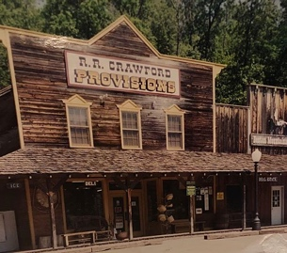
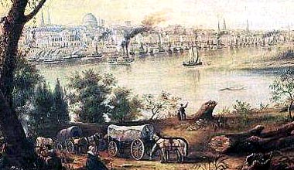

Entry 1: You have arrived in Independence, Missouri – gateway to the West and the start of trail. What are your hopes and dreams, what are you worried about? However, before you can leave you must organize into a trail party and make preparations and buy supplies of food and provisions for your wagon before you begin? Which characters do you meet? What are their motives for traveling West? Why do you think they will make good travel companions? What are your feelings as you set out in the wagon train and see Independence disappear on the Horizon?

Entry 2-5: You need to write 3 entries from different points on the trail that account for the events that have occurred to your trail party since the last time you wrote in your journal. These could include:
- Events that have occurred that have been memorable as having a positive or negative effect on your party
- Towns and places that you have encountered.
- Problems that you have encountered and comments on the landscape, considering the climate and time of year and weather.
- Commentary on the landscape, your travel companions and how well the trail party is coping with the stresses of the trail and whether they have provisioned themselves effectively for the journey.

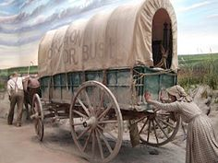
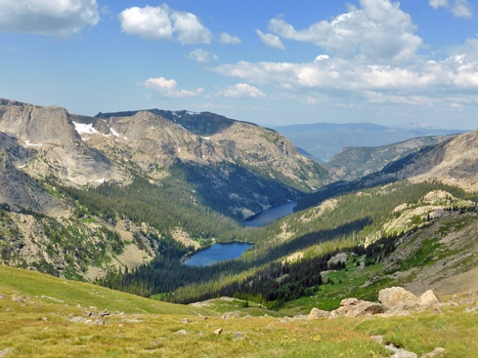
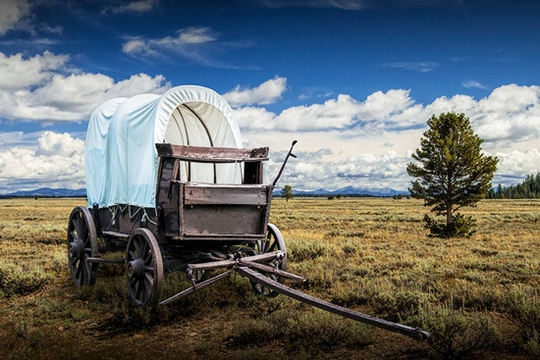

Entry 5: Your final entry! Have the dreams that you had in Independence, MO. been realized? Or did your trail experience end in disappointment or tragedy? Make sure to show your feelings and what would happen to your character next. Perhaps if you perished on the trail the final entry could be written by one of your travel companions explaining how you perished for anyone who should find your grave…How will your life on the homestead be different from the life you left behind, what regrets, if any, do you have?

