 | Innovations in Warfare 1850-1918 | Facilitating innovations  Why was Trench Warfare so Deadly? | What was it and how did it contribute to deadlier forms of warfare? | Soldiers experiences of this innovation
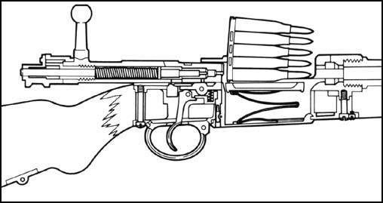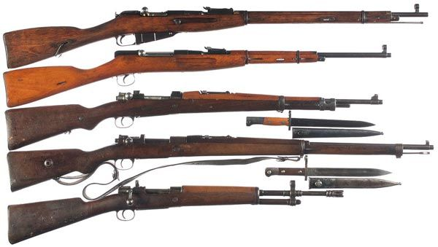 | Bolt Action Rifle | Mass Precision manufacturing, Needle rifle 1830’s, self-contained metallic cartridge 1840’s, Smokeless powder 1840’s
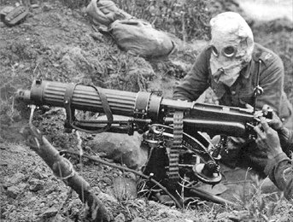 | Belt Fed Machine Guns | Mass precision manufacturing, water coolants, rifle metallic cartridges
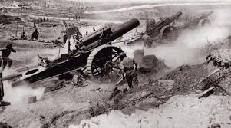 | Heavy Artillery | Mass precision manufacturing, improvements in Iron founderies
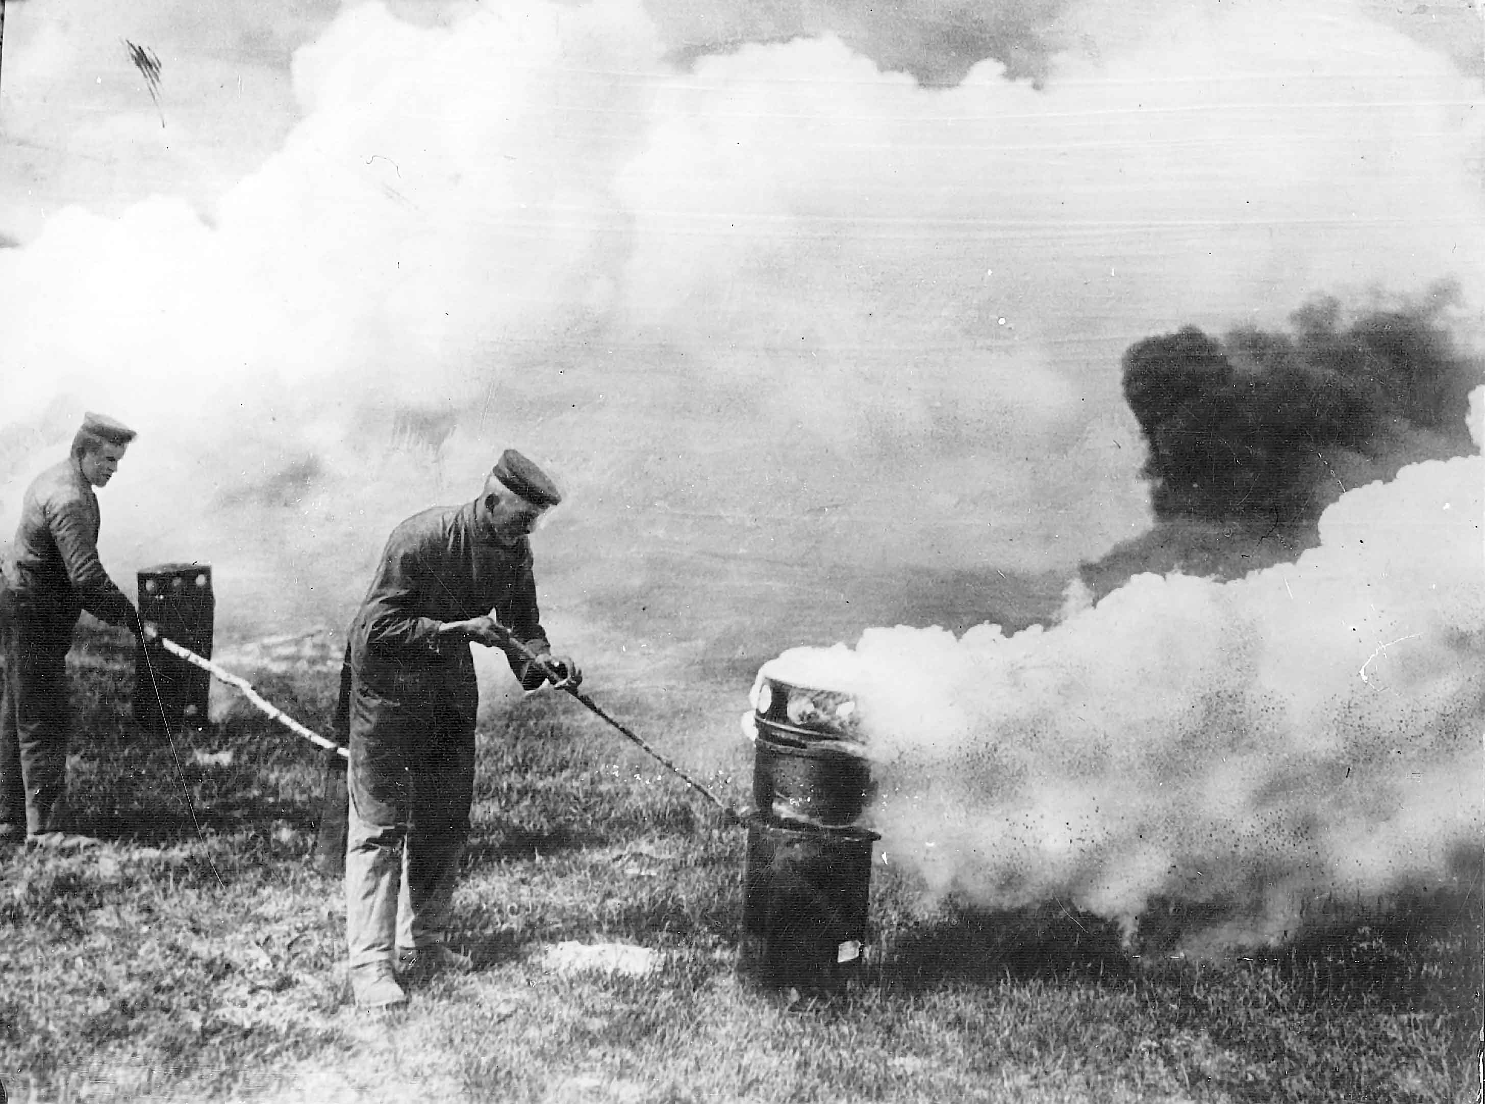 | Chlorine and Mustard Gas | Revolution in chemistry 1840’s onwards, HE shells, refrigeration 1870’s
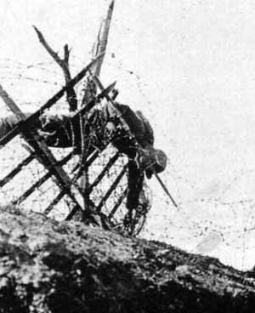 | Barbed Wire | Innovations in cattle ranching in USA 1860’s
 | High Explosive Shells | Mass precision manufacturing, precision watchmaking, Chemicals revolution 1850’s on
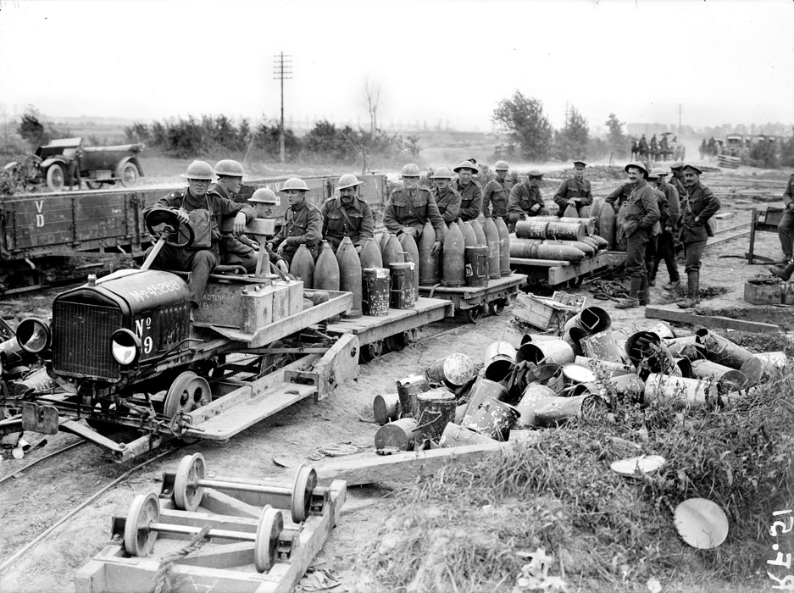  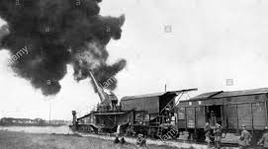 | Railways | Steam power 1740’s James Watt,
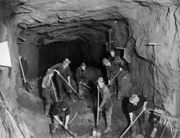  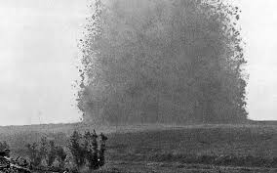 | Mining | Underground mining in the coal and iron industries, TNT, Dynamite and High explosives 1860’s
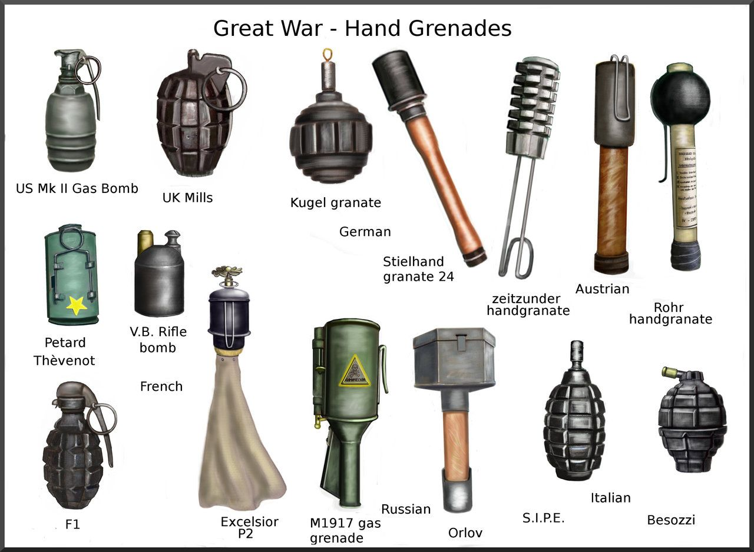 | Hand grenade | Chemical’s revolution, mass production watchmaking, TNT
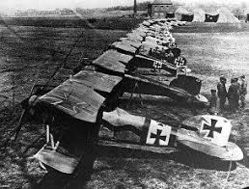 | The airplane | Wright brothers 1902, combustion engine, alternating propeller
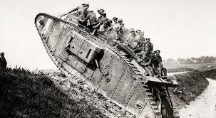 | The Tank | Mass production of Iron 1770’s, Internal combustion engine 1890’s, Diesel Engine 1890’s

