What: Essay- Why are some countries LEDCs?
Why: To develop a structured argument using a variety of information
Success criteria (how):
- 2-3 sides of A4
- Use examples of countries within your answer- Try and use development indicators to illustrate answers
- Try and explain reasons as social, economic, historic and environmental- Explain factors such as trade, colonialism and physical factors
- Present your work in a range of appropriate geographical ways (such as annotated maps and photos)
- Work is well structured and presented and has conclusions consistent with evidence presented

Support to help to structure the essay
Introduction | Define key terms- what does LEDC mean?  Give an overview of the factors that will impact the development of a country
What natural factors may impact development:  Climate  Geographical location | Point: What is the factor?  Evidence: What case study detail/ example of a country can you include to support this?  Explain: Explain what this means  Link: Link points back to the question…. why do the factors lead to a lack of development?
What economic factors may impact development:  Trade | Point: What is the factor?  Evidence: What case study detail/ example of a country can you include to support this?  Explain: Explain what this means  Link: Link points back to the question…. why do the factors lead to a lack of development?
What political factors may impact development  Colonialism  Corruption | Point: What is the factor?  Evidence: What case study detail/ example of a country can you include to support this?  Explain: Explain what this means  Link: Link points back to the question…. why do the factors lead to a lack of development?
Conclusion- can you make links between the different factors? 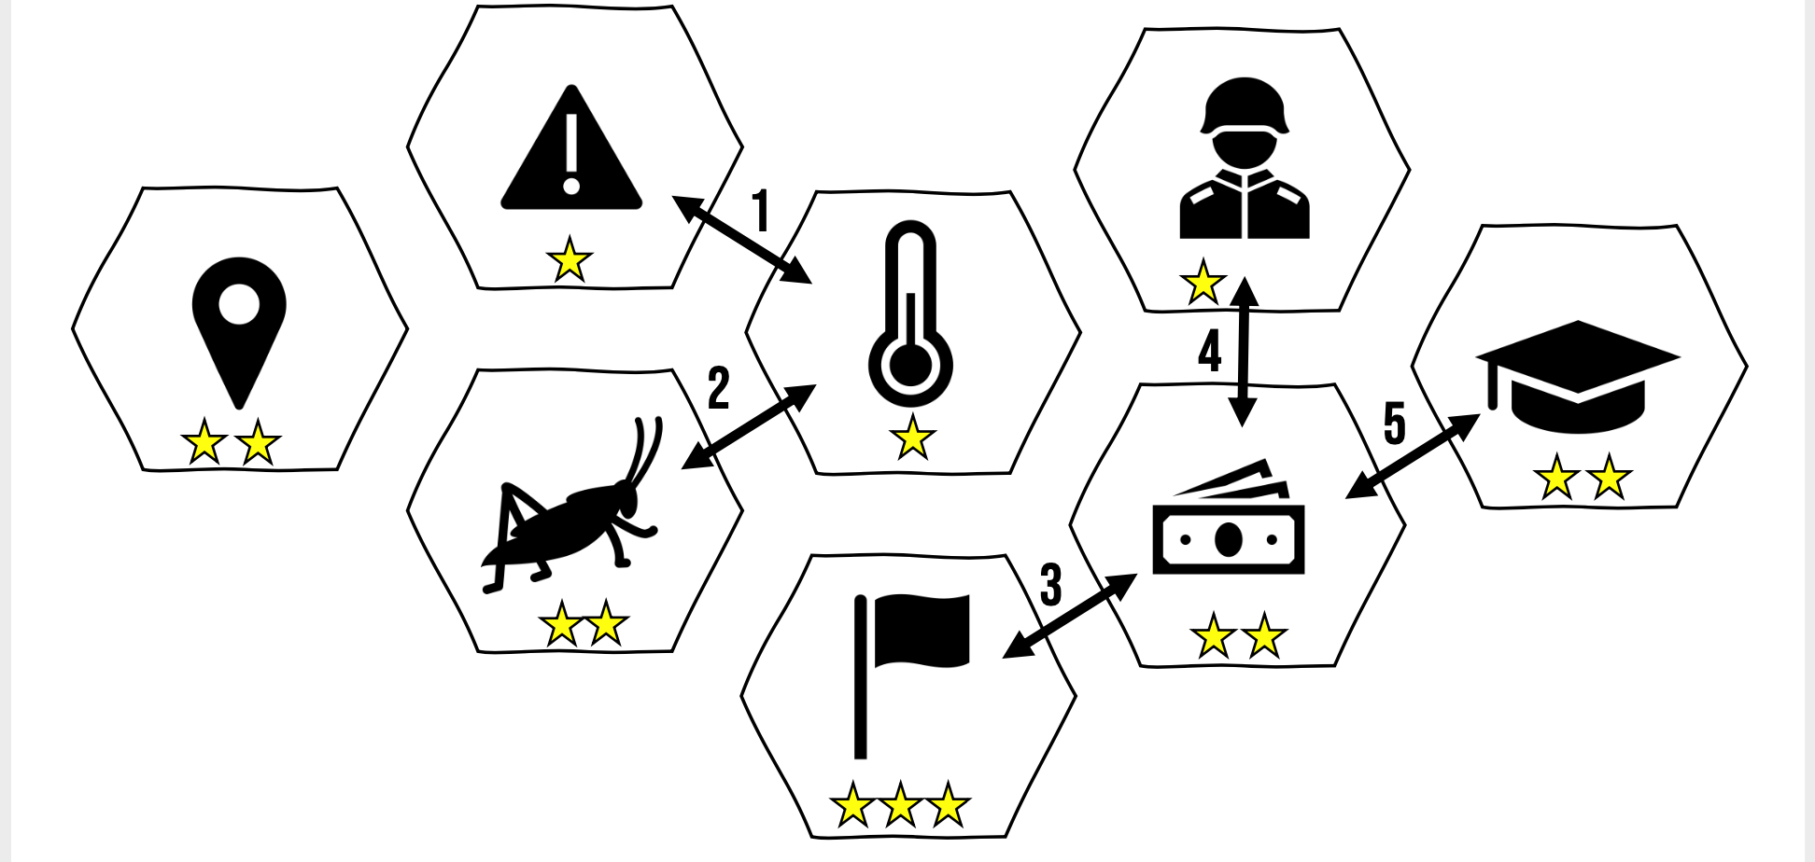 | How do the factors highlighted in the essay link together?  Can you give a summary of the main points in the essay to explain why some countries are less developed?

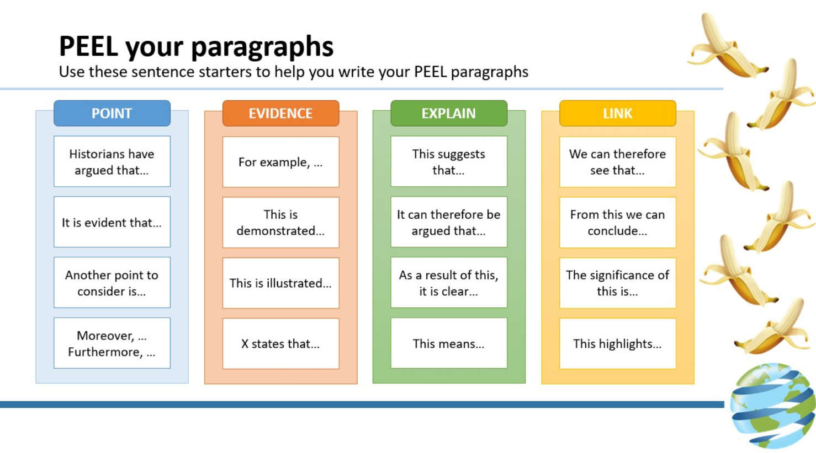

Example peel paragraph linked to this essay:

Colonialism is a historical and political factor that has impacted development. Before the Scramble for Africa, where European powers decided that they would take control of Africa and divide it into Nation states, Somalia was a country that was made up of 79 different clans. Because these different tribes have different views there has been a lot of conflict in between the clans and war lords have taken over. These war lords have invested their money into guns and ways to enhance their power and not in the interests of their population development, such as investing in schools and hospitals. This means that Somalia is a less developed country with a female literacy rate of only 25.8% and life expectancy of 56 years.

Example annotated photo to help explanation:

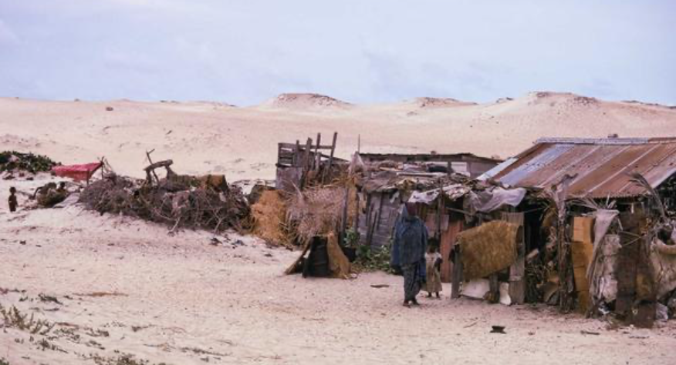
Figure 1: Image to show poor infrastructure in Somalia
There will be a lack of basic amenities such as sanitation which will cause disease- will impact life expectancy
The infrastructure is temporary as there is little investment because of poor governance
The area is very arid meaning that is hard to grow crops

Stretch. Things to evaluate…..

What do we mean by development?

From the National geographic: https://www.nationalgeographic.org/article/cattle-economy-maasai/12th-grade/
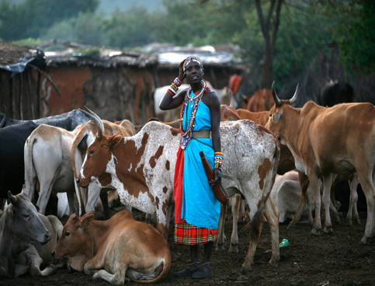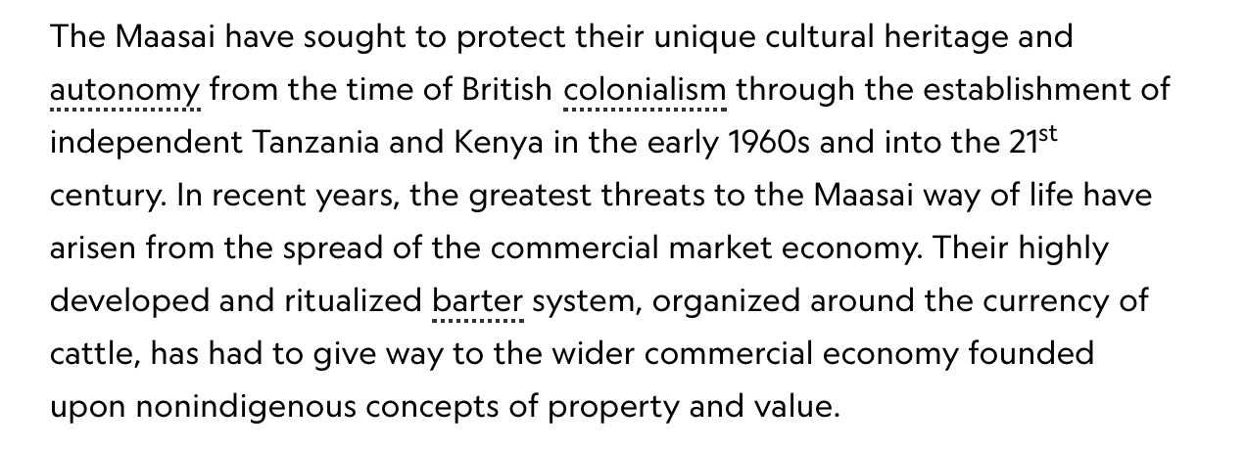

How do the Maasai use mobile phones for their development?
https://theconversation.com/on-the-savanna-mobile-phones-havent-transformed-maasai-lives-yet-78725
https://foodtank.com/news/2015/01/five-ways-cell-phones-are-changing-agriculture-in-africa/

What about quality of life and happiness? Consider the Happy planet Index: http://happyplanetindex.org

Have other continents experienced the same issues to prevent their development as Africa? Can you include some independent research to find out how why some other countries are less developed?

