3Civil war | Civil war can plunge a country into chaos. Infrastructure is damaged and can take years to rebuild, working populations are reduced and agriculture is severely limited due to the laying of landmines. | 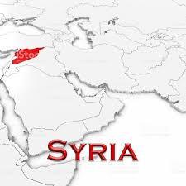 | Corruption | Countries often receive money from the UN and charities in the form of aid. Sometimes this money does not trickle down to the people who need it the most and is squandered by those in government to fund their lavish lifestyles. | 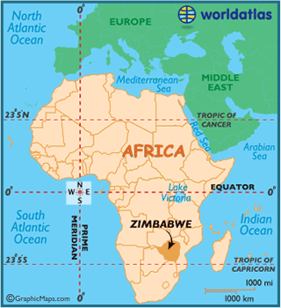
Climate | Unfavorable climate conditions such as prolonged periods of hot, dry weather can lead to drought. Not only does this lead to famine it can make a country less productive and unable to raise income through the exporting food. | 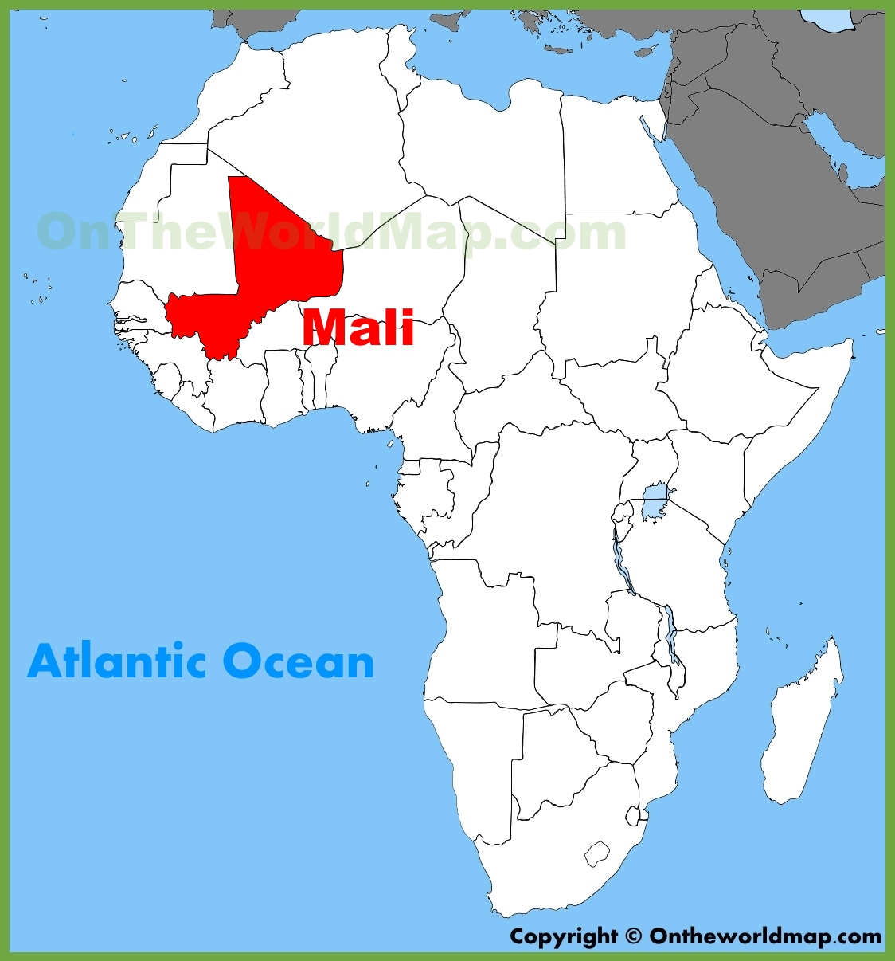 | Natural resources | Some countries have an unfortunate lack of natural resources. This means they have difficulties raising finance through exports. Alternatively, what little resources they have may be damaged due to mismanagement. | 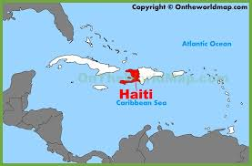
Disease | This country has one of the highest rates of malaria in the world. Malaria increases sick days preventing people from working and reduces the economically active population. Governments have to divert funding to try and address the problems created. | 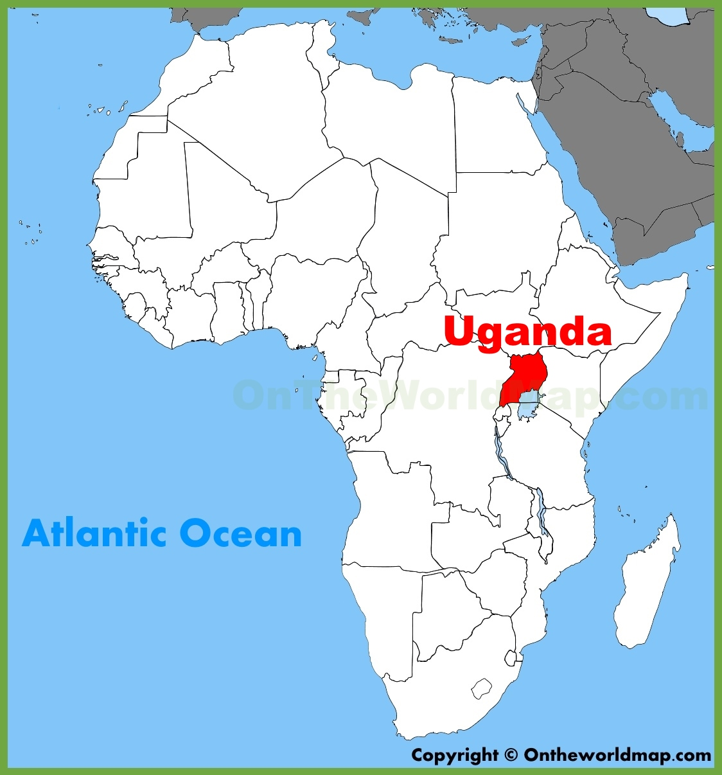 | Political instability | Despite having huge oil reserves this country has political instability which is hindering any future development prospects. There is high inflation and a lack of overseas development due to the political situation. | 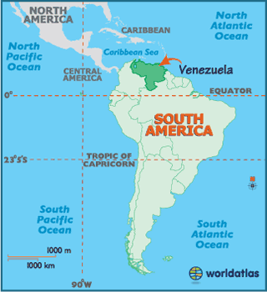
Colonialism | The British, French and Germans drew the boundaries we see on maps today during “the scramble for Africa”. As a result, they grouped together many tribes who had so many differences and had spent years fighting. These differences still exist today and cause many issues such as genocide, discrimination and ineffective governing. | 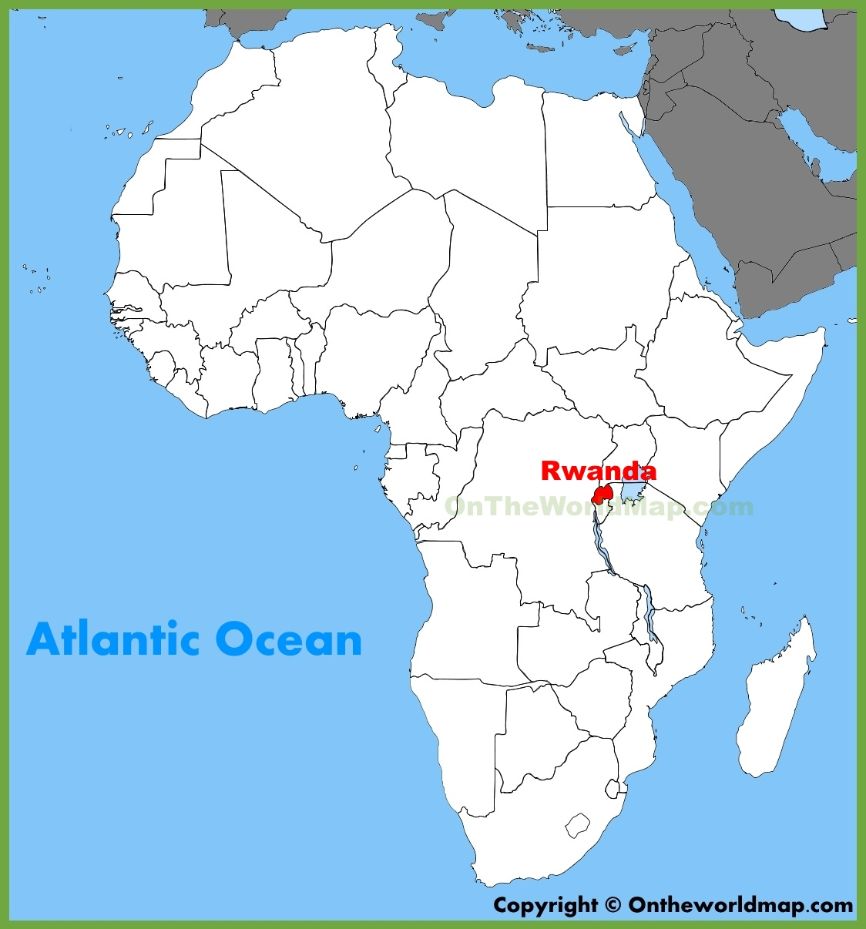 | Political regimes | Oppressive political regimes can hinder the creativity of the population and prevent investment. Sometimes governments will spend money on the military and not cater for the needs of the people. | 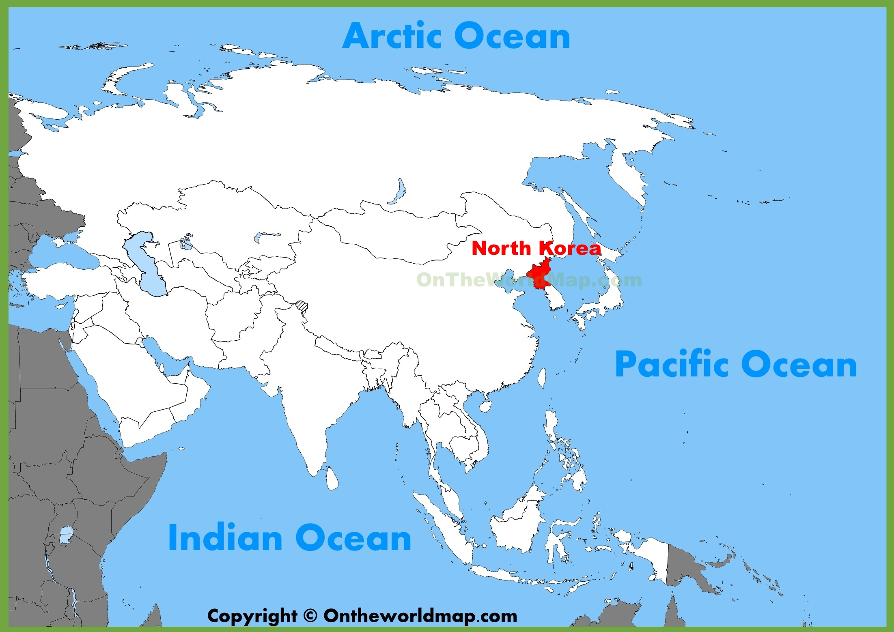
Topography | Being a too flat or too mountains can lead to serious problems. This country floods regularly as a result what little farmland there is becomes damaged destroying crops. Things look bleak for the future given the projected sea level rise. | 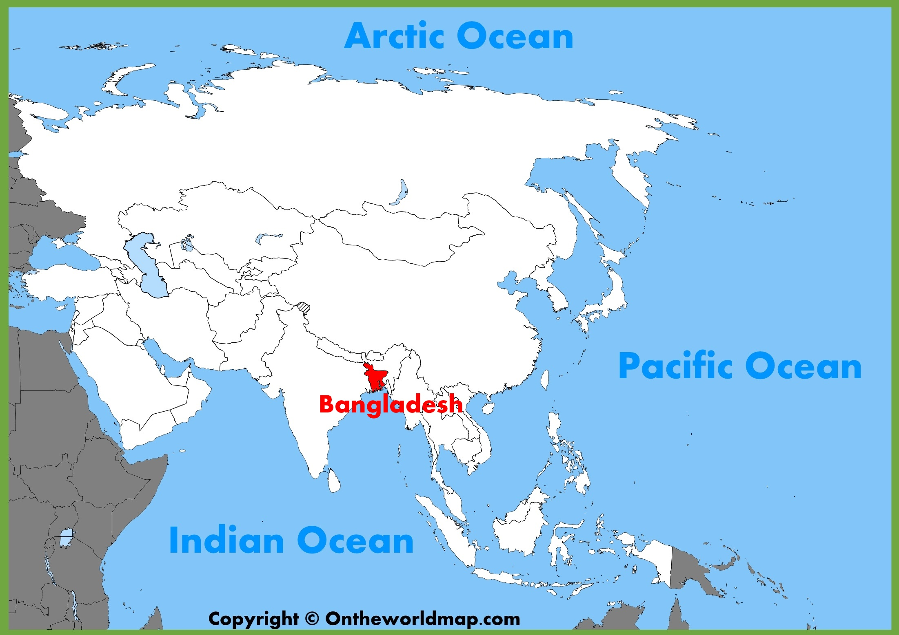 |  | .

Task

Group together the cards in sets. Eg Factor – explanation- example
- Try to categorize the factors
- Can you think of any other examples which may lead to countries being LEDCs?
- Can you rank the cards on a continuum with the first being the most important and the last being the least important factor for the reasons countries are LEDCs? Think carefully if these factors apply to MEDCs and MEDCs have been able to overcome them!

