Key Enquiry: Who were the Mongols?

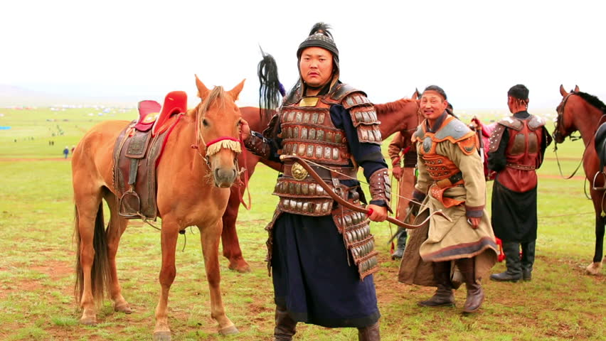

Geography, culture and lifestyle of the nomadic tribes of the Mongolian Steppe

Geography and Climate

The Mongolian steppe

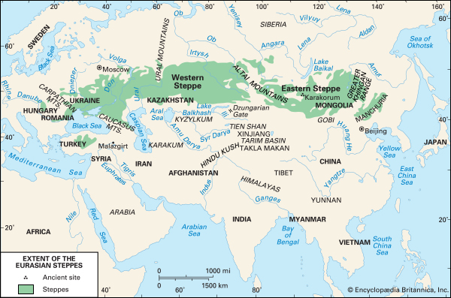
The climate is extreme and varied. The climate included very cold temperature and strong winds – gales were violent. Long winters lasted from November to March with below freezing temperatures. Temperatures remained freezing in October and April. Annually temperatures could range from 100f to - 43f.
The elevation of the region is well above sea level – which meant a short growing season and brief summers with unreliable rainfall – 10 – 20” per year. This made agriculture very difficult.
Of the region 1% is regarded as arable, 8-10% forest and the rest is pasture land or desert. Half of the land is subject to permafrost and lakes and rivers freeze during the winter months.
In contrast, the Gobi Desert covers most of southern Mongolia – climate is hot and arid and only the camel could survive in this environment.
Herders raised sheep and goats in pasture lands north and west of the Gobi.
ZUD – severe freezing weather and harsh conditions kept the population low compared with their nearest neighbor China. During the Mongol invasions, the Mongol population was around 1 million compared with 75 million in China.
Due to its location inland, far from the ocean the region resulted in a lack of humidity and snow but was surprisingly cloudless – enjoying 250 cloudless days a year – earning the name of the Land of the Blue Sky.

Key to survival was mobility. Mongols were principally nomadic moving from summer quarters to winter camps. They would sometimes move considerable distances to avoid ZUD.
Their lives centered around the quest to feed and water their precious animals. Physical strength was essential but skill and knowledge of the region was also critical. Knowledge of areas, plants, vegetation, markets and sustainability of camps were the key to survival.

Organisation and administration
Mongol society developed in three stages. It rose on the basis of a hunting economy in the forest regions to the north of the Mongol heartland. During this period was created the title mergen, meaning ‘a good hunter’ or ‘an intelligent person’. When the Mongols emerged from the forests, they created a new title, ba’atur, or ‘hero’, which shows that the distinct Mongol tribes of the day were at war with one another and were probably engaged in a nomadic way of life. Around the eighth century, two new titles appeared: noyan, meaning ‘lord’, and qan, usually transcribed in English as ‘khan’.
In the sixth century, Turkic nomadic tribes, later known as Orkhon Turkish, moved into the territory of present-day Mongolia and ruled the area until the middle of the seventh century, when they were replaced by the Uighurs (who stayed until the eighth and ninth centuries). By the tenth century, the Liao Dynasty (also known as Kitan) was established in the eastern part of the region, present-day Manchuria. The Kitan were in power from 916 to 1119, when they, in turn, were replaced by another nomadic people, the Jin Dynasty, also known as Altan Ulus (1115– 1234).
The Mongols were a small nomadic tribe in the area of Erongol of the many tribal peoples shifting about nomadically during this period. The people of the felt walled tents were the Tatars, the Onggirads, the Kereyids, the Naimans, the Tayichi’uds, and the Merkids. All these groups spoke a language akin to that of the Mongols, but they were only included in the category of Mongols after they had been conquered by, or pledged alliance to, the Mongol tribe. Chinggis Qahan’s ancestors belonged to the Kiyad group of the Borjigin clan of the Mongol tribe.
Tribal feuds and struggles for power continued for many generations among the tribes, while foreign enemies such as the Liao Dynasty and the Jin ruled them from the east. The Tangqut nation (1002–1227) to the south and the Uighurs to the west were awaiting their turn to attack.
By the twelfth century, however, the nations surrounding the area of present-day Mongolia were growing weaker; this was especially so of the Jin Dynasty, which was at war with the Song Dynasty of southern China. At the same time the Mongols, along with the other nomadic tribes, were becoming stronger economically through their vast herds of livestock. To enjoy this new prosperity, they sought to put an end to tribal warfare and to live in peace with one another, and at the same time to present a united front to external enemies. Chinggis Qahan, born in 1162, fulfilled a need for his people. The many tribes were strong, but lacked a leader to weld them into one.
The Mongol region was divided into many small bands headed by a chief or Khan and were loosely based on kinship ties. The two closest relatives of the Mongol tribes were the Tartars and the Khitan to the East. They shared common linguistics and ethnic heritage with some of the Siberian tribes where they possible originated.

The Mongolian tribes were surrounded by many established groups;

Uyghurs – Turkic people who had resided in Mongolia until the 9th century and had then migrated and created a flourishing culture in the oases of modern NW China. They were the first of the nomadic pastoralists to develop a written language and establish a capital city.

Naimans – inhabited the areas between the Altai and Khangai mountains in western Mongolia. They had close contact with the Uyghurs, adapting their alphabet and later converted to the heretical Nestorian Christian faith.

Kereyid – inhabited areas around the Selenge and Orkhan rivers in North Central Mongolia. They had also become more organized and some converted to Nestorianism.

By the late 12th Century these and many groups and clans were fragmented. Despite their similarities they were not united and frequently fought amongst themselves. They continued to differ in religion, sophistication and their acquaintances with foreign cultures.

Mongol tribes travelled in small groups and required a rudimentary system of administration. They had no need for a written language and organization of the group centred around hereditary leaders who controlled people and territory. Leadership was generally in the hands of patriarchs whose principle function was to determine water and grazing rights for individual families under his command. Other duties included preserving order and stability, leading people into battle and commanding hunts.

Some clans prospered and some floundered. Larger clans would absorb weaker ones. Larger units that encompassed more than blood relatives needed a more complex social organization. Usually a small ‘aristocracy’ of clan leaders who were loyal to the leader through personal relationship. There was no concept of loyalty to a leader. Loyalty was earned through achievements, by securing booty and maintaining close relations with clan leaders. As the clan grew in size and power his income was based on regular tributes and levies. He organized hunts to obtain food and to refine herders fighting skills as well as promoting physical conditioning.
As units increased in size and larger scale of warfare developed it led to a change in social organization. A new group of individuals (nokad) broke away from original units and joined major leaders to serve as a ready reserve of armed soldiers. As the leaders’ power grew old clan power eroded and moved to a new type of group affiliation.

Animals

As nomadic pastoralists, the Mongols relied on 5 principle animals.

Sheep (7,200,000) were the most numerous and most valuable in terms of provision. They provided food, clothing and shelter. Milk was an important product – providing butter, cheese and Koumiss (alcoholic drink).
Mutton was boiled and an integral part of the Mongol diet. Wool and animal skin was used to make garments. Dung was used for fuel. Sheep wool was pressed to make felt to make clothing and blankets as well as providing felt for the construction of the GER – or Yurt.

Goats – were less plentiful but just as vital for provisions. Goats were used for meat, milk and cheese like sheep. The poorer Mongolians wore goat skins.
They were not as tough as sheep and could not survive the demanding terrains. They also provided problems for pasture as they ate the roots as well as the grass causing desertification which was a problem.

Cattle (1,080,000) – were generally made up of yaks and oxen as well as the long-haired Mongolian cattle. They required excellent grazing grounds and could not endure marginal regions. The flourished only in the Steppe or the mountains ad were less able to fend for themselves. Like the sheep and goats, they were used for their meat and milk as well as their fur and skin.
The main use for cattle was as transport during the seasonal moves, heaving carts filled with gers and equipment from camp to camp.

* The last two animals – the horse and camel – were of less economic value but were held in higher esteem by the Mongols and they both heavily influenced Mongol culture.

Camel (230,000) – The Bactrian camel (2 humped camel) had a life span of 20-40 years was the work horse of the Mongolians. They were used to transport heavy loads through the desert and inhospitable terrains. They could carry loads of around 320 – 370lbs and could travel for up to 30 days without water. The camel required less pasture and enabled the Mongols to carry goods for trade or to move household belongings during migration or sometimes siege engines for troops.

Horse (1,150,000) – held economic value but was mainly invaluable in military terms. The horse was also woven into the spiritual and physical culture of the Mongols. Horses were small and sturdy – Mongols preferred geldings and mares to stallions as they were easier to control and produced milk.

Economically the Mongols would eat horse meat and would drink koumiss made from fermented mares milk. Horses were crucial to herding sheep and cattle, allowing animals to wander and to round them up.

The Horse was a strategic military advantage for the Mongols. Horses and cavalry gave them a military advantage over neighboring sedentary civilizations. Each Mongol man needed 5 horses to live well. Children were expected to mount and ride from age 3 upwards but would be strapped to horses much younger to get them used to the movement of the horse.
Horses were trained to respond to calls and whistles and carried waxed leather saddle bags to carry equipment.

The use of the stirrup allowed sturdy accuracy when firing from the saddle. Before combat, leather coverings were often placed on the head of the horse and the body was covered in armour. Each cavalryman had 4-5 horses so that at any one time the horses would get a long rest during a long journey. Some would carry equipment and other nothing at all so that they were ready for combat at any time.

Mongols esteem for their horses was reflected in their burial practices. When a Mongol nobleman died his horse was slaughtered and buried with him for the afterlife.

Economy and culture

Originally forest dwellers and hunters by the late 10th or early 11th centuries the tribes moved to Mongolia where they developed a nomadic pastoral society with hunting as a subsidiary.
Hunting provided extra food and increased military skill. Some tribes tilled the land where the climate allowed but life on the steppe was precarious.

The Mongol tribes faced many problems such as widespread disease, prolonged winters, summer droughts. Storing reserves of food was difficult in a nomadic culture so starvation was common. Nomadic movement prevented the development of an artisan class as craftsmen could not carry bulky tools therefore the Mongols had few potters, weavers or iron workers. Lack of these simple items led them to seek commerce with China and central Asia. They traded animal products for crafts. Where they couldn’t trade the Mongols would also raid other communities to gain the goods they needed.

In the beginning, it was the essentials that the Mongols sought to trade or raid. After a while they came into contact with the silk route communities who had access to greater luxuries from across Asia. The Mongols began to covet and crave these luxuries.

Food and living

The Mongol tribes lived simply with a diet of meat and dairy products. Their clothes were fashioned for comfort and simplicity with tunics made from buckram and furs with leather boots and upturned toes.

Drunkenness was something to be proud of and an expression of maleness. They were very fond of koumiss – an alcoholic milk drink. They would drink the milk until they were sick, would vomit it up and start again.

Gers – suited their nomadic lifestyle. They were easily dismantled, moved by cart and set up again. The Ger was round – 10ft high with an opening in the centre of the roof. Walls were made of sticks laced together in criss cross. The hole in the roof allowed smoke to escape. The roof was held up the roof and felt was placed on the outsides. Furs were added in winter for extra protection. Inside the ger Mongols made wooden beds lined with fur, chests and tables. Men occupied the left side of the ger and women the right.

Physical Appearance

The physical appearance of Mongols often shocked people who met them. According to Friar Carpini – a Franciscan who visited the Mongol court in the 1240’s described them as;

Unusually short and slim
Broad of face with prominent cheek bones
They wore their hair with a monk’s tonsure with an additional shaved strip from ear to ear, leaving a small tuft of hair at the front. Hair at the ear was worn in long braids.

Accounts of women range from distaste (fat/ugly/man like) to admiration. Women endured great hardship, rode horses like men and gave birth standing up. The Mongols had great respect for women and connected them to the moon.in their culture the moon held great importance. According to William of Rudbruck women were unusually fat. He observed that Mongols had a fascination with the nose - the smaller the nose the more beautiful the woman. Women would sometimes amputate their nose to make themselves more beautiful.

Persian and Asian sources describe them as hideous and frightful but it is likely a reflection of their bitter fear and hatred of the Mongols.

The Mongols wore what they could make from fur, leather, wool, felt and camel’s hair. The standard garments were a long tunic, ankle length and loose trousers underneath. To protect against the weather they wore felt capes, fur hoods and leather boots.

Women, to symbolize wealth, wore the BOGHTAQ – a headdress.

General lack of hygiene disgusted foreigners. Mongols were often superstitious of water and fearful of overuse. There was a general filth and lack of hygiene. William of Robruck observed that the Mongols would “stop mid-conversation and urinate or, if defecation was called for would simply move away, squat, sh** and continue talking”.

Religion

Religion played an influential role in Mongol society. They prayed to natural wonders such as mountains, trees, rivers and stars which were seen as a physical representation of TENGGERI (sky god) the Mongol patron and protector. Due to their nomadic lifestyle, the Mongols had no religion statues or buildings but performed ceremonies on hills and mountains where OBOO (piles of stones) were carefully arranged. By the 12th century Beki or shamans conducted religious ceremonies and acted as intermediaries between the dead, ancestors, Tenggeri and the living. Shaman played drums, performed dances, brewed up potions, recited incantations to cure ailments. They provided guidance by reading the stars and telling the future.

Military/strategy

The Mongols developed powerful military forces before Chinngis Khan.
Women could assume men’s herding duties easily so that all Mongol men could be mobilized for war. Thus women played a crucial role in Mongol military success.

Continuous training was essential. Boys took part in athletics and contests which required endurance and physical skill. They learned how to ride horses and shoot arrows. They accompanied men on hunts designed, in part as a military exercise where they learned tight control and subservience to their leaders.
A hunt (NERGE) – entailed creating a circle of men over a large area – closing in and trapping animals inside of the circle. Anyone who retreated or fled were punished often executed.

Once Mongols reached adulthood they were ready to join the combat. They had their mounts, bows, sabers, helmets, iron plate coverings, axes, armour and ropes.
Their greatest advantage was the use of the composite bow with a range of 75 meters which gave them an advantage over their rivals whose bows had a reach of 40-50 meters.
On the other hand they were not as skilled at hand to hand combat or swordsmanship like the Japanese samurai or east Asian forces.

Strategy became more sophisticated on the eve of Chinggis Khan’s appearance as a powerful leader.

Tactics used
1. They gave the impression of large numbers. Puppets were put on horses to fool the enemy into thinking they had a much larger force.
2. Feigned retreat – one group would retreat into an area so that they would draw in the enemy who were then flanked and surrounded by Mongol soldiers.
3. Psychological terror – massacres of whole towns were carried out to terrify other towns and cities into surrendering without a fight. They would place captured enemy civilians in the advancing frontlines when initiating combat to intimidate civilians into surrendering.
4. Intelligence – they established an excellent system of intelligence – they sent agents and merchants, native defectors out to towns, market places, oases, bazaars and caravanserais to seek information about their enemies.

Eventually they established YAMS – or postal stations every 20 miles or so to convey military information quickly. Maintenance of yams was left to local Mongol populations who had to provide provisions for horses , food and lodging for riders. Mongol riders were known to travel 200 miles per day to deliver info.
Mongols also prepared carefully with supply lines, logistics and medical care for the wounded in advance.

The Mongol cavalry were unsurpassed in its time. Both men and women had ridden horses since early childhood, learned to shoot a bow and arrow with deadly accuracy whilst riding at full speed.
Endurance was legendary – riders could ride for days on end. Well trained their commanders demanded absolute obedience and followed orders by drums and instruments during battles.

Why did the Mongols seek to conquer?
The precariousness of their economy left the Mongols vulnerable. Droughts, cold winters or disease amongst their animals threatened their survival. They had to trade or raid for essential items and over time they began to crave luxuries.

Nomadic pastoralism

The Mongol lifestyle created a military mind. Having to care for herds and move regularly relied on close supervision. Migration meant total alertness and readiness to fight.
Managing large herds of animals was both strenuous and dangerous. Their lifestyle bred a hardier bunch than the pastoralist peasantry. Fighting was also less destructive to the nomads that their static counterparts as they had no land to defend and they were much more mobile.

There were many ‘spin offs’ to the nomadic way of life. Herding and moving large herds required complex logistics so encouraged organization. The role of hunting was also important as a form of military training.

Political instability also encouraged a military mind. Every tribal leader had to deliver or be deserted. The Steppe World was a treacherous one and allegiance could never be relied upon.

