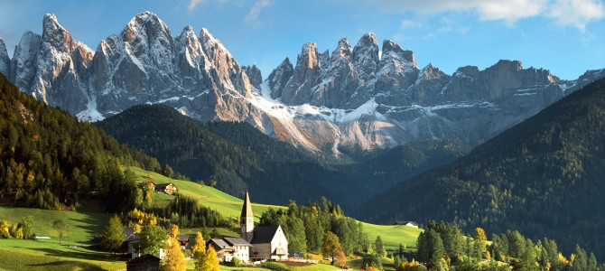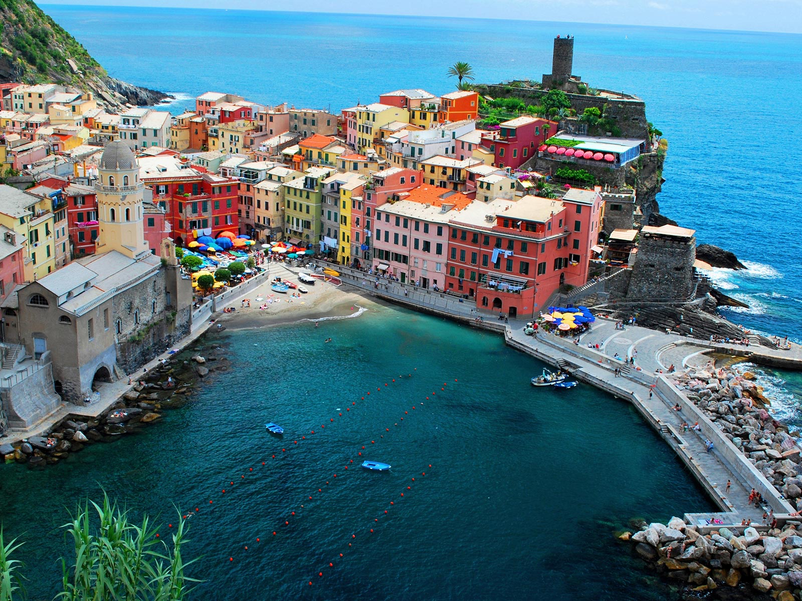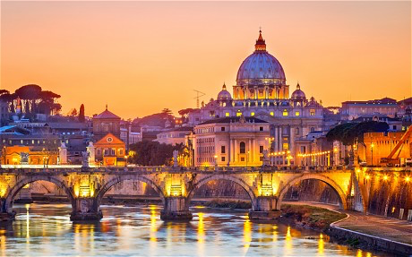

The factors, which attract tourists in certain places, are known as the ‘pull’ factors. These can be **physical** or **human**.

**Mountains- Alps**

**Coasts- Vernazza**

**Cities- Rome**