What was life like in Ancient Rome?

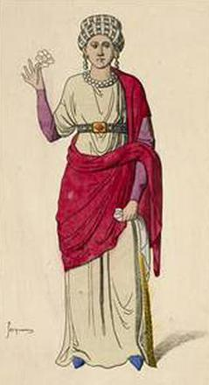 | 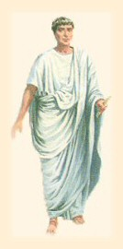
Woman | Rich Man | Child | Slave

Your task is to research what life was like for four different groups of people who lived in Ancient Rome. You should consider the following areas of everyday life for each of the people above;

- Homes and living
- Jobs/education
- Food
- Clothing
- Entertainment
- Position in society

How to research

- Cut out each of the pictures above and stick them, each on a separate page in your book.
- Use the websites and links provided on the Humanities website to guide you through your research.
- Make notes on the key facts that you find about each group of people.

