What is Money? – Creating an Infographic

Creating visual representations to encourage understanding and to highlight key information form heavy documents. Graphics are visual elements often used to point readers and viewers to particular information. They are also used to supplement text in an effort to aid readers in their understanding of a particular concept or make the concept more clear or interesting.

Challenge

Can we explain what is money through a thought-provoking infographic?

What is an Infographic?
An infographic is a popular form of content marketing that can help you simplify a complicated subject or turn an otherwise boring subject into a captivating experience. Ideally, an infographic should be visually engaging and contain a subject matter and data that is appealing to your target audience …something that is truly ‘link worthy’ or ‘share worthy’.

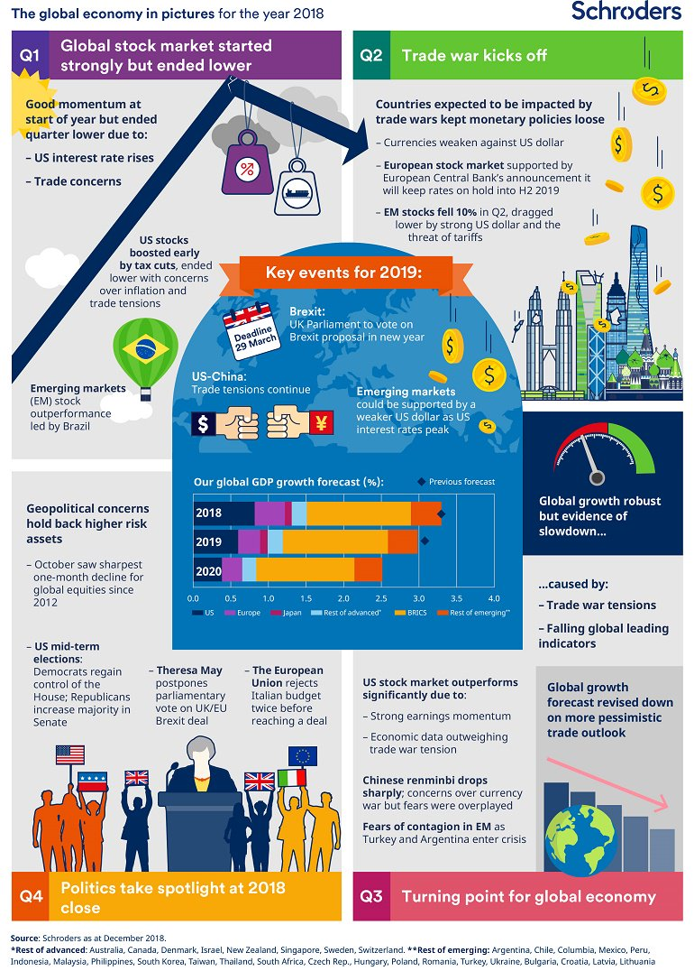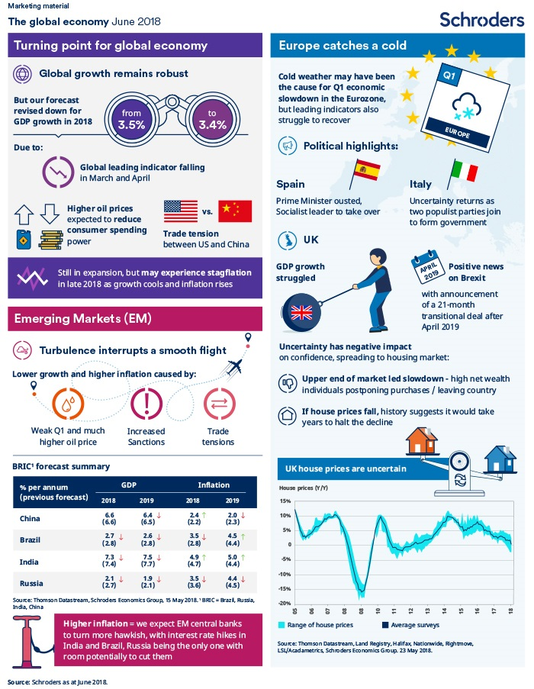
Picktochart
bishoustonhistory@gmail.com
bishouston

Venngage
bishoustonhistory@gmail.com
bishouston

Canva
bishoustonhistory@gmail.com
bishouston

Success Criteria???

What makes a good Infographic?

Look at some images online – google – infographic- images.

What do you like? What key features do they share?

Which are the best? Why?

A great infographic should have?
Eye catching: Colors, pictures, concise. Provocative questions?
Content: Clear and concise, accurate, easier to understand, relevant
Economic diagrams easy to understand, for each application of elasticity. Targeted to an audience that may not necessarily understand economics
Real World Examples of history, uses, functions, characteristics of money.
Well organized and formatted, clean looking
Cover all 5 questions listed
Research from iGCSE textbook.

