What causes Montserrat’s volcanic activity?
…………………………………………………………………………………………………

- Study the map below that shows Montserrat and the plate margins. The image comes from Appalachian State University (http://www.appstate.edu/~abbottrn/vlcns/sfrir.html)
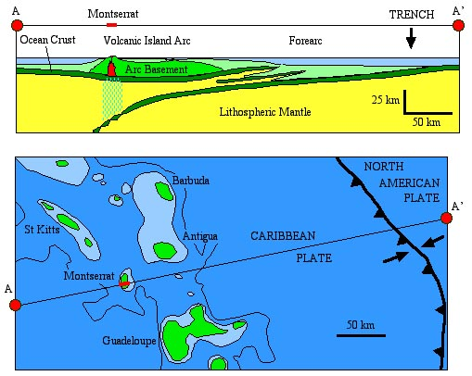

- Label the diagram above using these phrases, which have been jumbled:

Behind the subduction zone is a chain of volcanoes.
The Caribbean plate is crushing into the North American plate
The Caribbean plate is moving eastwards
The North American plate is being subducted beneath the Caribbean plate.
The North American plate is moving westwards
There are many volcanic islands in the Caribbean.
This is an island arc
This is the subduction zone
This is where two plates collide
This of the earth’s crust is lighter and so it ‘floats’ on a denser crust beneath
This part of the earth’s crust is heavier and gets dragged under the other

