Weather, climate and natural vegetation revision
WHAT DO I NEED TO BE ABLE TO DO:
- Describe how weather data is collected
- Make calculation using information from weather instruments
- Use and interpret graphs and other diagrams showing weather and climate data
- Describe and explain the characteristics of equatorial regions
- Describe and explain the characteristics of hot deserts
- Describe and explain the characteristics of tropical rainforest and hot desert ecosystems
- Describe the causes and effects of deforestation of tropical rainforest

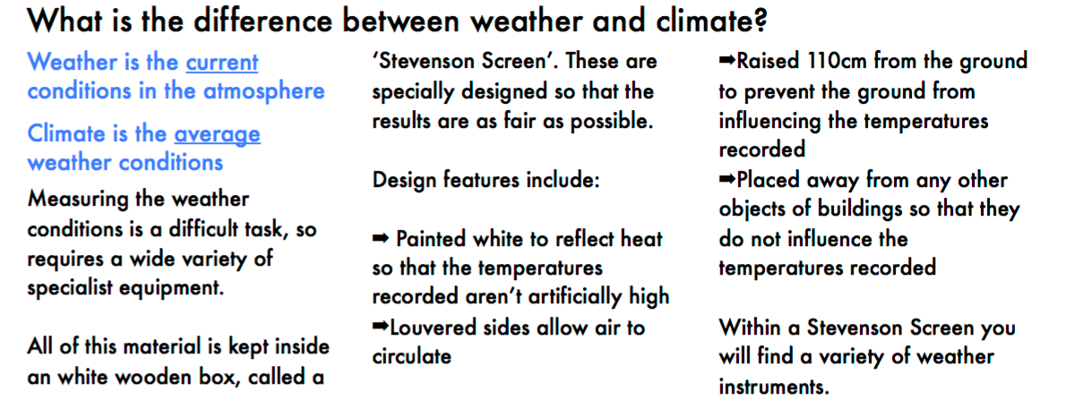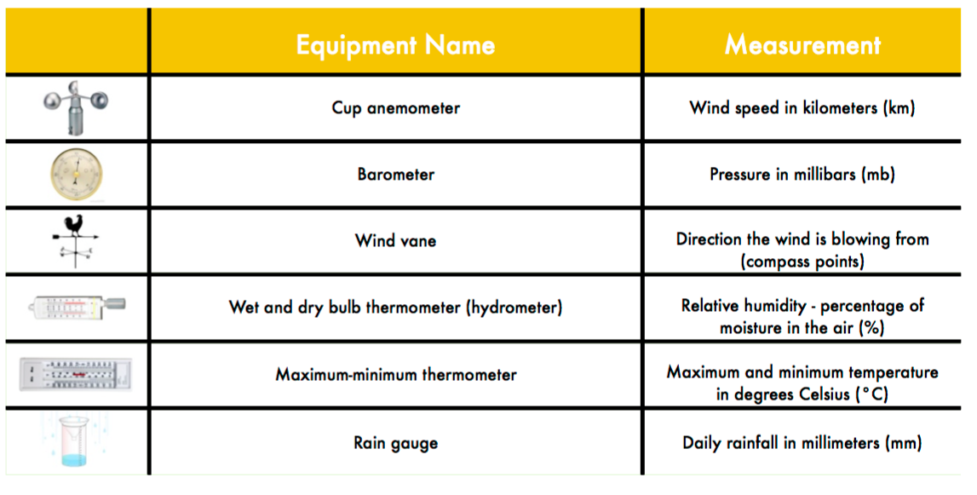
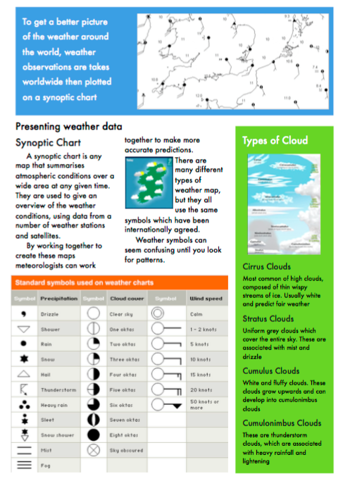

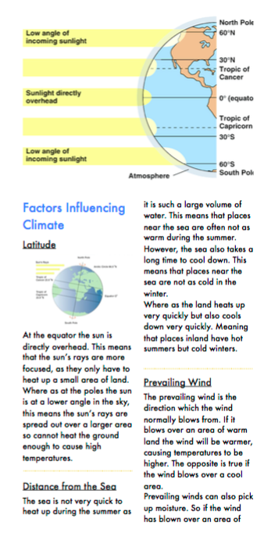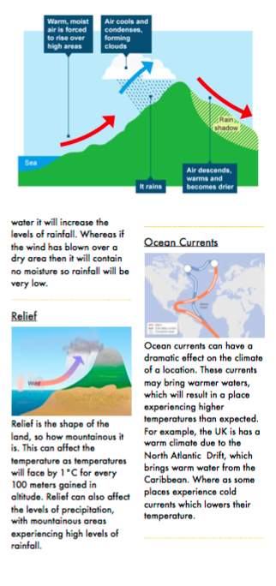
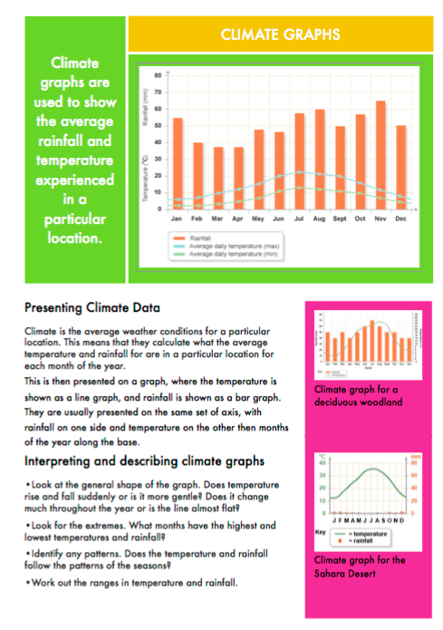

Types of rainfall

Relief rainfall
- Relief rainfall occurs when air has been blown over the sea and is then forced up over an area of high land.
- This causes the air to cool and the moisture in the air condenses and rain falls.
Frontal rainfall
- Frontal rainfall occurs when warm air is forced to rise over cold air.
- The moisture in the warm air condenses as it cools which causes clouds and rain.
Convectional rainfall
- Occurs mostly in tropics where it is hot.
- When air is hot is rises and cools and condenses forming rain.
- If the air is hot enough, it rises very quickly and can cause thunderstorms.

Tropical rainforest: Location:
Mean temperature of the hottest month: about 25°C Mean temperature of the coldest month: about 25°C Annual temperature range: less than 5°C
Rainfall – amount: exceeds 2000mm
Rainfall – seasonal distribution: same throughout year
Wind: low
Cloud: heavy
Humidity: high
Pressure: low

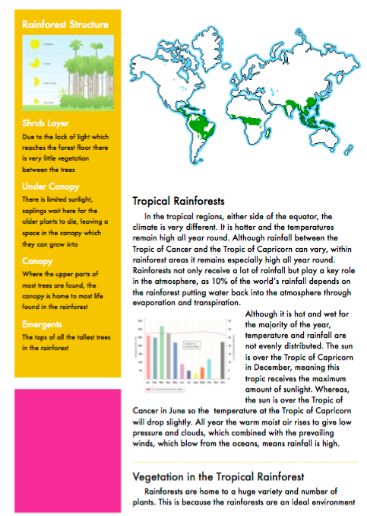

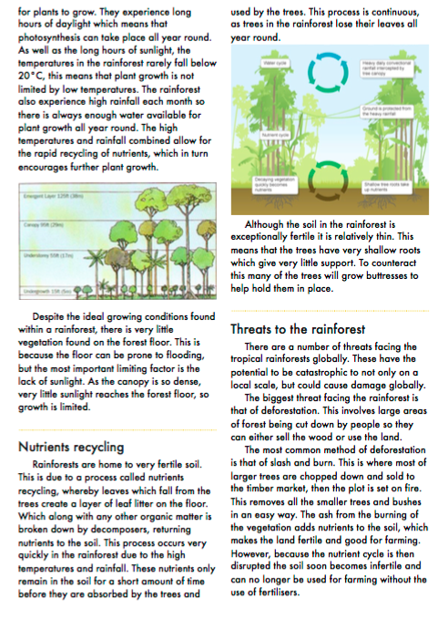
Adapting to rainforest life
The vegetation in the rainforest has evolved characteristics which help it to survive in this unique environment.
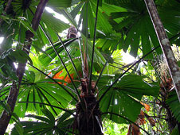
Each has adapted to rainforest conditions in a different way.
- Fan palms have large, fan-shaped leaves that are good for catching sunshine and water. The leaves are segmented, so excess water can drain away.
- Rainforests have a shallow layer of fertile soil, so trees only need shallow roots to reach the nutrients. However, shallow roots can't support huge rainforest trees, so many tropical trees have developed huge buttress roots. These stretch from the ground to two metres or more up the trunk and help to anchor the tree to the ground.
- Lianas are woody vines that start at ground level, and use trees to climb up to the canopy where they spread from tree to tree to get as much light as possible.
Strangler figs start at the top of a tree and work down. The seed is dropped in a nook at the top of a tree and starts to grow, using the debris collected there as nourishment. Gradually the fig sends aerial roots down the trunk of the host, until they reach the ground and take root. As it matures, the fig will gradually surround the host, criss-cross its roots around the trunk and start to strangle. The figs branches will grow taller to catch the sunlight and invasive roots rob the host of nutrients. Eventually the host will die and decompose leaving the hollow but sturdy trunk of the strangler fig.

A fan palm
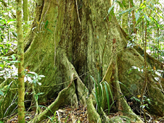
Buttress roots
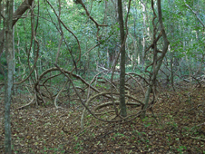
Lianas
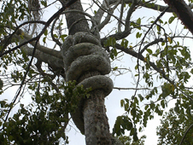
Strangler fig

Explain how animals have adapted to the physical conditions of the tropical rainforest.
[4 marks]
Paragraph 1: Outline how 2 animals have adapted to 2 physical conditions in the tropical rainforest.  e.g. if it was plants I would put that trees grow over 45m high to compete for sunlight due to the dark conditions closer to the forest floor. | ____________________________________________________  ____________________________________________________  ____________________________________________________  ____________________________________________________  ____________________________________________________  ____________________________________________________  ____________________________________________________  ____________________________________________________  ____________________________________________________  ____________________________________________________  ____________________________________________________  ____________________________________________________

Causes of deforestation

Cause of Deforestation | Description
Agriculture | Indigenous rainforest tribes practise subsistence farming. However, land is increasingly cleared for commercial farming – crop plantations and cattle grazing.  In Brazil, cattle ranching accounts for 80% of deforestation. In Brazil, soybeans, palm oil and sugar cane (for biofuel) are major crops.
Logging | Logging is the first step in the conversion of forest land to other uses. This may seem surprising giving that logging only accounts for 3% of the causes of deforestation in Brazil. This is because it is the eventual use of the cleared land is put to that is recorded in the pie chart. Trees such as mahogany and teak are highly valued (selective logging) for furniture and other uses. Smaller trees are used for fuel, pulped or made in to charcoal. Vast amounts of the rainforest are cleared in one go (clear felling). There is also lots of illegal logging.
Road Building | Roads bring supplies and provide access to new mining areas, new settlements and new energy projects.  In Brazil, the Trans-Amazonian Highway stretches for some 4 000 kilometres through the rainforest. This is accounted for in the 2% other category of the causes if deforestation in Brazil.
Mineral Extraction | Mineral extraction such as gold mining fall into the other category that accounts for 2% of the causes for deforestation in Brazil. In 1999, there were 10,000 hectares of land being used for gold mining. Today, there is over 50,000 hectares of land being used for gold mining. The rainforest also suffers from bauxite extraction which is used to make aluminium.
Energy Development | Also, included in the other category is energy development. An unlimited supply of water and ideal river conditions have encouraged dams to be built to generate hydroelectric power (HEP). This involves flooding vast amounts of rainforest. Often, the dams have a short life. In Brazil, the Belo Monte Dam will block the Xingu River flooding more than 40 500 hectares of land and displacing 15 000 people. The submerged forest eventually rots, making the water very acidic which then corrodes the HEP turbines. The dams also become blocked with soil washed down deforested slopes by the heavy rain.
Settlement and Population Growth | Population growth and migration to the area is also putting pressure on the Amazon rainforest, especially as the Brazilian government offers land in the rainforest to poor people from overcrowded cities. Many people migrate to the rainforest for work in the industries mentioned above. In turn, this means that land needs to be cleared to make way for settlements where workers and their families can live.

Impacts of Deforestation in the Amazon Rainforest
There are many consequences or impacts of deforestation, whilst two are of global significance, the others are essentially local.

Impact of Deforestation | Description
Soil Erosion | Soil takes thousands of years to form, but it can be stripped away in a matter of hours. Removal of soil by wind and rain is called soil erosion. The roots of trees and plants bind the soil together. As soon as any part of the rainforest is cleared, the thin layer of topsoil is quickly removed by heavy rainfall. Bare slopes are prone to soil erosion. Once the topsoil has been removed, there is little hope of anything growing in that area again. Soil erosion also leads to the silting up of river courses. Even when the soil is protected, it quickly loses the little fertility it has when covered by trees. Grazing and plantations do little if anything to keep the soil fertile. The decline in soil fertility leads to pastures and plantations being abandoned, so more areas of the rainforest are cleared.
Loss of Biodiversity  (Global) | Biodiversity is a measure of the variety of plants and animals in an ecosystem. Rainforest are the most biodiverse ecosystem in the world. Clearing tropical rainforests means that the biodiversity will be reduced, and individual species will become endangered and trees possible extinct. It has been estimated that 137 plant, animal and insect species are being lost each day due to deforestation. This amounts to 50, 000 species each year. As the rainforest species disappear, so do many cures for life-threatening diseases. Currently, over 120 prescription drugs sold worldwide come from plant sources. 25% of the active ingredients in today’s cancer-fighting drugs come from the organisms found only in the rainforest. Recent research has shown that the Amazon rainforest could lose between 30 and 45% of their main species by 2030.
Climate Change  (Global) | Climate change is amongst the significant global impacts of deforestation in the rainforest. During photosynthesis, the tree canopy absorbs carbon dioxide (a greenhouse gas) in the atmosphere which reduces the rate of climate change. The Amazon stores around 100 billion tonnes of carbon. When the trees are felled, this stops, and more carbon dioxide remains in the atmosphere. Fire is often used to clear the rainforests, this means that the carbon stored in the wood is released back into the atmosphere where it will absorb heat and increase Earth’s climate. Deforestation is responsible for at least 15% of global CO₂ emissions each year – more than all the world’s transport emissions combined. In addition, trees give off moisture from the process of transpiration; deforestation reduces the moisture in the air resulting in a drier local climate. With less moisture comes less condensation and in turn rainfall. The natural recycling of water is like a cooling system, once the recycling is reduced (through less moisture) the local climate becomes warmer. Increasing dryness and rising temperatures are not good for people or activities such as agriculture.
Economic Development | Deforestation in many parts of the world is driven by profit. Deforestation may lead to short-term economic gains, but it may also lead to long-term economic losses. The natural rainforest has brought wealth to countries that were poor. Agriculture makes a lot of money in the rainforest. In 2008, Brazil made $6.9 billion from trading cattle, Brazil is also the world’s second biggest exporter of soy bean. The mining industry creates jobs for local people, for example the Buenaventura mining company in Peru employs over 3100 people. Logging contributes a huge amount to Brazil’s economy. Companies will pay taxes to the government which can be used to improve public service such as education, healthcare and water supply. However, in the long-term, deforestation can destroy the resources that countries depend on such as timber and non-timber products, tourist numbers may also decline as the area reduces in attractiveness. The livelihoods of some local people are destroyed as deforestation can cause a loss of animals or plants that they rely on to make a living. For example, local Brazilian rubber tappers who extract natural rubber from rubber trees have lost their livelihoods as trees have been cut down.

CASE STUDY- the Amazon:

The climate of the tropical rainforest i.e Amazon rainforest (Ecuador)
Use a case study of a tropical rainforest to assess the impact of deforestation.
[7 marks]
Introduction:  What is your tropical rainforest? | ____________________________________________________  ____________________________________________________  ____________________________________________________  ____________________________________________________
Paragraph 1 –  Outline a negative impact with examples of deforestation – explain why this bad. | ____________________________________________________  ____________________________________________________  ____________________________________________________  ____________________________________________________  ____________________________________________________  ____________________________________________________  ____________________________________________________  ____________________________________________________  ____________________________________________________  ____________________________________________________  ____________________________________________________  ____________________________________________________
Counterargument –  Outline a positive impact with examples of deforestation – explain why this good. | ____________________________________________________  ____________________________________________________  ____________________________________________________  ____________________________________________________  ____________________________________________________  ____________________________________________________  ____________________________________________________  ____________________________________________________  ____________________________________________________  ____________________________________________________  ____________________________________________________  ____________________________________________________
Conclusion:  Your overall opinion linking back to the exam question. | ____________________________________________________  ____________________________________________________  ____________________________________________________  ____________________________________________________  ____________________________________________________  ____________________________________________________
The Equatorial Climate is characterised by hot average temperature all year round and high monthly precipitation, typically no less than 60 mm a month with annual precipitation tending to be over 2000mm. The diurnal temperature range is greater than the annual temperature range. The reason for this regular climate is due to a feedback between low pressure convectional processes that result from the high altitude of the sun (ITCZ) The Hadley cell means that at the equator, air is heated by the sun and forced to rise causing low pressure. As the heated air rises, it cools, condenses and forms huge storm clouds and rains causing rainforests. High levels of soil moisture and interception of rainfall from the dense vegetation cover leading to transpiration. This feedback leads to a repetitive climate pattern of hot humid air, dry but misty mornings and late afternoon downpours and convectional storms.

Effects of deforestation/ resource extraction in the tropical rainforest:

Tropical rainforests are fragile environments as they are easily disturbed by human activity. Areas like the Amazon basin in Brazil are under pressure because they not only have valuable timber resources but also minerals such as gold, iron ore, oil and gas. In the Oriente region of the Amazon in Ecuador Oil has discharged 4.3 million barrels of toxic waste into the environment each day. Toxic contaminants in dinking water have reached 1,000 times the safe standard Increases in gastrointestinal problems, skin rashes, birth defects and cancers (stomach cancer 5x more in areas with oil extraction). Miscarriage is high amongst indigenous people such as Huaorani. Plants such as periwinkle (used to cure childhood leukemia) are now endangered. The oil has only benefitted a few- many have become poorer- social inequalities. Only 20 years of oil left in the Amazon.
The reason it happens is because of the need for development in this LEDC area (the benefits outweigh the costs) and the needs for resources from this area.

Exam Style Question
Explain how deforestation can have economic impacts. [5 marks]

Introduce the location.
State a positive/negative economic impact and explain it. Support with evidence
State a positive/negative economic impact and explain it. Support with evidence.

Management of deforestation in the rainforest: could link to tourism unit and management of the negative impacts of economic development (section 3)

Case Study of the Napo region in Ecuador, an ecotourism area within the Yasuni National Park
● The Rio Napo region is situated at the western extreme of Amazonia where it has extraordinarily rich tropical moist forests.
● There has been a lot of oil exploration and deforestation in the past (a research by the British charity Action Aid proved this).
● This was destroying the traditional lifestyles of the locals (Quicha people).
● Action Aid developed the eco-tourism project to stop this from continuing and to provide a
sustainable income for the Quicha people.
● The Napo Wildlife Centre is a 100% community-owned lodge which is located inside the Yasuni National Park deep in the Ecuadorian Amazon.

● The Anangu Quichua community receives half of the profits from the lodge, this allows them to be active in conservation and to work towards preventing logging, market hunting, and oil extraction all of which are actively destroying local forests.
● The members of the community are active participants in the conservation and management of over 52, 000 acres within the Yasuni National Park as well as partners in the lodge
● Ten big luxury cabins, private shaded porches with lake view, ceiling fans, mosquito nets.
● Private bathroom, on-demand hot water showers, 24-hour electricity.
● Large thatch-roof dining hall
● Local fruits, fresh baked bread.
● 50-foot viewing tower, 120 foot canopy tower, parrot clay licks.
● This conservation region is more than 52, 000 acres in size, and an important biosphere reserve of Amazon rain forest.
● Costs roughly $865 for 4-5 days.
● All money goes to the local community so all Quicha people benefit with education and healthcare, etc.
● 85-93% of locals make up workforce, so a lot of employment has been made by eco-tourism scheme.
● The lodge has an environmentally sustainable sewage system and all waste water is treated to the highest standard in order to keep the swamps clean.
● Rubbish is kept to a minimum and they compost what they can, burn and bury what is safe to burn, and pack the remainder to designated landfills.
● Solar panels and diesel generations provide power.

Tropical desert:
Location: between 5° and 30° north and south of the equator
Mean temperature of the hottest month: 30°C
Mean temperature of the coldest month: no less than 18°C
Annual temperature range: less than 5°C
NOTE: during the day it can get to 50°C but during the night it gets to about 0°C so the average is lower. Rainfall – amount: less than 250mm in a year
Rainfall – seasonal distribution: irregular rainfall
Wind: strong
Cloud: virtually cloudless skies
Humidity: low
Pressure: high
Contributing factors:
distance from oceans;
winds blow over large areas of land;
winds blow offshore/do not blow from sea hence no source of moisture/water sources;
low humidity;
lack of evaporation;
sparse vegetation;
lack of transpiration;
high air pressure;
descending air;
cold offshore currents etc.

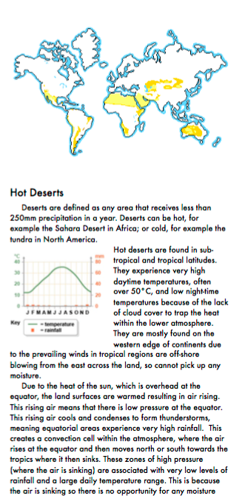
Hadley cell
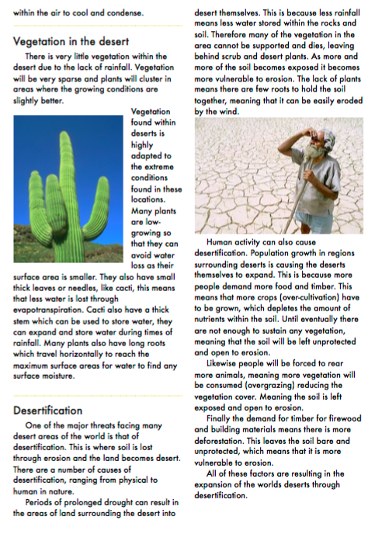

Case study of desert: Mojave desert and water supply from Colorado river (link to water unit):

Management in the Mojave desert:

The Colorado River is located in South-West USA and North-West Mexico. It is over 2,300km and has its source in the Rocky Mountains and its mouth in the Gulf of California. Its drainage basin covers an area of 640,000km2. The Colorado River and its tributaries pass through the US states of; Wyoming, Nevada, Utah, California, Arizona, Colorado and New Mexico. The climate across the river basin is very varied, in the Rockies temperatures can fall to -50 degrees Celsius an experience precipitation in excess of 1000mm, whereas some areas in the Mojave Desert can experience temperatures of nearly 50 degrees Celsius and precipitation as low as 15mm. About 12.7 million people live within the drainage basin of the Colorado River, although some people outside the drainage basin (especially in California) use water from the Colorado River. In total it is estimated that about 40 million rely on the river for domestic, agricultural, industrial and energy needs.
To cope with the massive demand, the Colorado River has become one of the most managed river's in the world. The river has over 29 major dams built along its and hundreds of miles of artificial canals. The Hoover Dam was one of the first major dams built along the river (and certainly the most famous), it was completed in 1936 and created Lake Mead - this is still the US's largest artificial lake.
Management Strategies
In an attempt to reduce environmental damage while allowing continued economic and population growth, a number of management strategies have been implemented and/or suggested, including:
Reduced leakage: It is estimated that 25% of all water is currently lost through leaking pipes and canals.
Recycling Water: Using more grey water in domestic homes.
Sewage Treatment: Recycling industrial and domestic waste more efficiently.
Domestic Conservation: Improving education and introducing things like half flush toilets.
Drip Irrigation: Use more efficient irrigation techniques.
Changing Crops: Growing crops or varieties that need less water-
Xeriscaping: a type of landscaping in which everything is designed to help reduce or eliminate the need for supplemental water from irrigation or other watering methods.
Metering and Pricing: Increasing the price of water and metering its use.
Cloud seeding: Using chemicals to create artificial rain has been talked about.
Desalination: With the Pacific Ocean on California's door step the technology of desalination could be improved.
Groundwater: Increase extraction of groundwater supplies.

Alternative case study (link to food production):
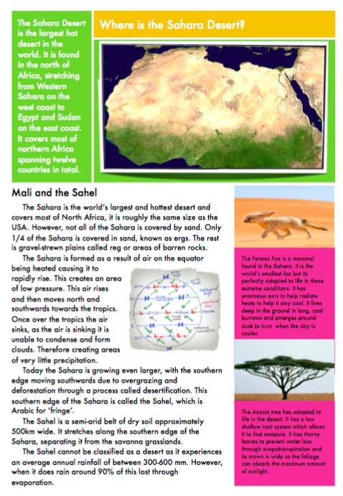

Examples of 7 mark questions:
2008: Many areas of natural vegetation are at risk from human activities. Name either an area of tropical rain forest or tropical desert which you have studied and explain why and how it is at risk from human activities. [7]
2010: For an area of tropical desert which you have studied, describe and explain the characteristics of its natural vegetation. [7]
2011: For a named area of tropical desert which you have studied, describe and explain the characteristics of its climate. [7]
2011: For a named area of tropical rainforest which you have studied, describe and explain the characteristics of its climate. [7]
2012: Describe the impacts of large scale deforestation of tropical rainforests on the local natural environment. [7]
2012: For a named area of tropical rainforest which you have studied, describe the ways in which it benefits people. [7]
2012: Describe and explain the main characteristics of the natural vegetation of a tropical rainforest. You must include a labelled diagram. [7]
2013: Describe the impact of human activity on a tropical rain forest ecosystem which you have studied. [7]
2012: For a named area of tropical rainforest which you have studied, describe and explain the characteristics of its climate. [7]
2013: Name an area of tropical rainforest which you have studied and explain why deforestation is taking place there. [7]
2013: Describe the impact of human activity on a tropical rain forest ecosystem which you have studied. [7]
2013: For a named area of tropical desert which you have studied, describe and explain the characteristics of its climate. [7]
2013: For a named area of tropical desert, explain why the climate is hot and dry. [7]

