Water

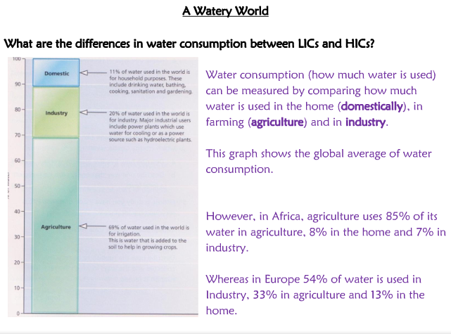

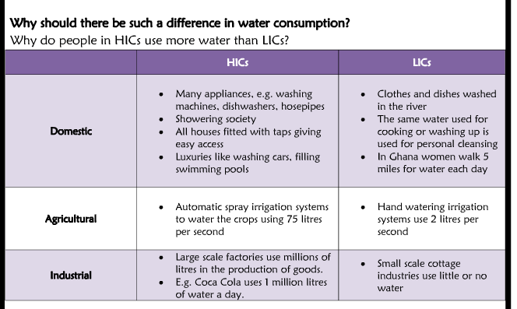
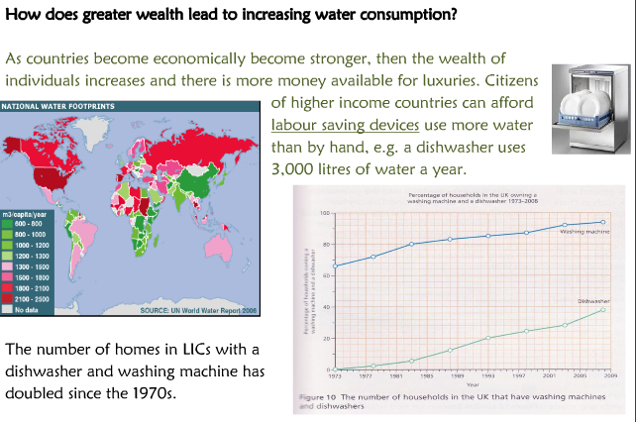

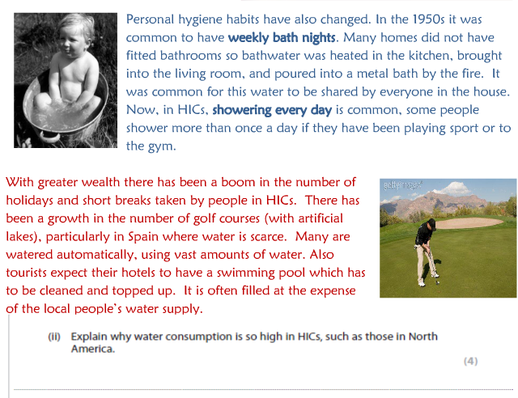

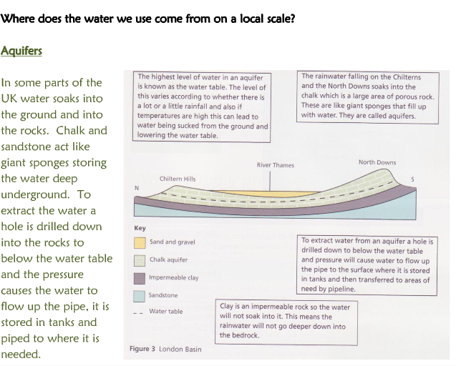

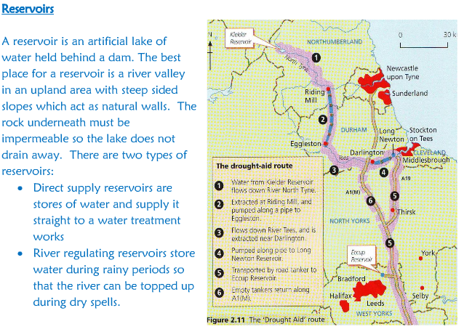

RESERVOIR BUILDING: Adds a new store to the hydrological cycle. But....brings
PROBLEMS:
Loss of land – drowns villages, farmland
Disease – stagnant water → mosquitoes  
Vegetation drowned releases methane = greenhouse gas
BENEFITS:
Water supply 
Can prevent flooding- e.g. Three Gorges Dam
Recreation – fishing, sailing, walking, wildlife

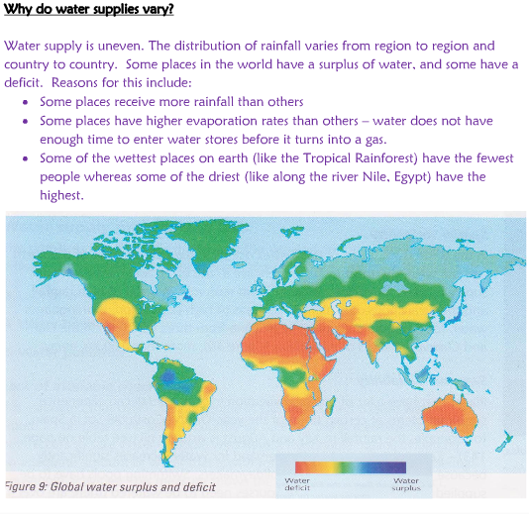

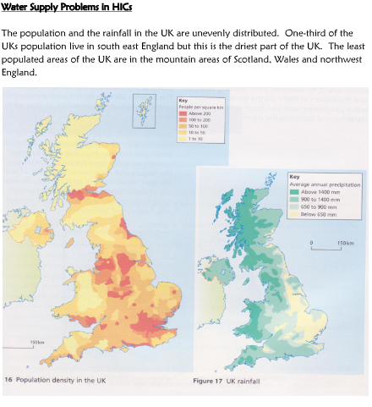

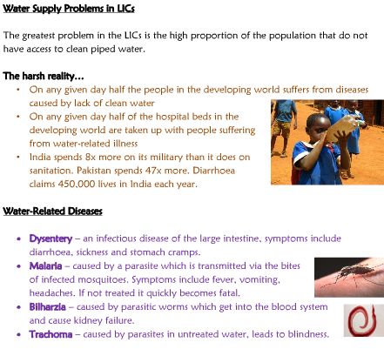

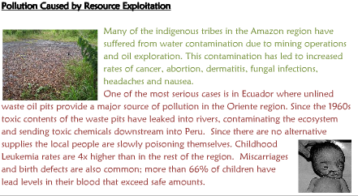

Increasing water supply in an LEDC:

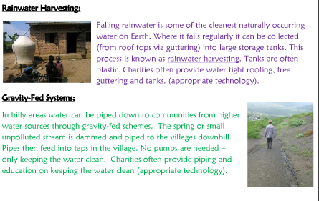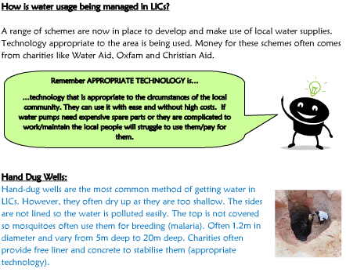

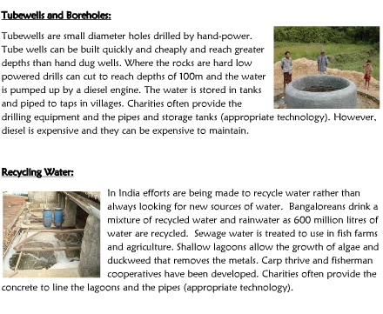
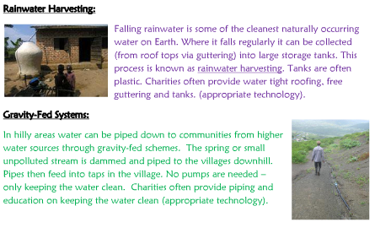

Colorado river basin case study:

The Colorado River is located in South-West USA and North-West Mexico. It is over 2,300km and has its source in the Rocky Mountains and its mouth in the Gulf of California. Its drainage basin covers an area of 640,000km2. The Colorado River and its tributaries pass through the US states of; Wyoming, Nevada, Utah, California, Arizona, Colorado and New Mexico. The climate across the river basin is very varied, in the Rockies temperatures can fall to -50 degrees Celsius an experience precipitation in excess of 1000mm, whereas some areas in the Mojave Desert can experience temperatures of nearly 50 degrees Celsius and precipitation as low as 15mm. About 12.7 million people live within the drainage basin of the Colorado River, although some people outside the drainage basin (especially in California) use water from the Colorado River. In total it is estimated that about 40 million rely on the river for domestic, agricultural, industrial and energy needs.
To cope with the massive demand, the Colorado River has become one of the most managed river's in the world. The river has over 29 major dams built along its and hundreds of miles of artificial canals. The Hoover Dam was one of the first major dams built along the river (and certainly the most famous), it was completed in 1936 and created Lake Mead - this is still the US's largest artificial lake.
Colorado River Aqueduct (CRA): This is 389km of tunnels, pipes and canals taking water from the Colorado River to California. The water is taken from the Parker Dam and is pumped up over the Rockies ending up at Los Angeles. Work on the project began in 1933 and water was first pumped in 1939. On average 1.5km3 of water is pumped through the aqueduct each year.
Central Arizona Project (CAP): This is 541km diversion canal. The canal was designed to provide water for irrigation of 405,000 hectares (1.85 trillion litres a year) and for domestic use in cities like Phoenix and Tuscon. Construction of the project began in 1973 and it was completed in 1993. The canal starts at Lake Havasu and eventually finishes at Tucson. The scheme cost about $4 billion to build.
California State Water Project (SWP): The project aimed to provide water for 23 million people and 6.6 million MWh of electricity to people living in Southern California. The project began in the 1950's.
Environmental Impacts
It is impossible to manage a river so much and not create some environmental problems. Problems include:
- The Colorado River used to carry about 90 million tonnes of sediment (alluvium) a year down to its mouth. However, the majority of this now gets trapped behind dams, damaging the delta and wetland ecosystem at the river's mouth.
- Salinity in the lower Colorado has increased changing the ecosystem.
- The number of fish shrimps and sea mammals have all reduced around the mouth of the river.
- Evaporation rates have increased behind the river's many dams. About 15% of water is evaporated.
- The deep water in the reservoirs behind the dams has reduced the temperature of the river in many areas.
Management Strategies
In an attempt to reduce environmental damage while allowing continued economic and population growth, a number of management strategies have been implemented and/or suggested, including:
Reduced leakage: It is estimated that 25% of all water is currently lost through leaking pipes and canals.
Recycling Water: Using more grey water in domestic homes.
Sewage Treatment: Recycling industrial and domestic waste more efficiently.
Domestic Conservation: Improving education and introducing things like half flush toilets.
Drip Irrigation: Use more efficient irrigation techniques.
Changing Crops: Growing crops or varieties that need less water.
Metering and Pricing: Increasing the price of water and metering its use.
Cloud seeding: Using chemicals to create artificial rain has been talked about.
Desalination: With the Pacific Ocean on California's door step the technology of desalination could be improved.
Groundwater: Increase extraction of groundwater supplies.

