IB DP Geography – Urban Tourism Hotspots – Venice
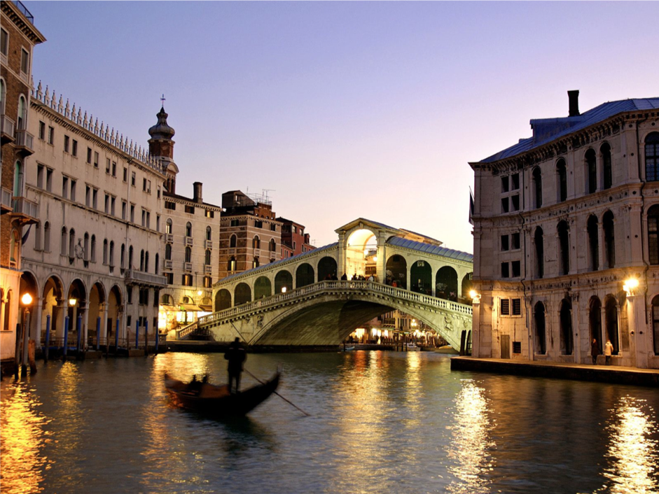
Task 1 – Brief introduction to tourism in Venice, including primary and secondary tourism hotspots, reasons for growth of tourism to Venice, carrying capacity for Venice.
Task 4 – Comment on the strengths and weaknesses of the management strategies

Task 3 – Outline 3 management strategies being used in Venice to maintain the carrying capacity

Impact Factors | Benefit | Cost
Social | 1  2 | 1  2
Economic | 1  2 | 1  2
Environmental | 1  2 | 1  2

Exam Practice: Discuss the strategies used to manage tourism in one named urban area

