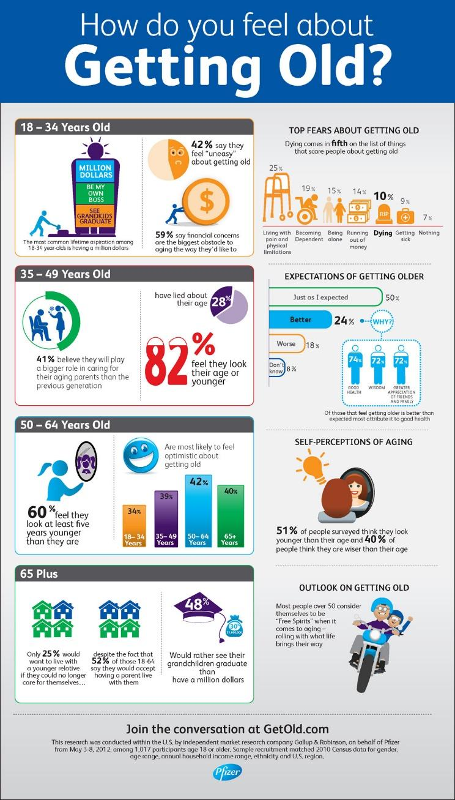https://www.pinterest.com/pin/541417186429500257/

Questions:
- a) Which age group are most optimistic about getting old? [1]

- What % of people would rather have a million dollars than see their grandchildren graduate? [1]

- Explain one reason why a country might experience a ‘high dependent population’. [3]

d) Analyse the pro-natalist policy of a country you have studied. [5]

