Unemployment

In the lesson today we will be looking at the following issues relating to unemployment.

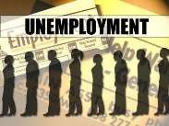
– Definition of unemployment
- – The measurement of unemployment and it problems
- – Consequences/costs of unemployment
- – Causes/Types of unemployment
- – Solutions to unemployment
- – Equilibrium and disequilibrium unemployment

- Give a definition for unemployment

- Please label the diagram below using the following terms: population, population of working age and labour force
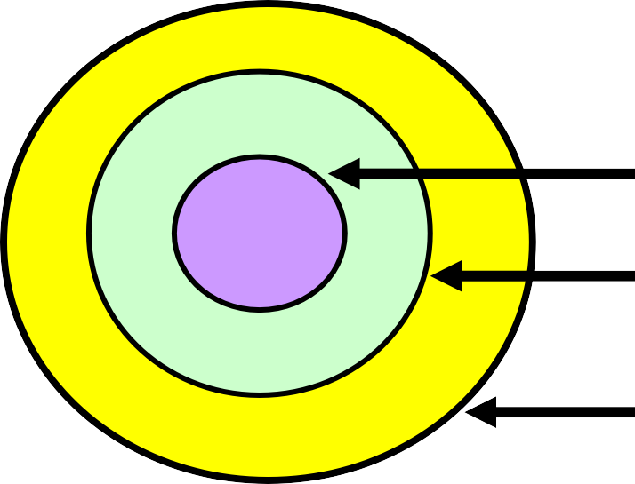
- Give examples of people in each group.

Labour Force | Population of working age | Population
→ | → | →
→ | → | →
→ | → | →

- Imagine an economy with the following population statistics.

Population | 100m
Population of working age | 80m
Labour force | 65m
Employed workers | 50m
Self-Employed workers | 13m
Unemployed workers

i) Calculate the a) number of unemployed workers and the b) unemployment rate.

- - In the table below try to identify the different types of unemployment and match them to their descriptors.

Structural Cyclical (Keynesian) Frictional

Classical/ Real wage
Seasonal

Type of unemployment | Definition
◆ | When an economy goes into recession unemployment rises because there is  insufficient demand in the economy.
◆ | This type of unemployment exists when the real wage rate is above that which is needed to clear the labour market.

◆ | This type of unemployment occurs in some areas such as seaside resorts where jobs are plentiful in the summer but prospects are bleak in the winter.  Workers such as ice-cream sellers are unemployed at certain times of the year.
◆ | This is where there is a temporary miss- match of workers and jobs. The vacancies and the pool of available  workers need to be combined.
◆ | This is caused when an industry such as coalmining closes down as the economy  evolves.
Answer the questions below and identify which type of unemployment is being described?

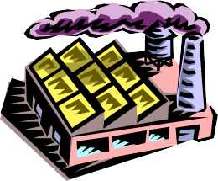
- A shipyard closes making its 1000 strong workforce redundant.

- A factory making children’s clothes is forced to make 100 staff redundant in a
recession.

- A Trade union negotiates higher wages for its members meaning that some members of the firm are laid off as the wage budget is exceeded.

- A trained engineer is out of work whilst she looks for a new job.

- Casual hotel workers in a seaside resort town are laid off.

Draw a diagram to illustrate the aggregate (macroeconomic) labour market.

Real Wage Rate

Define the terms that appear on the diagram

Number of workers employed

Aggregate Labour Demand

Aggregate Labour Supply

Disequilibrium unemployment

The first two types of unemployment that we are going to consider in more detail are
known as ‘disequilibrium’ unemployment.

These types of unemployment occur when there are factors that prevent the aggregate labour market from clearing
Cyclical

- Illustrate the cause of cyclical unemployment on the aggregate labour market diagram below.

Real Wage Rate

Number of workers employed

- Now use an aggregate demand/aggregate supply diagram to illustrate the cause of cyclical unemployment.

Price level

Real GDP

- What should the government do to reduce this type of unemployment?

- Illustrate the government action on the diagram below.

Real wage rate

Number of workers

- What are potential disadvantages of these policies?

Equilibrium unemployment

Even if there is no cyclical/demand deficient or real-wage unemployment in the economy, there are still likely to be unemployed workers. Unemployment can still exist even when the aggregate/macroeconomic labour market is in equilibrium.

This type of unemployment is known as ‘equilibrium unemployment’. We can also refer to this as the ‘natural rate of unemployment’.

Structural Unemployment

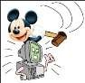
- What are the different possible causes of structural unemployment?

- Illustrate structural unemployment using a diagram.

Wage
of miners

No. of miners

- What is the difference between the fall in demand that leads to cyclical unemployment and that which creates structural unemployment?

- For the types of equilibrium unemployment you have to try to think of solutions
that government could adopt and complete the table below.

Type of Unemployment | Solution
❑ Frictional
❑ Structural | ❑          
❑ Seasonal

- What are the potential drawbacks of each of your strategies to reduce equilibrium unemployment?

Costs of Unemployment

- Unemployment has a detrimental effect upon whom?

1.
2.
3.
4.

- State how the following groups are affected by unemployment.

1.
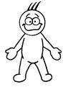
2.
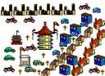

3.
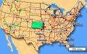

4.
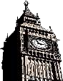

Draw two diagrams to show how the economy suffers when there are unemployed people.

Price Level

Real GDP

Consumer Goods

Capital Goods

