IGCSE Geography – MEDC Settlement Sites
Task 1 - Describe the site and situation of your home town (or favorite city)
Site of …..
Situation of ….
No matter whether we are talking about Houston or Honolulu, all settlements started off life because they met one or more important siting criteria. The table below outlines these.
Task 2 – Write in the appropriate factor name next to the description below.
Factor | Description
 | Water is essential when building a settlement. You need water to drink, to wash, to water crops and to cook. Water also contains fish that can be eaten and it can be used as a transport route.
 | All settlements need food so it is important to build need fertile soil, where it is possible to grow crops. If a settlement grows a surplus of food then they might be able to trade with neighbouring settlements.
 | It is a lot easier to build a settlement on flat land than in mountains.
 | When sites for settlements were first chosen (hundreds or thousands of years ago), battles between settlements would have been common, therefore a good defensive location (on a small hill or surrounded by water) would have been very important.
 | Most houses would have traditionally been made out of woods, reeds, etc. Therefore it would have been very important to have been located near a source of building materials.
 | There wouldn't have been roads and railways when the sites of settlements were initially selected. However, access to rivers, the sea or valleys would have been very important. If the settlement was built next to a river, a site that allowed easy access across the river would have been chosen.
 | Settlements would not have had electricity or gas so a location next to a reliable source of fuel would be essential. The fuel source would normally be wood, or possibly peat.
 | Sites with fairly stable weather will have been selected. You do not want some where too hot or too cold, too wet, too dry or too windy. To grow crops sun and rain would have been very important.
 | Settlements may have also been built for their access to trading routes. It would be very hard for one settlement to be totally self-sufficient so trade was essential. Coastal areas often make good locations to trade from.
 | It is useful being near resources like wood, coal, gold because you can use them to build things or trade with nearby settlements.
Task 3 – Settlement Detective. On the following images, add site information and then annotate on the relevant siting factors that would/still do exist. Check Google Maps/Earth too.
- Durham, UK
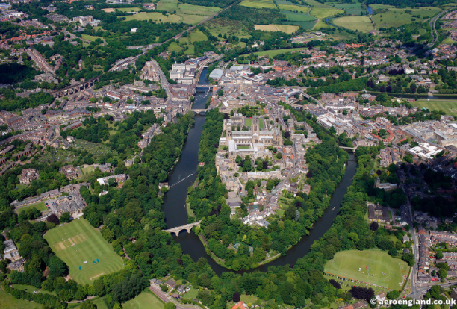

- Conwy, UK Site of Conwy:
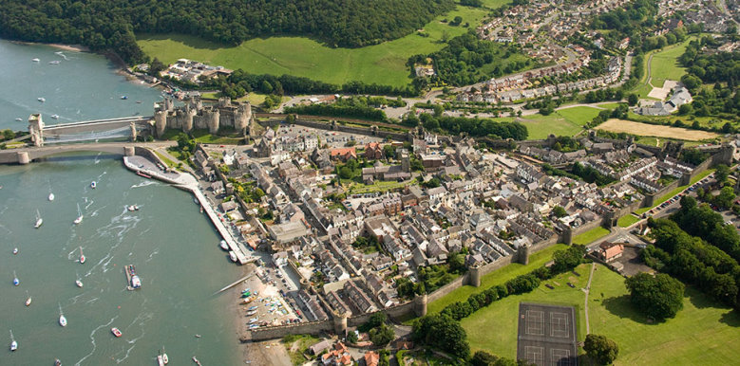

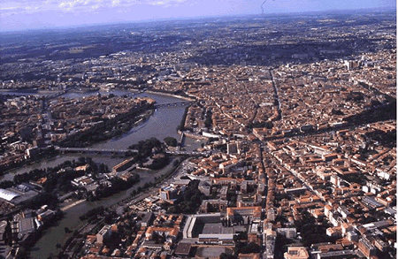
- Toulouse, France
Site of Toulouse

- Chesterfield Inlet, Canada
Site of Chesterfield Inlet:
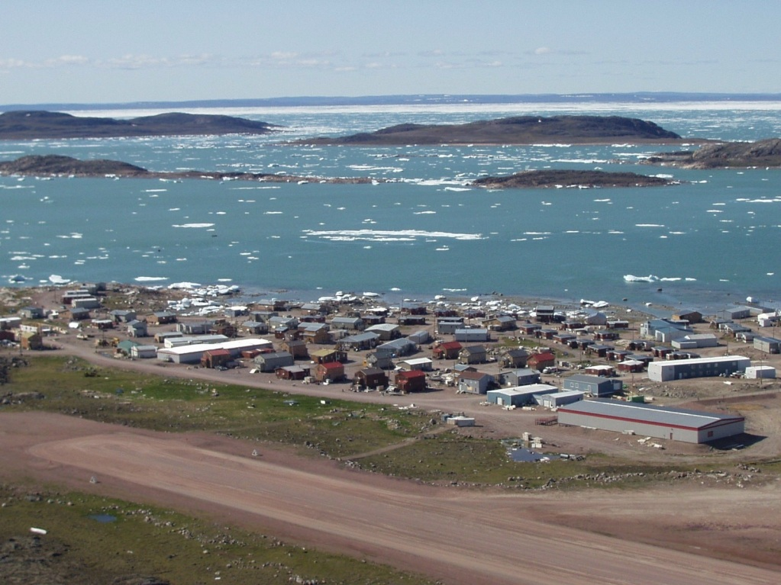

- My Home Town ________________
Site of ….

Insert image and annotations here…

Key Words – Need to Know
Urban: The built up area, any city with a population of 10,000 people or more.
Rural: Basically the countryside (everywhere outside urban areas). Rural areas maybe farmland, forest, desert or savanna depending on where you are in the world. Rural areas do contain small settlements of less than 10,000 people e.g. hamlets and villages.

