Traditional Dress, Homes And Diet
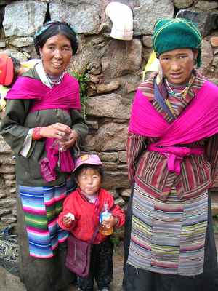

The traditional Sherpa clothing is similar to that of Tibetans. The basic garment, the chuba, originated in the cold climates of Tibet. It is a warm ankles length robe, bound at the waist by a long sash. The chubas upper proportion becomes a large pocket for everything from money to bowls; chubas were made from strips of hand-woven wooden cloth.

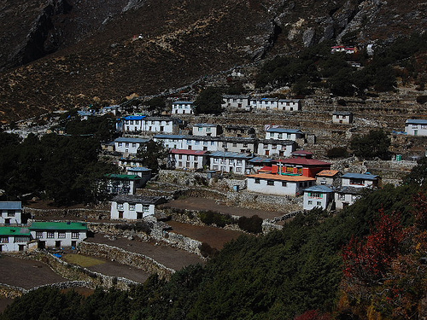
When the first Sherpa’s settled their homes were bamboo huts. Gradually they became half stone, half split wooden logs. Eventually they became stone houses and later two story buildings began to be built. The design of the Lha-Khang (chapel) was also brought from Tibet which serves as a reminder of spiritual matters in every home.

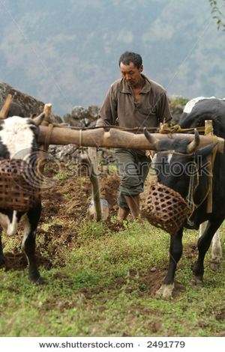
The major part of a Sherpa’s production consists of field agriculture. Potatoes are their main staple, with barely, wheat varieties and garden vegetables. No machinery is used for this farming, plowing is done with a single-bladed plow drawn by an ox. Another main component is livestock herding for dairy products such as butter and yogurt. Rice and fruit are bought from regional markets. Sherpa’s, being Buddhist, don’t slaughter animals and don’t generally eat meat, though they will eat meat bought at a market which was slaughtered by a non-Sherpa.

