Tracking Hurricanes – September 13th 2018

Task: Tracking active Tropical Storms
What: Understanding Tropical Storms and current weather systems
Why: To consider patterns and trends in Tropical Storms and their impact in the future.

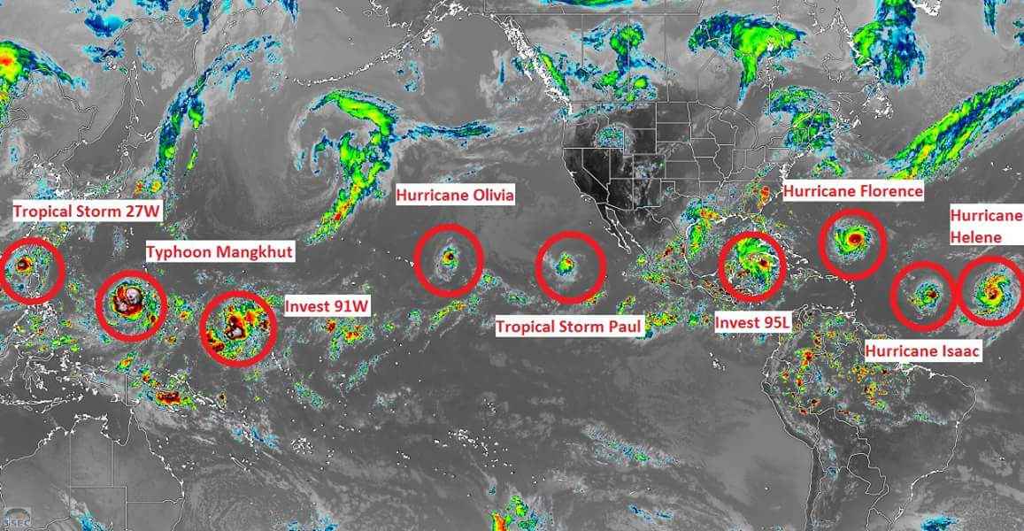
The current map of Tropical storms – September 14th 2018

Task - In pairs you will be allocated one of the current Tropical Storms. Your job is to research your allocated storm and to gather information;

- Where is it?
- What are the main features?
  - Strength
  - Size
  - Wind speed
  - Potential effects
- What is its potential track?
- What is expected to happen?
- Which areas of land will it effect?

Task: Using the relevant symbols locate the tropical storm on the large map. Track the cone of uncertainty and possible track.

Task: What questions do you have about Tropical storms and their effects? Write your questions on a post it note and place it at the bottom of the map.

Tropical storms – September 2018

Hurricane Florence

Hurricane Helene

Hurricane Isaac

Subtropical storm Joyce

Invest 95L

Hurricane Olivia

Invest 91W

Typhoon Mangkhut

Tropical Storm 27W

https://www.nhc.noaa.gov
https://www.tropicaltidbits.com/storminfo/
https://www.stuff.co.nz/world/107069048/typhoons-tropical-storms-and-hurricanes-are-sweeping-across-the-tropics
https://www.theverge.com/2018/9/13/17857478/hurricane-florence-storm-surge-flooding-the-weather-channel-video-graphics
http://www.ssd.noaa.gov/PS/TROP/Basin_WestPac.html

