Tourism

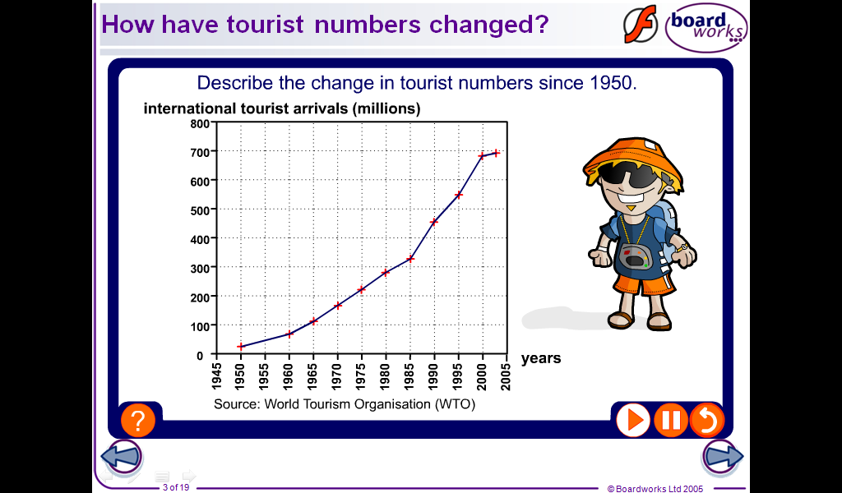**The growth in tourism**

With 700 million international travellers each year, tourism is the world’s largest industry. It has been estimated that tourism accounts for approximately 10% of the world’s economy and provides work for over 500 million people. In some LICs tourism is the main engine of growth, in some extreme cases accounting for 80% of GDP. Even in Britain tourism is big business with 24 million visitors spending £75 billion each year.

**So why has tourism exploded?**

Tourism has grown due to a combination of economic, social and political reasons.

**Economic** – The world is getting richer. As countries have become more developed the average income of their population has increased, resulting in a greater deposable income. This rise in wealth has been matched by increased access to credit. Credit cards, loans and overdrafts have meant that many people are no longer required to save for a holiday. At the same time holidays have become cheaper due to a number of travel and industry developments. The introduction of package holidays gave tour operators huge economies of scales which enabled them to bulk buy services driving prices down. More recently the growth of budget airlines and regional airports has lead to lower priced travel.

**Social** – Due to improved employment conditions and new approaches to work (e.g. flexi-time) most people in HICs have experienced a significant increase in leisure time. Changing family life – later marriage, fewer children and earlier retirement - has also given families more freedom to travel. Today, holidays for most have become a ‘given’ and a way of measuring progress against peers. Travelling can give you a ‘cachet’. Travel is viewed as broadening the mind and those that are actively engaged can appear cultured and experienced.

**Political** – A number of political changes have also stimulated the growth in tourism. Within Britain new legislation, such as statutory rights to paid holiday, have encouraged demand whilst at a European level the creation of the EU’s single market boosted continental travel by allowing the free movement of people between member states, removing the need for passports and visas. Changing internal politics within a number of countries, including much of Eastern Europe and China, has led to new more welcoming attitudes towards tourists, promoting further growth.

EXAM PRACTICE

1. **Describe** the growth in international tourism. (3)

2. **Outline** the reasons why many people now have more leisure time. (3)

3. **Give** two reasons why holidays have become more affordable. (2)

**TOURISM case study – KENYA**

**Attractions for tourists to Kenya**

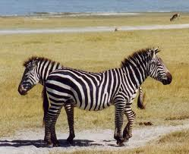

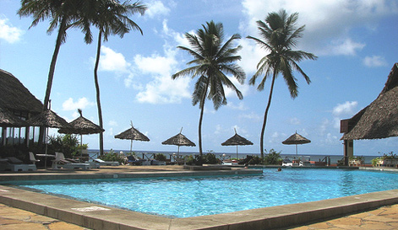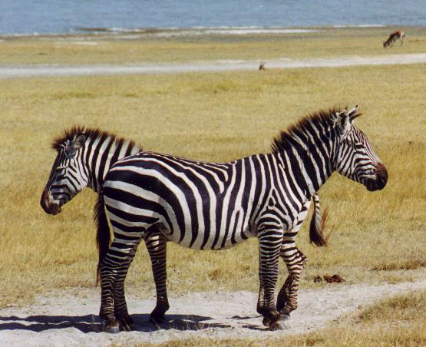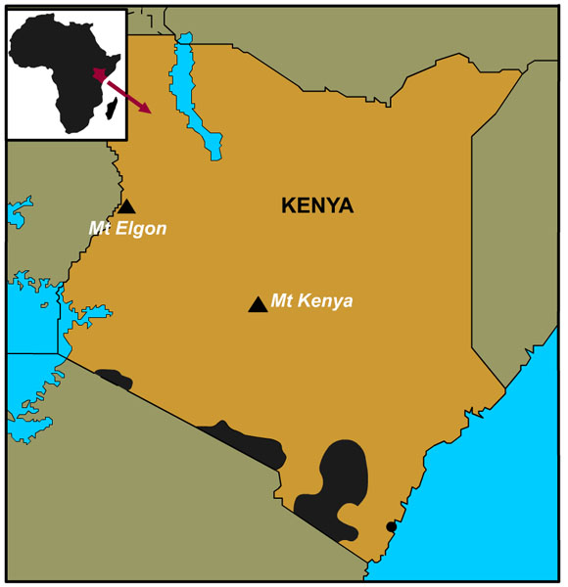

PHYSICAL

HUMAN

Modern / purpose built resorts with a wide range of facilities including water sports, spas, international restaurants and nightlife.

Unique culture of local tribes, e.g. Masaai.

Crystal clear seas and pure white sands. Coral reefs and diverse marine wildlife.

Dramatic landscapes: African rife valley and huge savannah plains. Safari wildlife: Zebras, Elephanes, Rhinos etc...

Sunny, hot, dry **all** year round.

INDIAN OCEAN COAST

GAMES RESERVES

Kenya offers a wide variety of holidays:

1. Kenya, like Thailand, has become a popular destination for ‘**celebration holidays’**. Luxury package deals usually aimed at couples.
2. Due to Kenya’s relative closeness to Europe, the region has become an increasingly popular ‘**winter sun’** destination as its tropical location guarantees warm sunshine even in the depths of winter.
3. Kenya is most famous for its ‘**adventure’ (wildlife)** holidays. Safaris take advantage of the countries amazing wildlife, huge plains and varied tribes. These holidays often involve an element of ‘roughing it’ (perhaps spending a night under canvas) but also normally include a week of luxury at a **fully inclusive** 5* beach resort.

**Background information**

2000 1,036,628 visitors arrived in Kenya and tourism receipts totaled $257 million. Between 2009 and 2010 tourism grew by 15% and after agriculture most of the population works in this industry.

Developments in transport (i.e. more/ cheaper/ faster planes and technology (better knowledge from internet etc.) have meant that tourism in Kenya is accessible to far more people. The Kenyan government also realize the importance of tourism so have invested in infrastructure.

**Positives**

• Biggest foreign exchange earne

• Money from tourism is used to protect the environment

• National parks (such as Amboseli) have been set up to protect the environment entrance fee pays for management (the entrance fee in 2018 is $60 and the park beings in approximately US$2 million per year). They use the money for schemes such as digging ditches to keep tourists away from animals.

• Jobs created- primary working directly with tourists and secondary (i.e. larger market for tourists)- create a multiplier effect

• The Maasai sell their crafts to the tourists

**Negative**

• Water is being used for swimming pools etc.- this is a scarce resource in the area due to drought etc. Locals have

to pay a high cost for the water.

• Wages are low (the average Kenyan tourist worker would have to work for 8 years to earn

enough to have a week in one of the Kenyan resorts).

• Much of the ownership is by TNCs- leads to economic leakage

• People walk on the coral and damage it

• Tourism is vulnerable to external shocks (such as recession and terrorist attacks). If the Kenyan economy becomes too reliant on tourism it will suffer badly if visitors stop coming.

• In Amboseli the protection of the national park has led to overgrazing by animals leading to

dust storms and soil erosion. This is also made worse by safari trucks. This has meant that wildlife has left the

park and impacted farmers as the animals such as elephants are trampling their crops

• The nomadic Maasai herdsmen have had to leave the parks and have been forced to settle- this is having an

impact on changing their culture

• The Maasai could be seen to be ‘selling’ their culture to tourists- zooifcation of culture.

**Management**

Bamburi nature park is located in the former Bamburi cement factory. They have used tourism money to re-develop the devastated landscape into an ecological reserve. Casuarina trees were planted which were the only species which could penetrate the reclaimed land and tolerate the saline conditions. This gives local children the chance to see wildlife and is a sanctuary for endangered animals.

Olare Orok conservatory Tourism in the Conservancy is limited to a maximum of 94 beds which equates to ratio of one game viewing vehicle for every 2,100 acres- this allows for a better view and less disturbance of the wildlife. This formula maximizes the client wilderness experience and minimizes the environmental impact of tourism. Built upon a partnership with local Maasai landowners, Olare Orok management has worked with the local people who agreed to move their homes and cattle, leaving the wildlife completely unimpeded. In the lodging the tents are powered using solar energy and are made to have minimum disturbance. The Maasai are employed as guides who help enrich experience by educating tourists about the local environment and culture

**EXAMPLE questions:**

Why do people who live in HICs now have more money to spend on holidays? (4 marks)

The increase in wages in HICs being greater than the increase in cost of necessities and the raise in minimum wage in the UK (£5.73/hr - Oct 2008) have contributed to an increase in disposable income (i.e. that available to spend after necessities have been paid for) and therefore people have more money to spend on holidays. Another reason for the increase in money to spend on holidays is that many families now have two wage earners (in 2008 - 68of mothers had full or part time jobs). Also as the average number of children per family has decreased (1.8 in the UK), there is more money to spend on luxuries such as holidays.

Communications networks have developed both in telecommunications and transport communications. How have these developments cause a growth in global tourism? (5 marks)

Telecommunications such as the internet and fax machines have speeded up the booking process. There are now a large number of online companies (e.g. lastminute.com) which can be used to book holidays and cheap 'no frills' airlines such as Ryanair will only take bookings on line. This allows cheaper holidays and encourages people to take several holidays per year (hence the growth in tourism). Global computer reservation systems also allow all parts of a holiday to be booked quickly and easily. Transport developments such as Eurotunnel and modern aircraft e.g. wide bodied jets and the A380 make travelling quicker and more comfortable. Better motorways and increased car ownership allow people to travel more with sat nav and air conditioning increasing the comfort.

Explain the social and economic reasons for the growth in tourism (4 marks)

There have been a number of social reasons for the increase in tourism. There has been an increase in leisure time, due to greater holiday entitlement (now 28 days paid leave/yr), the shorter working weak (average 35-40 hours) and the increase in number of retired people with pensions. Developments in communications and computer systems, with the introduction of major computer reservation systems such as Galileo and Amadeus and the ability for people to book holidays via teletext, the internet and call centres has also led to an increase. Economic reasons include the increase in disposable income, with more two-income families and also families having fewer children, leaving more money to spend on luxuries such as holidays. The increase in minimum wage has also meant more people can afford to go on holiday.

Define the term package holiday. Use an example in your answer (3 marks)

A package holiday is where transport and accommodation are booked together through a tour operator or travel agent. They may include other things like activities and car hire. An example would be a sun/sea holiday booked to Majorca staying in a 4* hotel including coach transfer from Palma airport.

Outline the ways in which tourism can have a negative impact on the environment. Include examples in your answer. (4 marks)

In Goa, India the water tables are being depleted so hotels can fill their pools, water their gardens and provide running water for their guests. Meanwhile locals have access to water for just two hours a day. One primary school says it no longer has drinking water for the children. The growth in tourism is rapidly outstripping the essential infrastructure. In many areas sewage treatment is inadequate, refuse disposal ineffectively regulated. As a consequence water supplies have been polluted by dumped refuse and the marine ecosystem is in danger of being irreparably damaged.