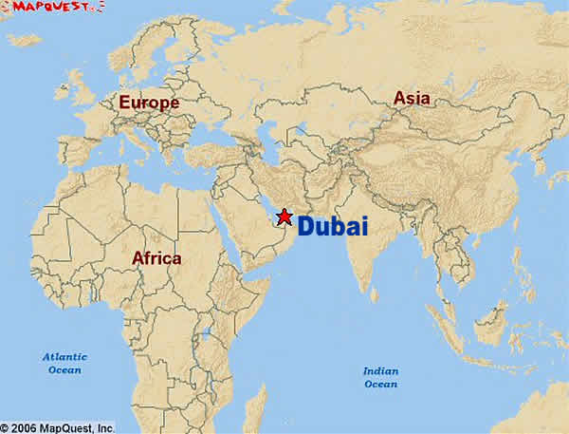

Dubai a tiny state is one of the United Arab Emirates

(UAE). It is located on the Arabian Golf Coast neighbouring Saudi

Arabia.

Because it is easily accessible from Europe, Asia and Africa (120 airlines fly there), tourism in Dubai is growing quickly. Hotel revenue was up 22% in the first quarter of 2008 compared with the same period the previous year and number of hotel and apartment bed nights increases by 2 to 3 per cent annually. Around 2.8 million people visited the principality in 2000, 4.9 million in 2003 and 5.4 million in 2004. By 2012 the number had risen to 9.9 million. These numbers are predicted to continue to grow further, which would make Dubai one of the world’s top tourist destinations.

**Tourism in Dubai**

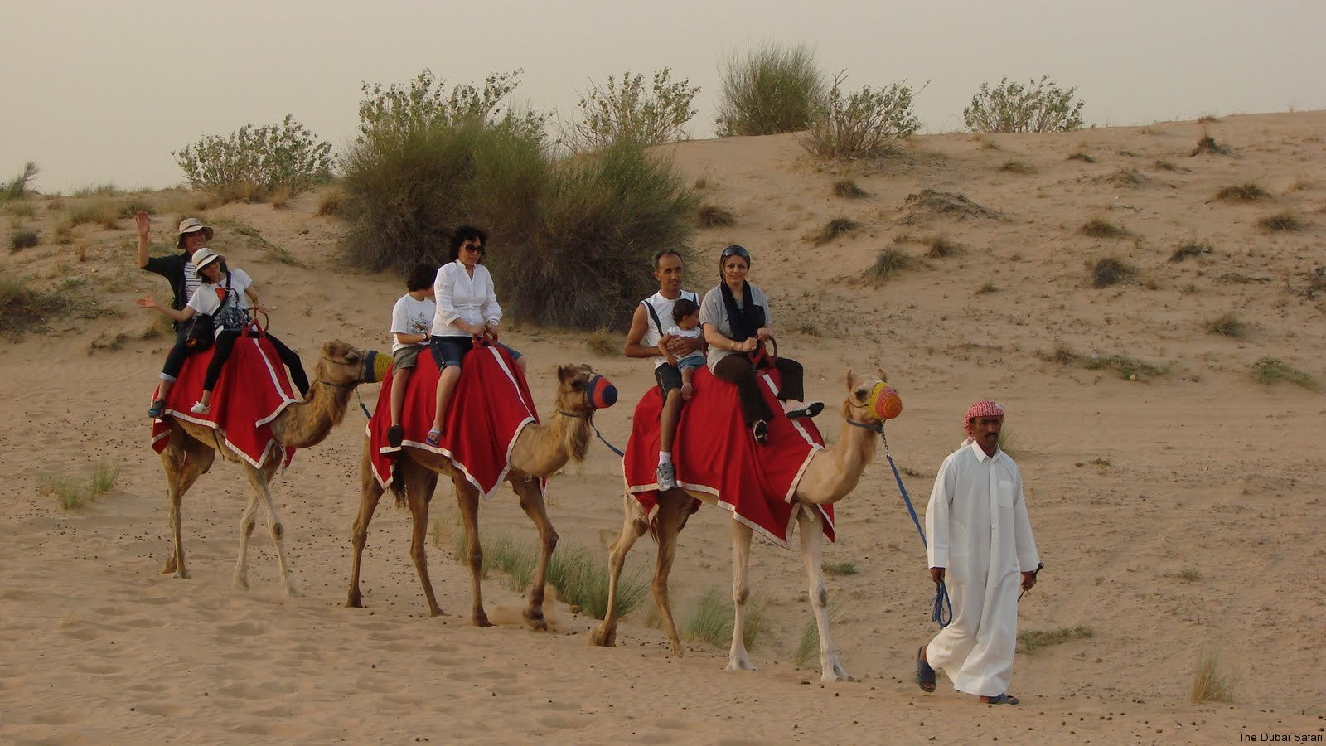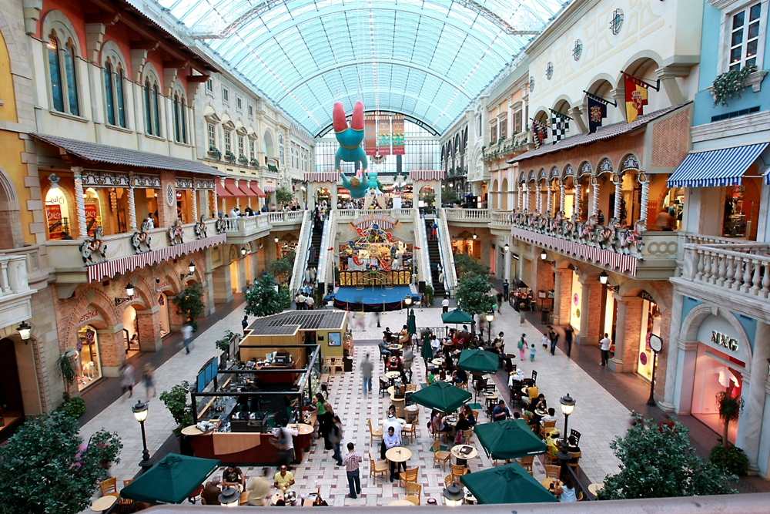

The state is famous for it’s duty free shopping malls with huge department stores and its markets. Prices are reasonable and there is huge variety. Emirates Airlines, which is based in Dubai, carries millions of long-haul passengers to hundreds of destinations and many stop over in Dubai as part of their trip.

Sightseeing is popular- the markets, the zoo, the dhow-building yards (traditional boats). Watersports and especially diving are growing in popularity. Excursions out from the city allow the visitor to see the desert and its wildlife. Bird-watching trips take visitors to the wetland mudflat areas where there are 400 species.

Ke

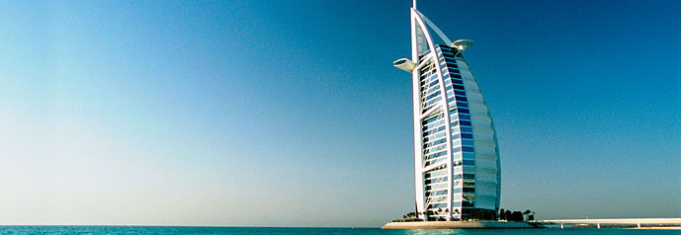

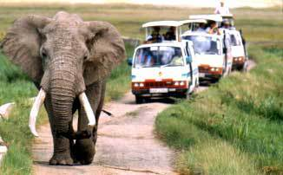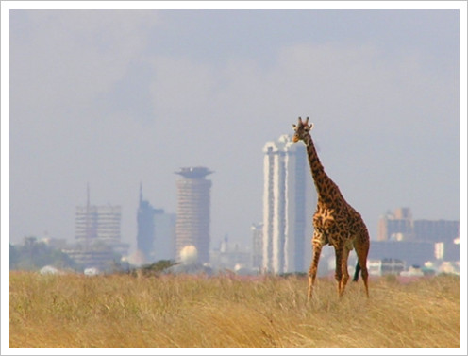

The main tourist attractions are photo safaris through the 19 national parks and game reserves. Other attractions include the mosques at [Mombasa](http://en.wikipedia.org/wiki/Mombasa); the renowned scenery of the [Great Rift Valley](http://en.wikipedia.org/wiki/Great_Rift_Valley,_Kenya); the coffee plantations at [Thika](http://en.wikipedia.org/wiki/Thika); a view of [Mt. Kilimanjaro](http://en.wikipedia.org/wiki/Mt._Kilimanjaro), across the border into Tanzania;and its beaches along the Indian Ocean. All these activities are good for Kenya’s economy and are an essential source of income to buy goods and services from abroad.

The large increase in tourism in recent years has also allowed many Kenyan’s to set up their own small businesses which serve the tourists and supply the services they demand such as taxies, bars, restaurants, builders and maintenance workers.

Kenya is a country within Africa. It is a coastal country and boarders Somalia, Tanzania and Uganda. Tourism is the second largest source of foreign exchange revenue following agriculture.

In 1995, there were 34,211 hotel beds with a 44% occupancy rate. BY 2000 1,036,628 visitors arrived in Kenya and tourism receipts totaled $257 million. That year, the US government estimated the average cost of staying in Nairobi at $202 per day, compared to $94 to $144 per day in Mombasa, depending on the time of year. Between 2009 and 2010 tourism grew by 15% and after agriculture most of the population works in this industry.

Following the controversial [2007 presidential election](http://en.wikipedia.org/wiki/Kenyan_presidential_election,_2007) and the [2007-2008 Kenyan crisis](http://en.wikipedia.org/wiki/2007-2008_Kenyan_crisis) that followed, tourism revenues plummeted 54 percent from 2007 in the first quarter of 2008.

**Tourism in Kenya**