What are Tornadoes and how are they formed?

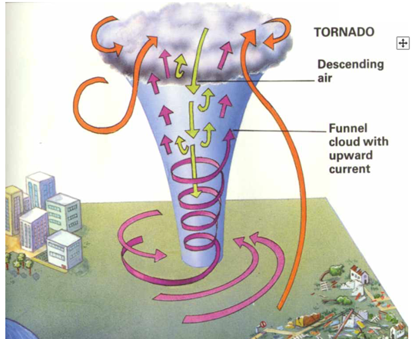
How long do they last?
What damage can they cause?
Can you predict them?
Where do they happen?
How big can they be?

What is a tornado?
How do they start?
What conditions do they need? How frequent are they?
Is there a Tornado Season?
How do we measure them?

