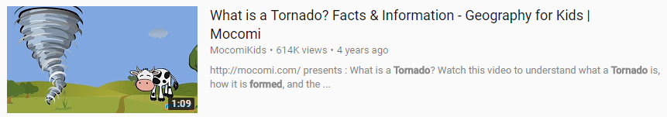

Task – Watch the clip above and record notes about what a tornado is.

Remember to…

… include important information only.

… keep your notes short and sharp.

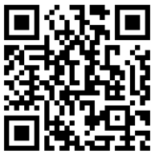

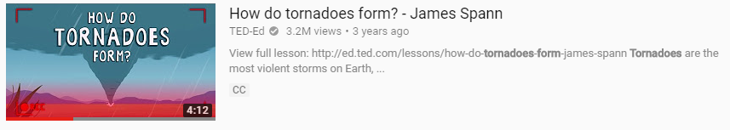

Task – Watch the clip above and record notes about what a tornado is.

Remember to…

… include important information only.

… keep your notes short and sharp.

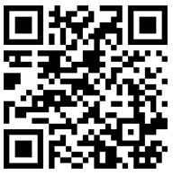

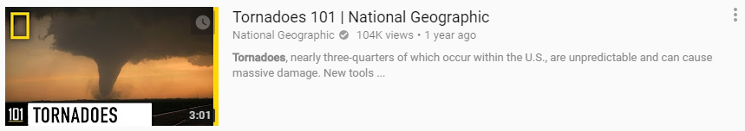

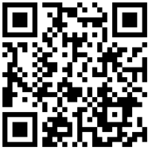

Task – Watch the clip above and record notes about what a tornado is.

Remember to…

… include imperative information only.

… keep your notes concise, short and sharp.