Chasing & Recording Twisters
Starter: Watch the video and write down all the important skills that would make a good storm chaser.

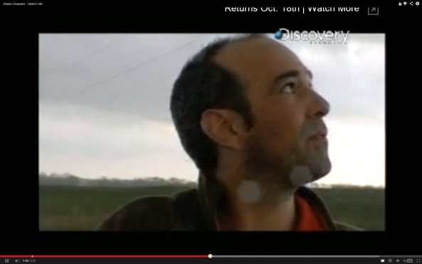

Task – What name are you going to give your company? Enter your full name below:
___________________________________________________________________________

Now think of all the words to do with tornadoes/twisters and enter them in the space below:

Choosing a location for a storm chase

Annotate on to the map where your storm chasing company will be located and why.
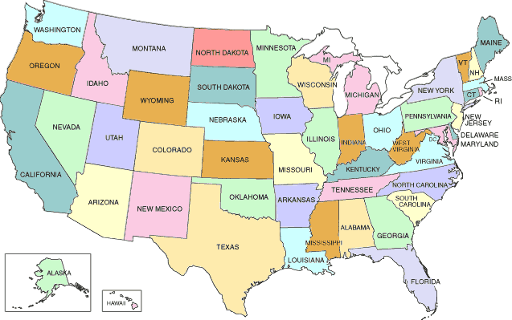

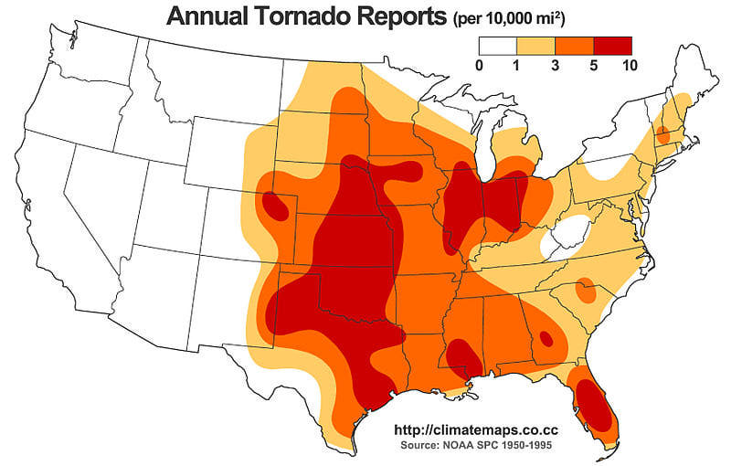

Advert for a National Newspaper
Guidelines:

a. Enter your company a name
b. What are Tornadoes?
c. Where do they form?
d. Why do they form?
e. When do they form?
f. How are they measured?
g. Why do people pay to ‘chase’ tornadoes?
h. What vehicles you own and how they will protect you.
i. How much does it cost for the experience?
j. Add photos, diagrams and maps
k. Add a telephone number, email address or pretend website.

Understanding a Tornado Intercept Vehicle
Task: Annotate the TIV below to show how it has been adapted to survive a tornado strike. One has been done for you. Try to identify five more.

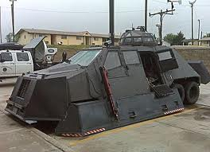

The vehicle is low to the ground so that the strong winds from the tornado don’t get underneath and flip the TIV over.

