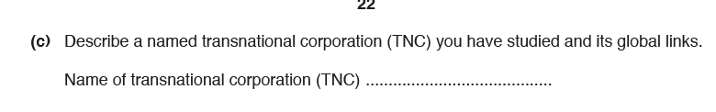
Task: Read the Apple case study from the IB text book. Use a range of highlighters to highlight:
- Products/ services offered
- Source of raw material
- Where production occurs
- Markets
- Transport of Raw materials
- Home/ country base
Ensure you collect case study detail for each point (place names and statisitcs )
Mark scheme:




