Reducing the effects – the 3 P s!

Unlike earthquakes we can use satellites to predict where hurricanes will hit and this allows us to prepare for them. The National Hurricane Centre in Miami will monitor hurricanes and give warnings to areas likely to be affected. People can be evacuated, windows boarded up and ships seek safe harbours. In Bangladesh cyclone shelters have helped to reduce deaths from 500,000 in 1970 to 4234 in 2007. Warnings by the government over the radio tell people when to seek shelter.

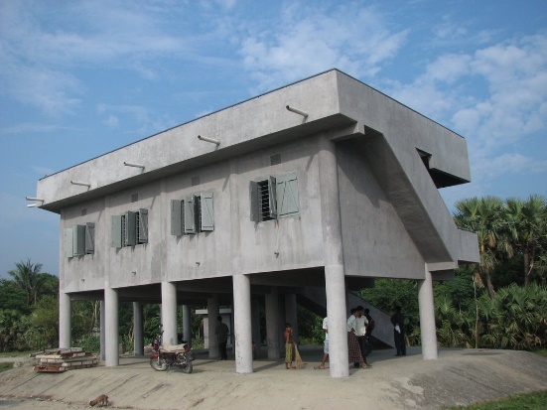

Reducing the effects of tropical storms- classify the information as either prediction, protection or planning.

|  |  |
| --- | --- |
| Houses close to the sea are constructed on stilts - | All cities need to have emergency procedures so staff know what to do - |
| Sea walls are built to protect important buildings - | National Hurricane Preparedness Week - |
| Information films shown on television- | Satellites monitor the track of hurricanes - |
| The Effects of hurricanes are taught in schools | Shutters attached to windows- |

In the boxes below draw 4 items that should be part of a hurricane survival kit and explain why you would have them.

|  |  |
| --- | --- |
|  |  |
|  |  |