The Roman Republic - Expansion

Overview
- Rome went from being one of many city-states in the Italian Peninsula to being the center of the most powerful empire in the world between the fifth century BCE and the first century CE.
- Rome was able to gain its empire in large part by extending some form of citizenship to many of the people it conquered.
- Military expansion drove economic development, bringing enslaved people and loot back to Rome, which in turn transformed the city of Rome and Roman culture.

Political institutions
How did Rome go from being one of many city-states in the Italian peninsula to being the center of the most powerful empire in the ancient world? Part of the answer lies in the political institutions that Rome developed early in its history. As Rome expanded its influence over more and more areas, its political institutions proved both resilient and adaptable, allowing it to incorporate diverse populations.
According to Roman tradition, the Republic began in 509 BCE when a group of noblemen overthrew the last king of Rome. The Romans replaced the king with two consuls—rulers who had many of the same powers as the king but were elected to serve one-year terms. Each consul could veto, or reject, the actions of the other consul. Although the office of consul probably did not exist in its final form until around 300 BCE, the idea behind this change—to prevent any one man from becoming too powerful—was present early on in Roman thought and shaped many of Rome’s political institutions.
Roman political institutions reflected Roman society, which was divided into two classes: the patricians, wealthy elites, and the plebeians, the common people. Initially, only the patricians were able to hold political office and make important decisions. For example, plebeians could not join the Roman Senate—an advisory body unable to create laws on its own but whose recommendations were taken seriously by the consuls. To become a senator, a Roman had to have held a political office, and plebeians could not. Over time, however, the plebeians were able to gain more influence in the political system.
Between the years 494 and 287 BCE, new political offices for plebeians were created and access to higher office, including the consulship, was opened to them. Voting assemblies and councils were established that gave plebeians more say in the politics of Rome. In 287 BCE, a law removed the last barrier to plebeian political participation by abolishing the requirement that proposed laws had to be approved by patrician senators before the Plebeian Council could consider them.
The Plebeian Council had real power and influence in Roman politics and some plebeians gained power and wealth under these new arrangements, but many remained poor. One reason that political rights did not lead to major changes was that the Comitia Centuriata—the main voting assembly that elected consuls and other important officials—was organized based on wealth. Each century—or voting group—had one vote, but the wealthy were split into smaller groups than the poor, giving the vote of a wealthy Roman more influence.

In what ways did the Romans limit the political power of any one man?
How did Roman political structures limit the influence of the poor?

Military
Although the voting system might appear a deliberate strategy to empower the wealthy, it was actually a reflection of the Roman military structure. The Comitia Centuriata was named for the century—literally a group of 100 soldiers, though in practice the division was never so exact—which was the standard Roman military unit under the kingdom and most of the republican era. Men were divided into classes based on their wealth because soldiers had to provide their own equipment. Only wealthy Romans could afford high-quality weapons and armor, which made them more effective soldiers. Men without property were not eligible for military service and these poorest Romans, though the largest class in numbers, were placed into the smallest number of centuries for voting.
Part of the reason that the Romans saw no problem with allowing the wealthy to have greater political influence was because they believed that those who had the most wealth also had the most to lose from Roman defeat, so the wealthy had better motivation to be good soldiers and a better sense of what was good policy for Rome.

What was the reasoning behind dividing the military into units based on wealth?

Foreign policy and expansion
The Romans did not set out any deliberate plan to build an empire. Instead, Rome expanded as it came into conflict with surrounding city-states, kingdoms, and empires and had to create ways to incorporate these new territories and populations. The Romans did not try to turn everyone they conquered into a Roman. For the most part, cities and regions that came under Roman control were allowed to maintain their existing cultural and political institutions. The only major requirement that Rome imposed on its defeated enemies was that they provide soldiers for military campaigns. In the ancient world, military victory usually meant a share of the loot taken from the conquered, so participating on the winning side of a conflict offered incentives to Rome’s new allies.
Most conquered enemies were offered some level of Roman citizenship, sometimes with full voting rights. Because a person had to be physically present in Rome to vote, the extension of voting rights beyond the population of the city itself did not drastically alter the political situation in Rome. However, the offer of citizenship did help to build a sense of shared identity around loyalty to Rome.
In order to manage the new territories that came under their influence, the Romans created formal provinces and appointed former political officeholders to manage them. Given the distance between most provinces and Rome, these governors often had considerable power and flexibility in dealing with local issues. The Romans tried to create a balance between giving governors enough power to control their provinces and preventing governors from becoming so powerful that they could challenge Rome’s authority.
Why might Rome have offered conquered people some level of citizenship?

Economic development
Although Rome had little interest in managing the daily affairs of its allies, it had to adapt as its influence spread. Roads were a way to extend Roman military and economic power; they made the movement of both soldiers and goods easier and faster. The Romans also minted coins as their influence spread, and in 211 BCE they introduced a small silver coin called a denarius, which became the standard unit of currency for much of the Roman period.
A standardized currency facilitated trade across the growing Roman world. Coins could be exchanged for any goods or services and were easy to transport. Currency made it easier to relocate and direct resources, and this in turn encouraged more economic interactions.
The Romans also engaged in trade across the Mediterranean Sea. Their network of trading contacts expanded along with their political influence since trade relations were usually dependent on good political relations. The combination of fighting piracy, building roads, minting coins, and extending military protection over an increasingly large area created many opportunities for economic interactions and growth.
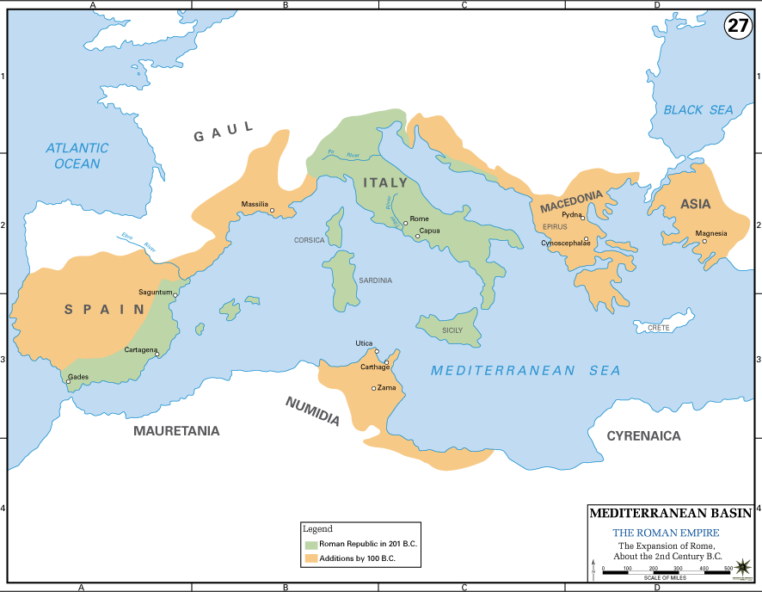
Map showing Roman expansion up to around 100 BCE; by this time, Rome controlled much of the western Mediterranean.

Like all ancient societies, Rome’s economy was based on agriculture, which was incredibly labor intensive. As Rome fought more foreign wars, many small landholders were away serving in the military for longer periods. If they failed to return or their farms went bankrupt in their absence, wealthy Romans bought their land, creating larger and larger farms, known as latifundia. Further, it was common practice to enslave and sell war captives; the increasing number of military conquests brought many enslaved people into the Italian peninsula. Because of economies of scale and because enslaved people could be made to work longer and harder than free Romans, this trend further increased economic production. The increased income from expansion supported development by creating demand for greater supplies of agricultural produce. Some owners of large farms even switched from growing staple grains to high-value crops, such as olives and grapes, or raising animals—this wouldn’t have been an option for small family farms.

Review the map above. How might Roman expansion have impacted trade patterns?
War captives were often sold into slavery. How might this practice have connected Roman military expansion with economic development in the Italian peninsula?

Urban development of Rome
Even as the empire expanded, all important political decisions for the empire were still made in Rome, and the city itself grew and changed with its empire. An increasingly large urban population required the development of sanitation systems to maintain a minimum level of public health. The Romans had developed a sewer system early in the city’s history. The first aqueduct—a structure to deliver water to the city over long distances—was built in 312 BCE, as was the first road, the Via Appia.
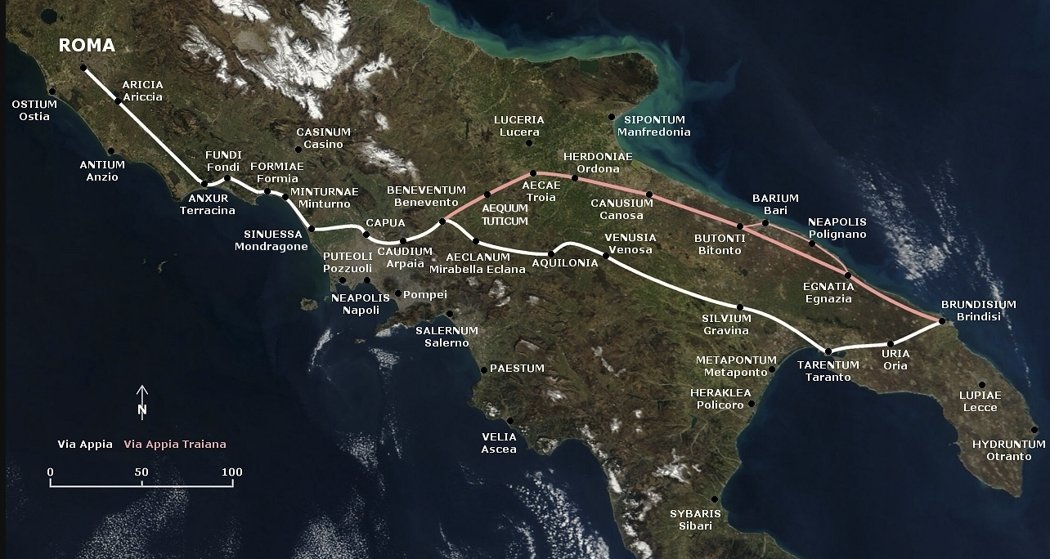
Map showing the route of the Via Appia, Rome’s first road, in white.
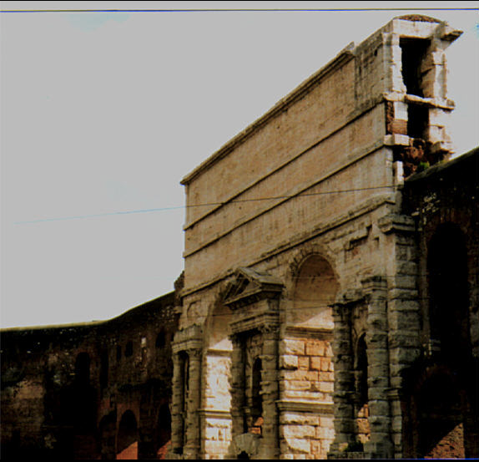
Remains of the Aqua Claudia in Rome; water flowed through the

The ability to collect taxes in currency, growth of economic production and trade, and military victories all provided funds for building projects in Rome. Besides roads, aqueducts, and sewers, the Romans built temples and political buildings. Victorious generals would dedicate temples to particular gods, and they paid for these temples with the loot they captured on campaign.

How did military expansion abroad directly impact the city of Rome?
Why would a road system have helped Rome militarily? How would a road system have encouraged economic activity?
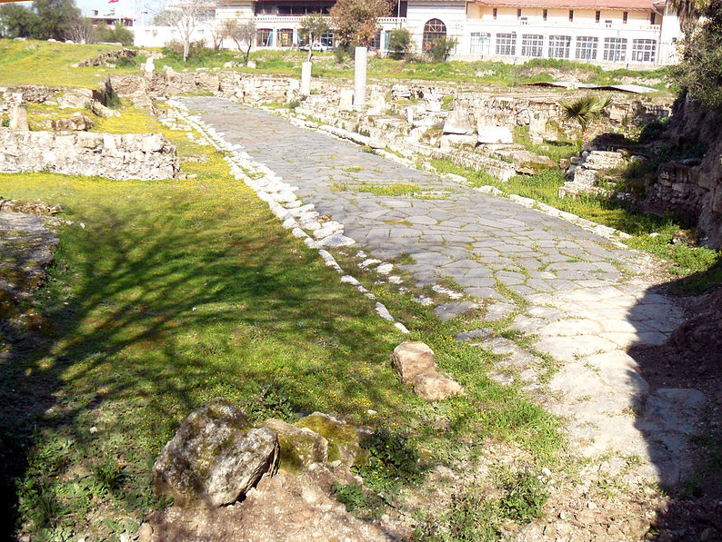
A Roman road in modern-day Turkey, near Tarsus.
A Roman road in modern-day Turkey, near Tarsus. Image credit: Wikimedia, Nedim Ardoğa, CC BY-SA 3.0

Conclusion
Rome became the most powerful state in the world by the first century BCE through a combination of military power, political flexibility, economic expansion, and more than a bit of good luck. This expansion changed the Mediterranean world and also changed Rome itself. New institutions, such as provincial government, were created to deal with the management of empire; culture was transformed as outside influences, especially from Greece, came into fashion in Rome; and the city itself was physically transformed by the influx of loot and people brought by successes abroad.

