The Role of Domestic Factors – 4.3

With reference to Zambia and the LEDC that you have chosen, we need to consider how the following domestic factors can contribute to economic development.

- Education
- Health care
- Infrastructure
- Political stability/Lack of corruption
- Legal System
- Financial system
- Taxation
- The use of appropriate technology
- Empowerment of women
- Income distribution

- Education

- – Draw a diagram to illustrate the impact that education can have on a nation’s macroeconomy.

Consumer
Goods
Price
Level
Real GDP

Capital Goods

- – Illustrate why education is beneficial for society as a whole, not just the individual concerned.

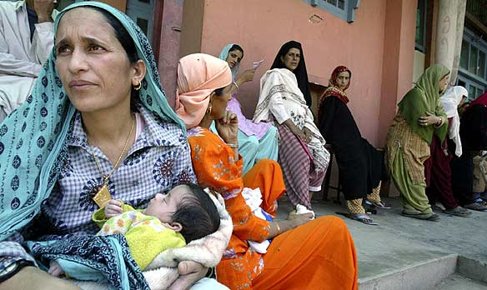
- – How and why might education improve the role and conditions for women in society?

____________________________________________________________________________________________________________________________________________________________________________________________________________________________________________________________________
Price

Qty D/S

- How does an increase in education levels, improve levels of health in society?

_________________________________________________________________________________________________________________________________________________________________________________________________________________________________

- What are the challenges facing an LEDC when trying to improve its education system?

Funding required

Rural/Urban

Family economic conditions

- Healthcare

- – What correlation would you expect to see between the proportion of national income devoted to healthcare and life expectancy?

________________________________________________________________________

- Why might this be the case?

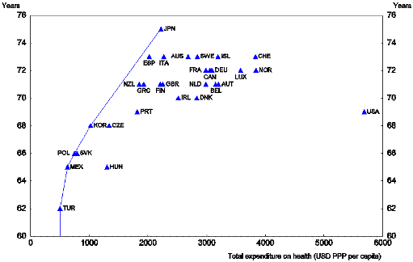

_________________________________________________________________________________________________________________________________________________________________________________________________________________________________

- What progress has been made, as regards healthcare, in LEDCs?

Doctors/Nurses _____________________________________________________________
Hospitals/Clinics ____________________________________________________________
Water _____________________________________________________________________
Immunisations ______________________________________________________________
Infant mortality _____________________________________________________________

- – Compare and contrast the following healthcare indicators for Zambia and an LEDC of your choice.

 | Public Health  Expenditure per capita | One year olds immunized against measles (%) | Births attended by skilled health personnel (%) | Population using improved drinking water sources (%) | Population using improved sanitation facilities (%)
Zambia

- Infrastructure

- – How would you define infrastructure?

______________________________________________________________________________________________________________________________________________________

- – Give examples of the four main categories of infrastructure using the terms below

Transport | Utilities | Public Services | Communication

Postal service | Telecommunication | Seaports | Internet
Roads | Waste Management | Water Supply | Sewers
Electricity | Railways | Radio/Television | Airports
Judiciary | Gas | Public Transport | Police Service
Sidewalk/Cycle paths | Health Service | Fire Service | Education system

- - Take one example from each of the four categories and identify how they contribute towards economic development.

Transport – ______________________________________________________________________________________________________________________________________________________

Utility -
______________________________________________________________________________________________________________________________________________________

Public Service

______________________________________________________________________________________________________________________________________________________

Communication Service

______________________________________________________________________________________________________________________________________________________

- Political Stability/Lack of corruption.

As you can see from the map below, there appears to be a negative correlation between the level of corruption in a nation and its level of development.

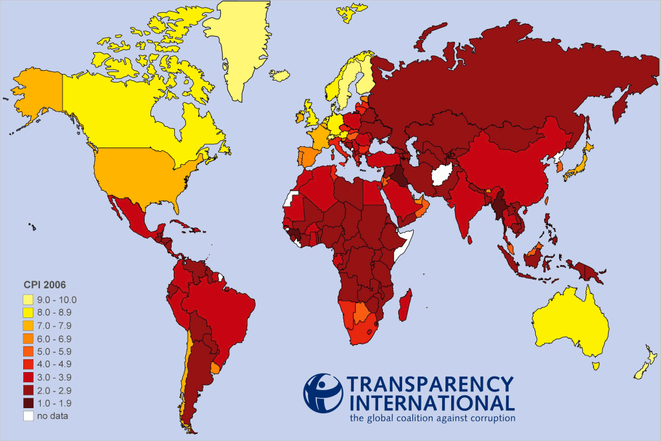
- .Identify some of the issues caused by corruption.
Electoral Corruption

Corrupt Legal System

Allocation of Resources

Bribery in Business

Corrupt Officials

Capital Flight

Legal System

A fully functioning and effective legal system is crucial for a country wishing to achieve economic development. First and foremost, it enables property rights to be upheld.

A property right can be defined as the exclusive authority to determine how a resource is used.

- These rights have five main components:-

- ________________________________________________________________
- ________________________________________________________________
- ________________________________________________________________
- ________________________________________________________________
- ________________________________________________________________
- – Why are property rights so essentially for a dynamic market economy?

____________________________________________________________________________________________________________________________________________________________________________________________________________________________________________________________________________________________________________

Financial System

- – Why are developed and independent financial institutions so essential for economic growth and development?

Saving________________________________________________________________________________________________________________________________________________

Investment____________________________________________________________________________________________________________________________________________

- – What will often occur in countries with weak financial institutions?

_________________________________________________________________________________________________________________________________________________________________________________________________________________________________

- – Why do poor people within LEDCs struggle to gain access to official financial markets?

______________________________________________________________________________________________________________________________________________________

- – Use the table below to summarize how ‘microcredit’ schemes are providing development opportunities in LEDCs.

Origin

Purpose of micro-credit
loan

Examples

Main recipients

Taxation

- – Taxation revenue enables a government to____________________________________

- – Collecting sufficient tax revenue is problematic in LEDCs due to the fact that:-

- Income tax_______________________________________________________________

- Corporation tax___________________________________________________________

- Excise duties_____________________________________________________________

___________________________________________________________________________

- Administration ___________________________________________________________

- Informal markets__________________________________________________________

- – What are the drawbacks for workers of operating in informal markets?

______________________________________________________________________________________________________________________________________________________

The use of appropriate technology

- – How might one describe the factor endowment of a typical LEDC?

_________________________________________________________________________

- – What type of technology would therefore be appropriate in order to encourage economic development?

_________________________________________________________________________________________________________________________________________________________________________________________________________________________________

- – How might decisions about which consumer goods to buy also have an impact upon economic development?

_________________________________________________________________________________________________________________________________________________________________________________________________________________________________

The empowerment of women

In many LEDCs women face higher death rates, lower levels of literacy and lower incomes, not mention other forms of discrimination. This is largely due to the fact that the role of women is secondary to that of men.
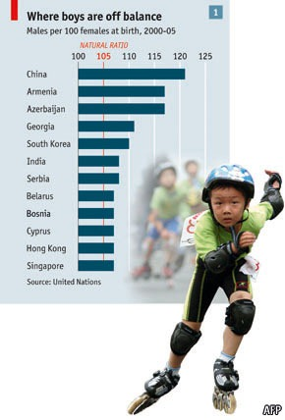
Improving the health and education of women will benefit not only the individual women concerned but will generate additional positive externalities.

Family health

________________________________________________________________________________________________________________________________________________________

Education
__________________________________________________________________________________________________________________

Income
______________________________________________________________________________________________________________________________________________________

Population
______________________________________________________________________________________________________________________________________________________

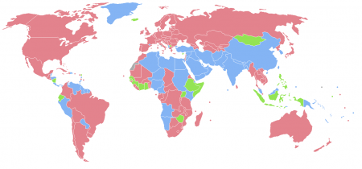

- Pink = More women than men
- Green = Equal
- Blue = More men than women

Income distribution

- – How is income generally distributed across the population of an LEDC?

______________________________________________________________________________________________________________________________________________________

- – Why does a high level of income inequality have a detrimental impact upon the development of a nation?
_______________________________________________________________________________________________________________________________________________________________________________________________________________________________________________________________________________________________________________________________________________________________________________________
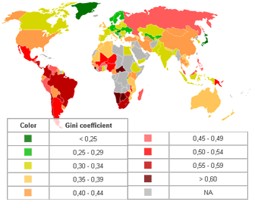

- – What is the Gini Coefficient in Zambia and your chosen LEDC?

_________________________________________________________________________________________________________________________________________________________________________________________________________________________________

