Paper I | Prescribed Subject 4: Rights and Protests (Apartheid South Africa)  Subsection: The Nature and Characteristics of Discrimination

The Nature and Characteristics of Discrimination under Apartheid

Racism and segregation is often blamed on the Afrikaner NP party, however it also has origins in the British rule in the Cape Province. Contact between the British and Xhosa were frequent, as many Xhosa went to look for work in the cities. British attitudes became increasingly racist, as is evidenced in the 1853 constitution that distinguish between “civilized” (white) and “uncivilized” (black) who were subjected to certain punitive laws. They were required to carry “passes”, documentation papers when traveling outside their residence. These passes regulated their movement and prevented them from leaving their jobs.
Curfews were created to prevent Blacks from entering white neighborhoods at night. In the 1890s Cape Town rapidly expanded which accelerated segregationist policies as whites feared “racial swamping” and a deterioration of sanitation. When the Bubonic Plague broke out in Cape Town in 1901, residential segregation was introduced with the Black-only township of Ndabeni located far from the city center.
While the Afrikaner and English groups differed on many issues, the one thing that united them was the desire to maintain cheap African labor. They both believed that economic growth could only occur if they created a political union. Infrastructural planning on a national level would be implemented through a segregationist system. An alliance was built between the white populations at the expense of everyone else.
The South Africa Act restricted voting rights to the minority white population, with the very small exception of some Coloureds and Blacks who met the franchisement qualification (landowners) in the Cape Province and Natal. Other segregationist laws included:
- Mines and Works Act 1911 - reserved skilled and semi-skilled jobs for whites - thus Blacks were stuck in the poorest paying positions
- Natives Land Act 1913 - prohibited Africans from owning or renting land anywhere outside certain areas designated as native reserves...Africans made up ⅔ of the population while Native Reserves made up 7.5% of the land.
  - Also brought an end to rural sharecropping that deprived many Africans of their livelihood.
- The Natives (Urban Areas) Act 1923 - cities were for whites, any Africans who resided there had to carry passes, and anyone without a pass would be arrested.
- Industrial Conciliation Act 1924 - allowed for legal registration of Whites in a trade union, not their black counterparts. - Thus they were denied opportunity to negotiate better pay and conditions.
- Wage Act 1925 - granted preference to white workers in hiring
- Representation of Natives Act 1936 - removed Africans (but not Coloureds) from the electoral roll in Cape and established an Advisory Natives Representative Council (but it lacked power)
- Native Trust and Land Act 1936 - extended native reserves to 13% of the total land, and increased power of authorities to evict Africans
- Native Laws Amendment Act 1937- more strictly enforced the Pass Laws

In the 1940’s there was a resurgence of Afrikaner Nationalism as the they felt alienated from the “elitism” of the UP and the fact that they hadn’t done anything to increase their standard of living. Poor whites demanded an even more radical system of racial segregation and discrimination. During the economic boom of WWII, there was an increase in Squatter Camps outside the cities as the Black labor force grew in size and militancy. This heightened Whites fears and led to the murder of nine black strikers in 1946. The Fagan Commission was setup to investigate the situation and it found that the African urbanization was irreversible and it would be in the best economic interests of South Africa to normalize the status of Blacks who lived in the cities by relaxing the Pass Laws. This increased fears even more and led to the extreme Apartheid laws of the NP in 1948. The NP played on White fears of a “Swart Gevaar” (Black Peril) and “Rooi Gevaar” (Red Peril - as the Cold War reared its head and anti-communism grew). Malan’s NP won the election of 1948 and began ushering in apartheid laws.

Apartheid Begins
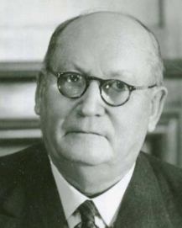
After DF Malan won the election in 1948 he issued a series of laws that became the basis for apartheid. The system was an extension of the segregationist system that had been set up under the UP leadership of Smuts and Hertzog before 1948. They shared common goals of prioritizing White interests over everyone else's. Apartheid was different in that it was more ideological and was enforced with more rigor and enthusiasm. It was more than strict racial laws, it sought to create an all-encompassing system of institutionalized racism based on the superiority of South Africa’s minority White population.
The first stage of apartheid is known as “petty apartheid” (baasskap - “boss rule”). This occurred in the first few years of Malan’s rule and later in Strijdom’s rule. Its principle purpose was to ensure the complete domination (economic & political) of Whites over Blacks. It covers the more brutal subjugation of the Black majority and the response to anti-apartheid opposition. The term petty refers to the unnecessary nature of the laws themselves as well as the brutal enforcement of them.
The second stage is referred to as “grand apartheid”, which began under HF Verwoerd’s rule in the late 1950s. This is marked by its focus on territorial segregation, rather than just racial discrimination. There’s an attempt at eluding to a “separate but equal” concept, except that they stop at the “separate” and never really discuss being “equal”. This is because they did not believe the races were equal. Under grand apartheid, they proposed that each race would fulfill their potential through separate development within their own national jurisdiction. The word “grand” thus refers to their attempt at giving a moral legitimacy for the apartheid system, by claiming it would allow each race to reach their full independence. It’s no surprise this came about under increasing global hostility to apartheid.

Division and Classification of People

In 1950 the Population Registration Act classified everyone by race. Prior to this, people had a more straightforward approach. If you were born into a White family, you were White, even if your skin tone was a bit darker. Miscegenation, sex between people from different racial groups, was common. Generations of people born from master-slave relations, before apartheid, had been accepted as part of the White family. For the conservative NPs, the idea that a White could be “darker” than a Coloured, was unacceptable, and this led to the Prohibition of Mixed Marriages Act (1949) and the Population Registration Act.
Under this act, everyone had to be identified under a national population register. Each citizen was categorized according to their biological, rather than cultural factors. Their race was then recorded into their official identification documents. A code representing their racial group was included in their ID number. The Act decreed that South Africa was made up of three basic racial groups: White, Coloured and Bantu (Black African). The NP initially denied the Indian population, and didn’t classify them as “Asian” and part of the Coloured population until 1959.
Racial groups were classified according to common physical and intellectual characteristics. The ridiculousness of this can be seen in the wording of the law:

“A White person is someone who is in the appearance obviously white-- and not generally accepted as Coloured -- or who is generally accepted as White -- and is not obviously Non-White, provided that a person shall not be classified as a White person if one of his natural parents has been classified as a Coloured person or Bantu.”

Apartheid was supposedly based on “scientific” evidence and natural law...which, if that was the case, one would think the law would be more precise and less…cloudy, illogical. This lack of clarity made the boundaries between groups fluid and confusing, yet it was enforced with a vengeance. A Race Classification Board was set up to apply the new law. They further confused things by creating Sub-categories of different groups. For example, under Coloured, one could be: Cape Coloured, Malay, Griqua, Chinese, Other Asiatic, and Other Coloured.
People who had previously been considered Coloured, now sought to be officially recognized as White in order to take advantage of the White privileges. In some instances, people would report individuals whose racial classification they didn’t agree with, which led to bizarre and humiliating tests that individual would have to go through. Some such tests included a linguistic proficiency test and a skull measurement. The Pencil Test was also applied. A pencil would be placed in a person’s hair, and if it fell out, that person was White. People could be classified and reclassified more than once, as was the case with Vic Wilkinson. He was classified as Coloured to White, and then back to Coloured.
The consequences of this act were devastating for many families. Within families certain genetic traits can skip generations. This led to many families on different sides of the classification divide. A child born to White parents but with darker skin could be classified as Coloured under the new law. Other laws that segregated private and public spaces would tear these families apart. The social stigma attached to these cases often led to some Afrikaner parents abandoning babies born with frizzy hair or dark complexions. Reclassification usually meant “demotion” from White to Coloured or from Colored to Bantu. This had negative consequences on their future prospects and job opportunities.
In order to ensure future clarity on racial identity, the Prohibition of Mixed Marriages Act and the Immorality Act were designed to outlaw sexual relations between different populations. Apartheid saw miscegenation as a cause of racial degeneration, therefore it had to stop. This was also connected to the Calvinist obsession with morality and government intrusion into its citizen’s private lives. The issue of mixed marriages was not a large problem in South Africa, there were only 75 such cases TOTAL in 1949. The purpose was to stop it and maintain control.
The Immorality Act banned all sexual relations between Whites and Non-Whites. It did NOT ban sexual relations between Coloured and Bantus. Clearly, the government was only concerned with “protecting” the “purity” of the Whites and maintaining their control. The ways in which these laws were enforced were intrusive and horrific. Police would react to a tip-off by staking out the house of the suspect. They would burst into the home in the middle of the night in hopes “catching them in the act”. The home would be ransacked and underwear taken for evidence. The guilty couple would be given fines and prison terms, with the Coloured or Bantu receiving a substantially higher penalty.
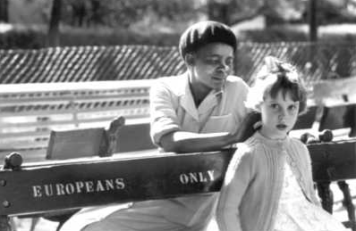
The Reservation of Separate Amenities Act passed in 1953. It strictly segregated by race all public amenities. Prior to this buses, trains, hospitals, and toilets had already been segregated, but now it was taken to the extreme. Separate entrances and service counters were mandatory in shops and post offices. There were separate waiting rooms and platforms for train stations. Parks and other recreational facilities, such as beaches and swimming pools were designated for use by one race only. Hotels and restaurants in city centers had to serve only whites. Segregation went to such an extreme level that even public benches and water fountains were reserved for “Europeans/Whites Only”. Coloured and Bantus risked arrest and imprisonment for using the Whites-Only facilities.

As you would expect, the facilities for Bantu and Coloured were of worse quality, which is what distinguished the new legislation. Prior to apartheid, segregation was mandated so long as the amenities were of equal quality. The Group Areas Act of 1950 decreed that city centers were for whites’ only residence purposes. Blacks however still worked in these areas that did not offer public facilities for them. This meant they would have to wait till they got home to use facilities for them. As townships for Bantus and Coloured were rapidly and hastily built, the amenities were an afterthought and not well constructed. This symbolized a drastic decline in their status under apartheid. As it separated public spaces it also kept races more separate making it more difficult for Whites and Non-Whites to create friendships. Certain places that before offered limited access, like libraries, museums, concert halls and theaters, were now entirely off limits. This limited the educational and cultural experiences of Bantus and Coloureds.
The Natives Act of 1952 (known as the Pass Laws Act) replaced the existing passbooks with more comprehensive documents that Africans were required to carry with them at all times. Initially it just pertained to men, but by the late 50’s women had to carry them as well. It was a 95 pages booklet officially called the “reference Book”. They contained a person’s employment record, tax payments, reports of any police encounters and more. It was a criminal offense for a Black person to refuse to present his/her reference Book on demand at any time from any white person. It included a complicated system of permits for travel and work. A permit was required for any Black person to travel from a rural area into the city. Once he/she arrived, a new permit was needed from the police allowing them to stay for 72 hours to look for work. Once that time was up, they had to return back to their township or break the law and stay to continue their search for a job. Thus, many Africans were made into criminals for nothing more than trying to find a job.
Reference Books were frustrating even for those who had all of their paperwork in order. The police would often stop and harass them on the pretext that they needed to inspect their passes. It was also humiliating, as any white person, even a child could, stop a Black man in a White area and demand to see their passbooks. These laws enforced a strict regulation on Black movement and allowed the government to surveillance the Black population. They could be used against Black politicians and to intimidate the African National Congress (ANC) by doing nighttime raids on their homes under the pretense that there was someone there who didn’t have the right documents. While the Pass Laws allowed the government more control, it also became a focal point to protest against and was used as a weapon against the regime.
Two other laws helped to keep the races apart. Prior to apartheid there was laws that kept skilled and semi-skilled jobs in the hands of Whites. The Bantu Building Workers Act of 1951, however, reinforced the residential segregation because it allowed skilled Blacks to work in areas where Whites were excluded. This kept the races divided in the workforce. The Prevention of Illegal Squatting Act of 1951 allowed the government to forcibly remove Africans that had settled in areas that were to be designated as Whites-only under the Group Areas Act. This also brought an end to sharecropping, where white farmers allowed Blacks to live on their land and cultivate it, taking a portion of their crops. While this ended the “problem” of Blacks and Whites living near each other in the countryside, it added to the problem of “city squatters” as Blacks had to go to the city to look for work now that they couldn’t farm.

Forced Removals and Creation of Townships

The Group Areas Act of 1950 became the “essence of apartheid” as it was designed to bring about the total residential segregation of different racial groups in urban areas. This was specifically done by removing Non-Whites from the inner city areas designated for Whites only. It was based on the racist notion that Africans were a rural people and their permanent exposure to urban life would “breakdown” their social order. This was based on the Sauer Report of 1947, that concluded all Africans belong in the native reserves and that their presence in and around urban areas should be tolerated only so long as they remained economically useful to Whites. Africans would be confined to the townships on the outskirts of the city where they could live in a manner “appropriate” to their lowly status in the apartheid hierarchy. Once they stopped being economically useful, they would be sent to the reserves.
Before 1955 the Group Areas Act was mainly used to target the Indian and Coloured populations. Many Indians were traders within the cities and had small businesses. This law forced them to sell their business and close, which was welcomed by their White competitors who had enthusiastically supported the law. One quarter of the Coloured and one-sixth of the Indian populations were forced to move to their respective outer-suburb communities. It was a bit more complicated for Africans, who were not allowed to own property outside of their reserves. Their cheap labor was needed for the urban economy, so they were forced to relocate to new townships far from the city centers and suburbs, but close enough for daily commutes.
Many towns had mixed-population areas, called onderdorpes. Major cities contained “Black Spots”, mostly African areas in the midst of White suburbs. This led to the Natives Resettlement Act in 1954 coupled with the Group Areas Development Act in 1955. These acts now gave the government authority to forcibly remove Blacks from certain areas, the most notorious of which was Sophiatown in Johannesburg.
Sophiatown was a mostly Black neighborhood surrounded by working class Afrikaner areas. It was a vibrant area and a rarity, since it was a place where some Blacks could still own property. It wasn’t without faults though, as crime and violence were also common, as they are in most inner cities. Sophiatown had a number of illegal bars, called shebeens, and music halls. It was the cultural hub of South African Jazz and intellectual/political activity. The ANC frequently held meetings there. By taking out Sophiatown, the government would be striking a blow against the ANC.
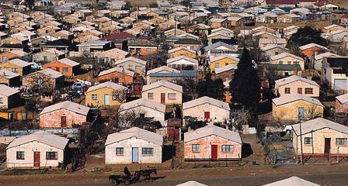
In January, 1955, the Western Areas Removal Scheme forced the residents of Sophiatown out. Armed police moved in, anticipating a backlash. Residents were forced to load up their belongings onto trucks and transported to the Meadowlands area that would become the township of Soweto. Bulldozers stood by to level their homes. Anti-apartheid activists (Nelson Mandela, Ruth First, Trevor Huddleston) tried to save it, but Sophiatown was destroyed and 65,000 residents had been relocated. They were replaced with a new Afrikaner suburb called, Triomf, the Afrikaans word for “triumph”.
The Sophiatown pattern was repeated in numerous other “Black Spots” across South Africa. Those who were forced out of their homes had to report to the Native Resettlement Board in their new reserve. They were given basic provisions before being dumped off in front of their new homes. These “matchbox” homes were small, cramped, did not have running water or toilets and housed between 7 and 14 people in a single dwelling unit. The speed with which relocations occurred quickly led to overcrowding in the reserves. Soweto became the largest and famous with a population of nearly 2 million.
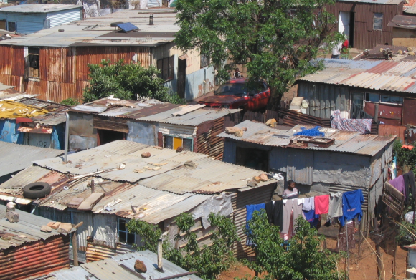
The forced removals had a major impact on the lives of millions of South Africans. Townships were located many miles away from the city where many Blacks worked, forcing them to commute to work on buses which were expensive. Education for Blacks was never a priority for the apartheid government, so schools were scarce and overcrowded. Since the construction was done hastily, sanitation and infrastructure was lacking. There were few, if any, hospitals, clinics, or police stations. Since there were few police, crime was rampant and tsosis, urban gangs, were common. Old social norms had been bulldozed along with their old homes which led to a rise in criminal activity. People suffered from a loss of identity. Others, who were denied the right to formal resettlement set up shanty towns on the outskirts with what little resources they had. Approximately 3.5 million Black people were uprooted and transplanted into these townships.
Not all Black people were kicked out of the city. A few were allowed to remain if they fit the specific qualifications: (1) They had been born there AND employed there for over 15 years, (2) they had been employed by the same person for more than 10 years, (3) Black women were allowed to live in the White homes of the families they worked for as nannies or maids. Their families however could not join them. The impact of this was that young Blacks were removed from the city, and families were broken up.

The Bantu Education Act

The Bantu Education Act of 1953 made it mandatory for schools to focus on ONE racial group only and put the education of Africans under the control of the Native Affairs Department. This took the responsibility for the education of Africans out of the Ministry of Education, which was responsible for educating all other races. This didn’t just prevent children from attending school with kids from other races, it eliminated the idea of a single education model for all children to follow and created separate school boards for each race. They would now have their own distinct and different curriculum that would be tailored to what the authorities believed was appropriate for their “intellectual capacity: and practical requirements of each racial groups in apartheid South Africa.
As you can already expect, the education of African children was far inferior to that of the Whites. Their curriculum would have very little academic content, going over only the most rudimentary literacy and numeracy skills. The basic skills they obtained would help them to perform domestic services for Whites or sell unskilled labor in the mines and manufacturing industries. Black children would attend school in daily three-hour shifts. Books and other essential materials were nonexistent. Teachers and students would write on the ground with sticks. The government spent 7 times as much on white students as they did on Black ones. This included the salaries paid to White and Black teachers. Many Black teachers left their profession, and after a while, 85% of Black teachers had no professional training or qualifications.
Many parents simply took their children out of school. There was an attempt to foster a stronger sense of tribal identity. Instruction was to be in their mother tongue throughout primary school with a gradual transition to Afrikaans and English after. This angered many Black parents, however, because they believed the hallmark of a decent education was instruction in English. The reality of the Bantu Education was that it was setup to prepare Africans for a life of servitude to Whites and fulfilled the institutional framework of promoting White domination. Their education would allow them to develop at their “naturally slower intellectual pace.” It also served to further segregate Black people among themselves by stressing tribal importance and identity.
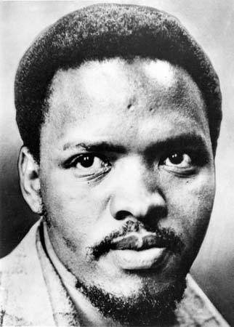
Despite the racial discrimination, some young Africans accessed quality education before the Bantu system. This was mainly due to mission schools and in the rural areas by European groups. They were partially funded by the government, but after 1953, they were told they had to submit to the new education system. If they refused they would lose their funding. Most schools chose to shut down rather than comply. This left the Bantu Education the only one available for Africans. It was hypocritical, as it stressed rediscovering their traditional identities that Afrikaners had said were corrupted by “rootless cosmopolitanism” while also stressing Christian Nationalism. It was paternalistic, patronizing and deeply demeaning of African culture. It taught them that their culture was backward and they were incapable of progressing outside the confines of their tribal life. The best they could hope for was to be of service to their own people or temporary service to Whites.
Steve Biko argued that Bantu Education was designed as a means of denigrating and dehumanizing Black people. He created the Black Consciousness Movement, with its slogan, “Black is Beautiful” to combat the psychological self-hatred. Young people lost hope and became desperate and many turned to crime. There is a correlation of an increase of violence in the 1980’s of young people against their communities and the system of Bantu education. The psychological brutalization was denied as a shared experience due to the focused tribalism of the system itself. Thus the system was a success for the apartheid government, it had successfully inhibited the growth of a mass-based African nationalism. In the 1990’s violence erupted between the Inkatha Freedom Party (Zulu) and the ANC in different townships.

The Extension of University Education Act of 1959 brought an end to allowing a small number of Universities to register students of all races. Universities would now be required to restrict their registration to one racial group and in the case of African universities, a single tribe. New Universities were built for Indian and Coloured students who had previously been allowed to attend White universities. This was meant to foster separate development of the races. They would each be endowed with their own set of educational facilities and institutions to create self-contained political and economic systems. The academic community protested, and some resigned in protest.

The Bantustan System

This was hailed as the “flagship” of grand apartheid. The plan was to give the different Black peoples of South Africa their own self-governing homeland. They would transform existing native reserves into small independent states. In time, all Black South Africans would be required to live in these homelands. They would be citizens of the various Bantustans, not of South Africa, which would be an exclusively White country.
The first step in this program was the Bantu Authorities Act in 1951, which created regional authorities for Africans based on the reserves and got rid of the native Representative Council, which had been an elected national body that represented all Africans. The next stage was the 1959, Promotion of Bantu Self-Government Act. It divided the African peoples into 10 ethnic groups and each was assigned a White commissioner General (Self-government?) to assist them in making political transition to full self-government in their designated area. The apartheid government could now claim they were not responsible for Black South Africans. All Black South Africans would be able to vote in their homelands elections regardless or not of whether they actually lived there. By 1970, South Africa claimed ALL Black South Africans were citizens of their homelands and not of South Africa, making many of them foreigners in the land where they lived and worked and under constant threat of deportation to the homelands.
Some Bantustans became independent in the 1970’s:
- Transkei - 1976
- Bophuthatswana - 1977
- Venda - 1979
- Ciskei - 1981
Other Bantustans independence were put on indefinite hold in the 1980’s as steps toward dismantling apartheid took place. Generally the Bantustans were led by corrupt and brutal oligarchies that did not deal with any opposition. The South African government gave them political support and military assistance whenever they needed it.
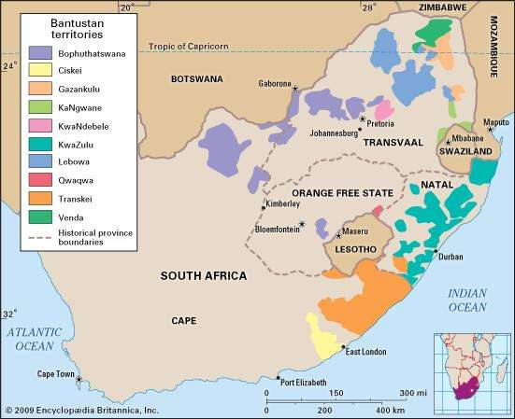
Most Black South Africans felt no political allegiance to their assigned Bantustan and regarded their leaders as self-interested apartheid stooges. The International community didn’t recognize them either, with the exception of Israel (who took similar actions against Palestinians) and Taiwan. Nobody else fell for the fake moral peace offering that they had created independence for Africans.

The Apartheid leaders never looked at the Bantustan leaders as their equals. The South African government continued to use the Bantustans as their dumping ground for populations of Africans that weren’t needed in the cities. Workers from Bantustans were no citizens of foreign countries and had no employment rights under South African law.
After their independence, the Bantustans became even more overcrowded. The Bantustans made up only 13% of the total land area of South Africa, yet contained 55% of the population of South Africa. Their semi-rural shanties became infamous. The land was overgrazed and the soil was exhausted which caused severe environmental degradation. They were never economically productive. Men of working age were typically living in the townships by the cities near work or in mining camps, leaving families behind in the homelands.
There was hope that the Bantustans would be self-sufficient. The Bantustan Investment Corporation Act of 1959 encouraged business growth, but ultimately they remained rural and backwards with few opportunities. The irony is that some businesses flourished, such as the casinos, cabarets and nude shows. The homelands were supposed to “rescue” traditional cultures, but instead became famous for their moral depravity.

Other laws to enforce segregation

Separate Representation of Voters Act of 1951 removed all Coloureds from being eligible to vote in the Cape Province. It was overruled by the Supreme Court of Appeal, who argued it violated the 1910 Constitution. The government required a ⅔ majority of a joint sitting of parliament to remove a clause from the Constitution. Instead, the National Party (apartheid government) meddled with the judiciary by increasing the size of the senate and packing it with NP members. This ensured they could then pass the act in an amended form in 1956. This was illegal, but they got away with it and demonstrated the lengths the NP would go to get their way.
Other laws were passed to strengthen state security, such as the Suppression of Communism Act of 1950. This made the Communist Party of South Africa (CPSA) illegal, forcing it to change its name to the South African Communist Party and go underground. It also defined communism as all forms of opposition to the apartheid system. Anything that involved “the promotion of disturbances or disorder” would fall under the law. Therefore, any opposition was deemed “communist” and therefore a threat. It also had the edge of playing on Western Cold War fears to try and create support for the apartheid regime. It was clearly designed to crush the anti-government activities of the ANC. Anyone prosecuted under this law would be subject to banning orders and not allowed to participate in meetings. Banning orders were an effective weapon of repression against the ANC. Senior leaders, like Chief Luthuli and Nelson Mandela were removed from the day-to-day organization of their group.
The Public Safety Act of 1953 gave the government the right to suspend the constitution and declare a state of emergency. Censorship was also enforced under the Customs and Excise Act of 1955 and Official Secrets Act of 1956. They allowed the government to establish a Board of Censors that could restrict/ban any media, book, film, etc. produced either within or outside South Africa. Anything that might upset the political, moral or religious sentiments of the White public and their Christian Nationalism must be banned. The Criminal Law Amendment Act passed that same year allowed the courts to impose severe penalties on people who committed acts of civil disobedience by breaking apartheid laws. This was used effectively to end the Defiance Campaign (discussed later). The Native Administration Act of 1956 allowed the state to “banish” Africans found guilty of persistent political offenses to the rural areas. The Unlawful Organization Act of 1960 allowed the government to ban the ANC and PAC after the Sharpeville massacre (to be discussed later). The General Laws Amendment (Sabotage) Act of 1962 made any act of sabotage a capital offense. Together, these laws constituted a wall of repressive legislation that effectively crushed the struggle for freedom.

Information has been adapted from the following sources:
Clinton, Peter and Mark Rogers. Rights and Protest: Course Companion. Oxford: Oxford University Press, 2015.

Bottaro, Jean and John Stanley. History for the IB Diploma Paper I: Rights and Protest. Cambridge: Cambridge University Press. 2015.

