The leisure hierarchy and Intra-urban spatial patterns
Hierarchy: Placing things in an order of importance.
Threshold population: The minimum population required for a service to be offered.
Sphere of influence: The area that people travel from to use a service.
Intra-urban: Urban means a settlement of over 10,000 people, intra means within. Therefore, intra-urban means within an urban area.
Rural-urban fringe: The boundary between the urban area and the rural area.
TBD or RBD (Tourist or Recreational Business District): The main centre of tourist activities and facilities within an urban area.
Functions: The purposes or jobs of a settlement. As a settlement grows the size and importance of the tourism function will normally increase.
Leisure Hierarchy: The leisure hierarchy has a strong correlation with settlement hierarchy. Settlement hierarchy is usually measured by three variables:  - Population size  - Range and number of services  - Sphere of influence  Normally the higher up the urban hierarchy a settlement is, the greater the variety (range) and number of leisure, sport and tourist activities and facilities. For example:  A village may only have a community hall and football pitch offering basic leisure activities like:  - Bingo  - Football  - Yoga  - Scouts  - Badminton  However, there are factors which might mean that a settlement has more leisure/tourist facilities than you would expect. These might include:  - Level of development  - Location (near the coast or a National Park)  - Accessibility (airport, roads, railway)  - History (historical buildings or events)  - Advertising and recognition  - Weather  - Events e.g. Olympics, Rugby World Cup. | 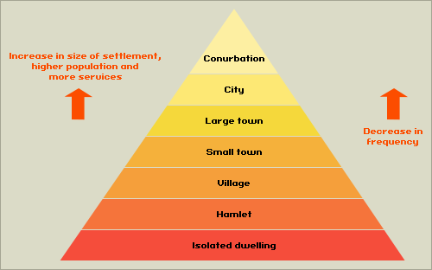

SETTLEMENT TYPE | SETTLEMENT SIZE | TYPES OF RECREATION FACILITIES | TYPES OF RECREATION ACTIVITIES
Hamlet | Up to 10 houses and population of about 50 | - Public house? (bar)  - Countryside  - River? | - Quiz night  - Meal at public house restaurant  - Walking  - Cycling  - Horse riding  - Fishing
Large Town | About 50,000 people | - Sports pitches (football, rugby, cricket, etc.)  - Swimming pools  - Community centres  - Cinema  - Some accommodation e.g. 3* hotel  - Bowling alley  - Golf course  - Garden centre  - Parks  - Restaurants  - Shopping high street  - Colleges  - Libraries | - Range of sports (cricket, footbal, rugby, etc.)  - Dance classes  - Spanish lessons, photography lessons  - Bingo  - Scouts  - Golf  - Gardening  - Walking, cycling  - Eating (dining at restaurants)  - Watching films and possibly amateur dramatics  - Basic shopping
Capital City e.g. London | Usually over 1 million, London is about 6.5 million | - All of the above and....  - Range of accommodation (B&B to 5* hotel)  - Theatres  - Museums and art galleries  - Velodromes  - Olympic size swimming pools  - National sports stadium e.g. Twickenham (rugby) and Wembley (football)  - Concert venues e.g. Wembley Arena and Earl's Court  - International events e.g. 2012 Olympics  - Historic buildings (including government buildings e.g. Houses of Parliament)  - Large shopping centres  - Theme parks  - Zoos | - All of the above and.....  - Viewing top level sport e.g. the Barclay's Premiership  - Attending international sports events  - Visiting top class art galleries and museums.  - Tours of historic sites  - Shopping (including specialist and designer)

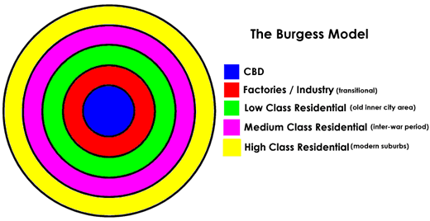 | Intra-urban Distribution of Recreation Facilities. When looking at the distribution, it might be easiest to divide the city into urban zones, like in the Burgess Model.  TBD: Sometimes coincides with CBD but will contain historic buildings, museums, theatres, galleries, top end hotels and restaurants  Transition zone: The old industrial area in MEDCs. Might contain cinemas, bowling alleys, shopping centres, sports centres.  Suburbs: The residential area of the city may contains parks, libraries, sports centres, community centres  Rural-urban fringe: The boundary between the urban and rural area may contain parks, hotels, shopping centres, golf courses, stadiums  Urban area: The built up area, anywhere with a population of over 10,000 people is considered to be urban.  Rural area: Everywhere outside the urban area, the countryside. Rural areas may contain small settlements like villages and hamlets and leisure facilities like national parks, lakes, canopy tours, farms, country homes, etc.

‍Reasons for Changes in Recreational Provision in Urban Areas
Space: Some recreational activities take up a lot of space e.g. golf. It would not be possible to find enough space in the centre of the town to build a golf course.
Historical Location: Historic buildings are normally found in the centre of urban areas. The reason main historic buildings e.g. castles and cathedrals were built at the same time the urban area was settled, so the urban area has grown around them.
Land value: Some recreational facilities will not be able to afford to locate on higher value land. For example a local cricket pitch would not locate on expensive land because it does not generate any income. However, a five star hotel might locate on high value land because it generates lots of income.
Land Use of Surrounding Area: Some recreational facilities will be attracted to certain locations. For example a hotel would normally be located in the TBD or on a good transport link, because this is what tourists demand. They would not locate in in the middle of a residential area, because demand would be less. Alternatively a library or sports centre is more likely to be located in a residential area, because this is where the demand will be.
Accessibility: Some recreational facilities need a higher threshold population to be offered e.g. shopping centres, therefore they need to be in a location with a large population and are easily accessible. Facilities like new sports stadiums are also built near main roads or good public transport links.
Socio-economics Status: Some recreational activities e.g. golf are expensive to participate in. Because of this some facilities will locate in areas of higher socio-economic status. Alternatively football is traditional a more working class sport so football clubs (recreational not professional) maybe located in more working class areas.
Physical Characteristics: Some recreational activities are dependent on the physical environment e.g. potholing, fishing and skiing. Because of this you are not going to find some recreational facilities inside urban areas, but more in the rural-urban fringe or rural area. Areas that have outstanding natural beauty or great weather may also have above expected facilities e.g. the island of Menorca in the Mediterranean or Monteverde in Costa Rica.
Sports Events or Exhibitions: Some cites areas may have above expected tourist or recreation facilities because they have recently hosted a major sports event, conference or exhibition. Qatar in the Middle East has a population of only 1 million but will host the football World Cup in 2022. After the World Cup many settlements in Qatar will have more tourist and recreation and facilities than you would expect for a settlement of their size.
Advertising and Recognition: Some locations are very good at promoting themselves and attracting new customers and users and therefore have above expected facilities for their size e.g. the Bahamas, Dubai or Phuket in Thailand.
The diagram below was taken from an old IB exam. It is the kind of diagram you might see in an exam. It may look unusual but if you study it carefully it is quite simple. The diagram shows that there are not many country parks (National Parks), but they are bigger in size and have a bigger sphere of influence (catchments area). At the other extreme it shows there are many local parks, but they are smaller in size and are located closer to where people live and work (have a smaller sphere of influence).
