**The Jews of medieval England**

Jewish people first began arriving in England following the Norman Conquest in 1066 and their histories can be traced in the country’s major cities today. Through the story of a bronze cauldron known as the Bodleian Bowl, historian Rebecca Abrams explores the experiences of Jews in medieval England, from prosperity to persecution…

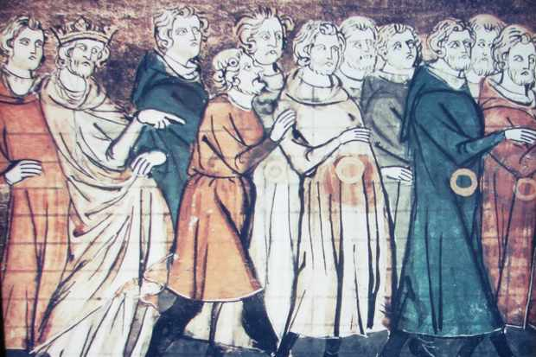

Jewish communities spread rapidly throughout the Mediterranean world from the first century AD, but it was not until the 11th century that Jewish people in any significant number began to cross the Channel and settle in England. This magnificent bronze cauldron, from the Ashmolean Museum in Oxford (pictured below), is intimately bound up with the story of how the Jews first came to England in 1070, and what happened to them during the next 200 years before they were abruptly expelled from the country in 1290.

Known as the Bodleian Bowl, it was discovered at the end of the 17th century in a disused moat in Norfolk, and remained shrouded in mystery for several hundred years. It was bought in 1742 by Dr Richard Rawlinson, who bequeathed it to the University of Oxford on his death in 1755. Standing almost 25cm high and weighing in at a hefty 5kg, the bowl has a long Hebrew inscription encircling the rim and is impressively decorated with hoof-shaped feet, birds, flowers, stags and fleurs-de-lys. The bowl’s value and importance were beyond doubt, but who owned it, what it was for and how it ended up in a Norfolk moat resisted answers for a long time.

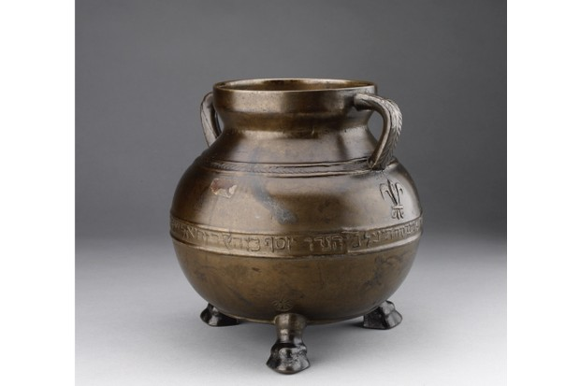

*The Bodleian Bowl, discovered at the end of the 17th century in a disused moat in Norfolk. (Image used with permission from R Abram*s)

The Marquis of Northampton, writing in 1696, thought the bowl “a great mystery” and described it as a “rabbinical porridge pot”, intended by its users to symbolise the biblical pot of manna. Other theories were that it might have been used by rabbis to wash their hands during ritual observance, or to hold water during the preparation of the dead for burial. It is now generally agreed that it was in all likelihood used to collect charitable donations. The Hebrew inscription also puzzled scholars with its tantalising mixture of abbreviations, missing letters and words without clear meaning. A credible translation for the inscription reads:

“This is the gift of Joseph, son of the Holy Rabbi Yechiel, may the memory of the righteous holy one be for a blessing, who answered and asked the congregation as he desired, in order to behold the face of Ariel as it is written in the Law of Jekuthiel, And righteousness delivers from death.”

Property deeds and other documents, which came to light in the 19th century, revealed that Joseph was a leading member of the Jewish community in Colchester in the 13th century, and the eldest son of Rabbi Yechiel of Paris, a leading Talmudic scholar in 13th-century France and head of the renowned Paris *yeshiva.*Joseph had spent time in prison (we don’t know for what, exactly) and on his release made a vow to emigrate to the Holy Land, an intention he began to realise in around 1257. Before his departure, Joseph put his affairs in order, transferred his property in Stockwell Street, Colchester to his brother Samuel and presented the bowl as a gift to the local Jewish community, possibly to thank them for raising money to help fund his journey. Joseph left England in 1260, either with his father, or possibly after his father’s death, travelling first to France and Greece, then on to Palestine, where he subsequently died. He was buried not far from Haifa in a graveyard at the foot of Mount Carmel, alongside many other eminent rabbis.

**The origins of the Jewish community in medieval England**

The bowl’s decorative features, its owners and their connections with France reflect the origins of the Jewish community in medieval England, which came originally from Rouen in Normandy. Actively encouraged by William the Conqueror, who was keen to foster trade between the two countries, Norman Jews began arriving in England soon after the Norman Conquest. They spoke a form of medieval French in their daily life and studied Torah with the help of French translations. They also frequently had French names, such as Bonami, Bonafoy, Deulecresse and Joiette. Rabbi Joseph of Colchester was also known by the splendid name of Messire Delicieux.

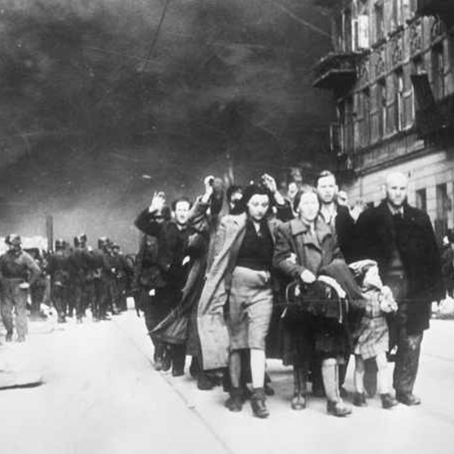

For the next century, Jews flourished in England, forming settled communities in many towns and cities, including Norwich, Oxford, Hull, Lincoln and York. Highly literate and numerate, especially compared to the general population of medieval England, their opportunities for employment were nevertheless very restricted, but they played a vital part in the economic life of the country as financiers and moneylenders, the main occupations they were permitted to practise and which were forbidden to Christians.

One of the oldest Jewish communities in England was in Oxford, where Jews had begun to settle as early as 1075. Over the next two centuries they grew steadily in number, wealth and influence, owning some impressive stone properties in and around Great Jewry St (now St Aldate’s.) At its peak, between 1170 and 1220, the medieval Jewish population of Oxford consisted of around 100 people in a city of about 2,000, and owned perhaps as many as 100 to 150 properties. The graceful vaulted stone ceilings of one of these medieval Jewish homes has survived to this day and can be viewed in the current Town Hall. Archaeological excavations in 2015 from the old Jewish quarter included vessels that had been used for smelting metals, supporting theories that the Oxford Jewish community was involved in both the procurement of bullion for the Royal Mint and the actual production of coins. Earlier excavations revealed that houses in the Jewish quarter were connected by underground passageways, possibly designed for the safe traffic of money to and from the castle mint.

Jewish landlords and property owners also played a significant role in the establishment of the university. Merton College, one of the earliest colleges in Oxford, was established in the 1260s with the help of a wealthy local Jew named Jacob of Oxford, who was instrumental in the purchase and even the purpose-built designs of some of the buildings. Balliol College and Christ Church were also endowed with properties that were originally owned by the city’s medieval Jews. Cash-strapped students, meanwhile, would often pawn their books to local Jewish moneylenders in order to fund their drinking sprees and other expenses. In 1244, so many books were held in pawn that a riot broke out. The chancellor of Oxford, Robert Grosseteste, banned all further contact between Jewish pawnbrokers and the students, and set up a university-run loan chest, called St Frideswide Chest, to enable students to borrow money without jeopardising their studies.

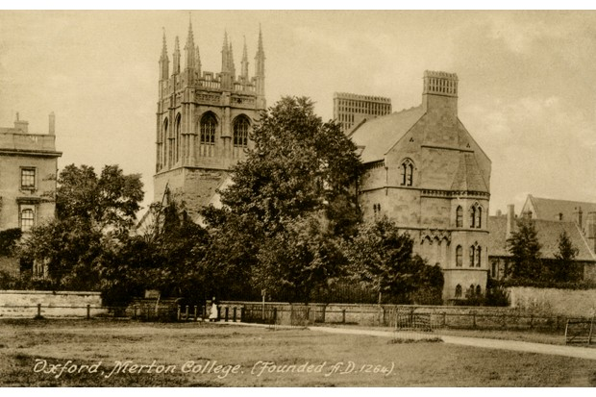

*Merton College, Oxford University. Jewish landlords and property owners played a significant role in the establishment of the university. (Photo by Culture Club/Getty Images)*

As private tutors, local Jews also assisted the university’s students and scholars in their study of Hebrew texts. The Franciscan philosopher Roger Bacon (c1220–92), who spent many years of his life in Oxford, not only wrote with genuine admiration about Jews, but was an excellent Hebraist and, in all likelihood, was personally acquainted with members of the Jewish community and may have worked with respected Jewish scholars**,** such as Jacob of Oxford. One unnamed Christian deacon, who was taking Hebrew lessons with an Oxford Jew in the early 13th century, fell so in love with his tutor’s daughter that he had himself circumcised and converted to Judaism in order to marry her, for which on 17 April 1222, he was found guilty of apostasy and burnt at the stake at Osney Abbey.

The relationship between Christian Hebraists and Jewish scholars appears in several cases to have been a close one in the 12th and 13th centuries, with evidence of English Christians, such as Herbert of Bosham (c1120–94) and Ralph Niger (1140s–c1199), studying Hebrew texts and working with Jewish scholars for assistance with their study of the Hebrew Bible, the Septuagint (the Greek translation of the Bible) and the Vulgate (Latin Bible). A number of medieval manuscripts have survived in which the Hebrew text of the Bible has been painstakingly translated, with the Latin written word for word above the Hebrew in places to create a bilingual edition, enabling the two versions to be directly compared.

**Taxed by the monarchy**

Jews in medieval England were legally the personal property of the king and came under royal protection. As wards of the crown, they had the freedom of the king’s highways and, as royally protected financiers, they participated to some degree in court affairs. But they were also subject to heavy taxation. At the end of the 12th century, the Jewish community made up less than 0.25 per cent of the English population, but was providing 8 per cent of the total income of the royal treasury. During the 12th and 13th century, extra taxes levied on the Jewish community, as well as assets confiscated from wealthy individuals, helped to fund the Christian crusades and the construction and expansion of many of England’s finest churches and cathedrals, among them Norwich Cathedral and Westminster Abbey in London.

As long as the Jews had money (and no competition from other moneylenders), they were a valuable source of income and could rely on royal protection. But the medieval Jewish community was exceptionally vulnerable to the caprices of individual monarchs. The battling royal cousins Matilda and Stephen repeatedly imposed exorbitant additional taxes called tallages on the Jews, in part to fund their internecine civil war. Richard I (reigned 1189*–*99) not only used the Jews to finance his 1189 crusade, but also forced them to pay the enormous sum needed for his ransom when he blundered into captivity on his way home. In Richard’s absence, his brother John taxed the Jews relentlessly, and took this practice to a new level when he in turn became king. Having bankrupted the country with his disastrous campaign against the French, in 1210 John imposed crushing taxes on his only remaining source of funds: his Jewish wards. Punishments for non-payment included confiscation of goods and property, severe fines, and collective imprisonment.  Entire communities of men, women and children, young and old, were locked up on numerous occasions. Desperate to keep his rebellious barons on side, the king allowed them to plunder whatever Jewish assets they pleased. Under John’s son Henry III (r 1216*–*72) and grandson Edward I (reigned 1272*–*1307), the situation deteriorated still further.

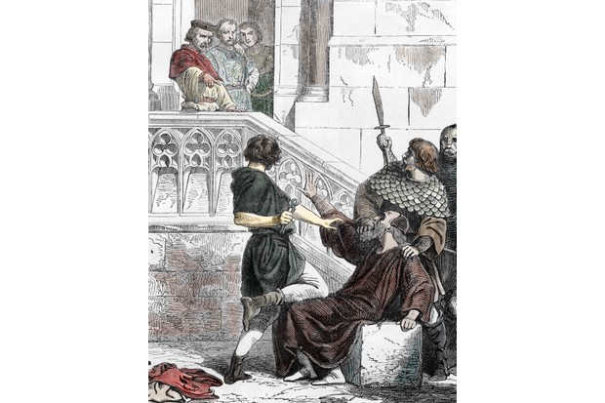

*King John of England imposed crushing taxes on his Jewish wards, says Abrams. Engraving from ‘Histoire de France’ by Lahure, 1866. (Photo by Leemage/Corbis via Getty Images)*

**The rise of anti-Jewish hostility**

Fuelled by zeal for the crusades and resentment of the Jews’ special status and presumed wealth, physical assaults on Jews escalated from the middle of the 12th century. As moneylenders, Jews were despised and came to be hated by the very people who relied upon their services. In 1190, a violent riot erupted against the Jews of York, and the entire Jewish community was forced to take refuge in the castle, where they eventually committed suicide *en masse* rather than fall into the hands of the murderous townsmen. Other attacks took place in London, Norwich and King’s Lynn. Around this time a new papal decree obliged Jews across Europe to wear an identifying badge to distinguish them from other citizens. In England, it was ordained that “every Jew shall wear on the front of his dress tablets or patches of cloth four inches long by two inches wide, of some colour other than that of the rest of his garment”. This usually took the form of a white or yellow badge signifying the two tablets of Moses.

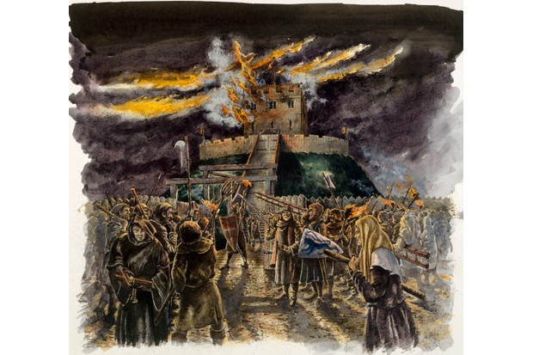

*In 1190, a violent riot erupted against the Jews of York, and the entire Jewish community was forced to take refuge in the castle. A 20th-century depiction of Clifford’s Tower, York, during the 1190 riot. (Photo by English Heritage/Heritage Images/Getty Images)*

The most pernicious form of anti-Jewish hostility in medieval England was the blood libel, the accusation that Jews were murdering Christian children as part of their Passover rituals. The allegation was made for the first time in 1144 in Norwich, then home to one of the oldest and richest Jewish communities in England, after the mutilated body of a young man called William was found in woodland near the city. No evidence was found to connect Jews to William’s death, nor were any Jews in Norwich found guilty of the crime. But six years later, in 1149, the allegation was resurrected during the trial of a Christian knight called Sir Simon de Novers. Newly returned from the Second Crusade and deeply in debt, de Novers was accused of murdering a local Jewish banker to whom he owed money.

In itself, the murder of a Jew in medieval England was hardly ground-breaking news, but as Jews were chattels of the king, the crime had to be prosecuted. As there was the clear evidence that de Novers had arranged the murder, the outcome of the trial was generally assumed to be a done deal. What turned the case into a high-profile spectacle was the defence mounted at the trial by Bishop William Turbe on the knight’s behalf.  The bishop’s audacious line of argument was that, “we Christians should not have to answer in this manner to the accusation of the Jews, unless they are first cleared of the death of our Christian boy, of which they are themselves known to have been previously accused and have not yet been purged”. In other words, Simon de Novers should not be punished for killing a Jew until the Jews had been collectively punished for killing William.

In the event, no ruling was reached, the case was adjourned, and the guilty knight walked free. However in 1150, Thomas of Monmouth, a young monk at Norwich Cathedral, decided to make a martyr of William. In his book, *The Life and Passion of William of Norwich*, Thomas presented the Jews not just as William’s killers (despite not a shred of evidence to support this assertion) but as insatiable for Christian blood in general. The myth of the blood libel rapidly took hold in Christian imagination from then on. Whenever a Christian child died accidentally or in some unexplained manner, the Jews were likely to find themselves accused. This resulted in massacres in Bury St Edmunds in 1181, Bristol in 1183, Winchester in 1192, London in 1244 and Lincoln in 1255. In the French town of Blois in 1170 it was the excuse for executing 30 entirely innocent Jews, 17 of them women, some pregnant, others holding young children in their arms, all burned to death in the building where they had been locked.

**Poverty and despair**

By the time Rabbi Joseph left Colchester in 1260, the Jewish community in England was sunk in poverty and despair. The ban on Christian usury had recently been lifted, Jews were facing stiff competition from non-Jewish moneylenders, and the beleaguered crown had less reason to stick its neck out to defend them. Stripped of their assets, the Jews were deprived of the means to earn a livelihood and increasingly afraid for their personal safety. Between 1263 and 1267, the combined forces of England’s barons and gentry (the two groups most indebted to moneylenders) attacked one English Jewish community after another, murdering many of their inhabitants under the guise of waging war on the crown. In addition, they put huge pressure on the king to introduce increasingly oppressive restrictions on the Jews. In 1269 new laws were passed forbidding Jews from owning land or property other than their own homes or those rented to other Jews, and confiscating all their assets when they died. Jewish children were no longer allowed to inherit from their parents and, from 1275 on, Jews were banned from lending money.

The end was now in sight. With almost no way to earn a living, some resorted in desperation to illegal options. In 1278, 293 Jews were found guilty of coin-clipping and hanged at the Tower of London. A heart-rending poem, written by Rabbi Meir of Norwich, expresses the dreadful plight of the Jewish community at this time:

*Forced away from where we dwelt*

*We go like cattle to the slaughter*

*A slayer stands above us all.*

*We burn and die.*

On 18 July 1290, just 30 years after Joseph had left for the Holy Land, Edward I issued an edict expelling the entire Jewish population from the country in return for a huge grant from his knights and barons of 150,000 marks to support his war against the Scots. Any Jew remaining in the country after All Saints’ Day (1 November) of that year did so on pain of death. Between 4,000 and 16,000 Jews fled to the continent. Many returned to northern France or moved to countries such as Poland, where Jews were still legally protected. A small number remained, either by converting to Christianity or concealing their identity and religion. England was the first European country to expel its Jewish population but in the following centuries France, Spain, Portugal and others would follow suit.

*The expulsion of Jews from France in 1182. Found in the collection of the Bibliothèque Nationale de France. (Photo by Fine Art Images/Heritage Images/Getty Images)*

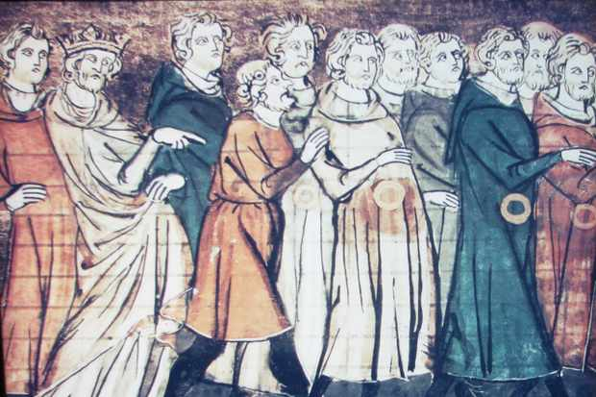

In the space of just two centuries, the Jewish community in medieval England arrived, thrived and was systematically demolished. Encouraged to come to the country, they were then despicably abused, exploited as cash cows by the crown, mercilessly stripped of everything they had worked so hard to create, and finally forced from the towns and cities they had come to regard as home. For the next 350 years, Jews were officially banned from England.

A small number remained in the country, however, either as crypto-Jews or as converts to Christianity. Small communities of Spanish and Portuguese conversos in London and Bristol were tolerated by both Henry VIII and Edward VI. Many of the foreign musicians in the Tudor and Elizabethan court, notably the Lupos and Bassanos, were most probably also originally or covertly Jewish. In 1655, the position of Jews in England was transformed when Rabbi Menasseh ben Israel of Amsterdam delivered his famous petition to the Council of State, requesting their readmission. Oliver Cromwell supported the petition and established that no actual law forbade readmission, thus paving the way for Jews to return to the country.

The frantic exodus that must have followed the king’s edict in July 1290 may explain how the Bodleian Bowl found its way to the bottom of a moat in Norfolk. Perhaps it was dropped by accident during the fear-fuelled dash for the coast. Or perhaps it was intentionally hidden in the moat, in the hope it might be retrieved at some point in the future. Whatever the answer, the Bodleian Bowl is a poignant relic of England’s medieval Jewish community, a reminder of its technical accomplishments, commercial savvy, religious piety and enormous financial contribution to the country. It stands as a symbol of the fluctuating fortunes of the Jews in the Middle Ages, not only in England, but in the medieval diaspora as a whole.

**This article is extracted from**[***The Jewish Journey: 4000 years in 22 objects from the Ashmolean Museum***](https://www.ashmolean.org/jewish-journey)**by Rebecca Abrams, with a foreword by Simon Schama (published by the Ashmolean Museum, £15)**