The IB History Learner Leader Profile
The Task
What: You will create a presentation of the IB History Learner Leader Profile.
Why: Over the next two Years you will learn about a range of Historical Leaders who have shaped the past. One of the key concepts that we cover in IB History is that of the role of the Individual. Historians often debate the significance of prominent individuals and seek to find qualities that they share. This brief task will allow you to become familiar with some of our key figures and to consider their characters and their importance in history.
How: You will select 3 individuals from the list below. You will research the life of each individual and decide which aspects of the IB Learner Leader Profile best suits their character and their role in history.
You will create a presentation of your 3 historical figures - explaining which attributes you have identified. You should use specific historical details to support your choices.
You can choose any medium to present your findings and any platform to enable collaboration.
For this project, you will choose NOT ONLY how to present your research and conclusions, BUT ALSO how you would like the teacher to assess your work.
Student Names:

Research: The IB History Learner Leader Profile

Brief Description of project:

 | Skill  Research/Knowledge/  Evidence/explanation/  Critical Thinking | How will YOU demonstrate this skill in the project? (TIP: start with phrases like ‘I will include…’, ‘I will ensure…’, ‘I will try…’). | When your project is finished, give yourself up to FIVE marks for this attribute, with ‘5’ being the best score*
1
2
3
The History IB Learner Lear Profile Task
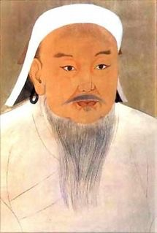 | 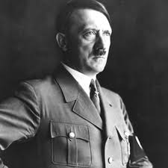 | 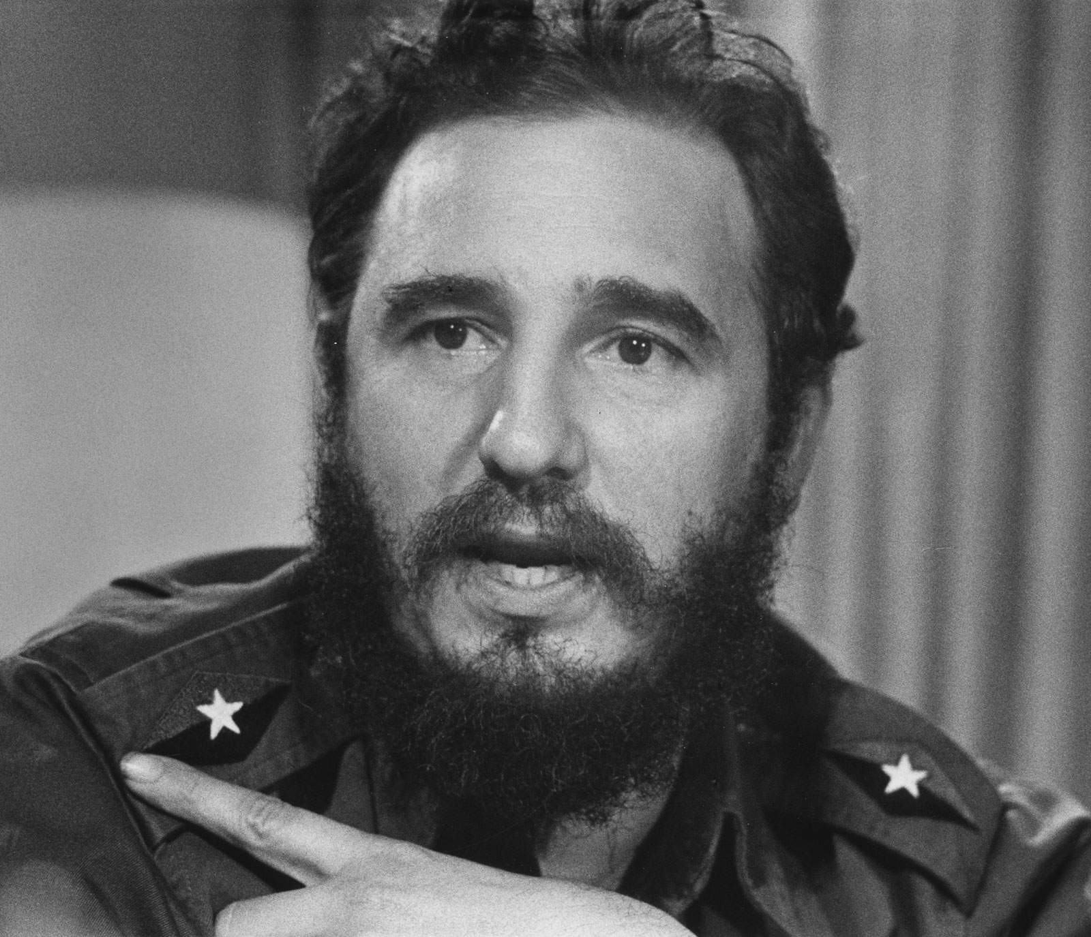
Genghis Khan – Asia - 12th/13th C | Adolf Hitler -Europe - 20th C | Fidel Castro - The Americas - 20th
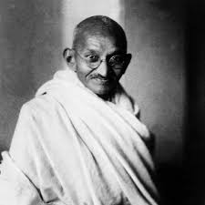 | 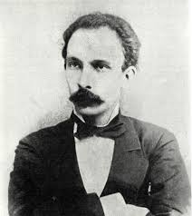 | 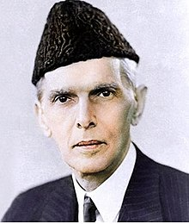
Gandhi – Asia – 20th C | Jose Marti - The Americas - 19th C | Jinnah – Asia – 20th C
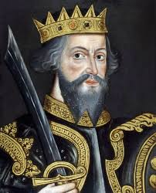 | 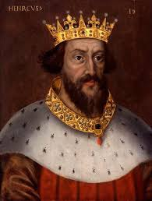 | 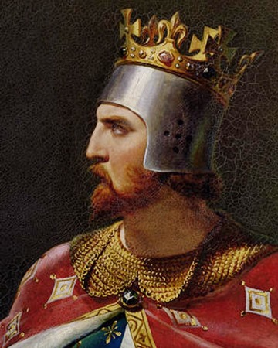
William I – Europe – 11th C | Henry I – Europe – 12th C | Richard I – Europe – 12thC
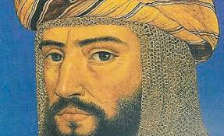 | 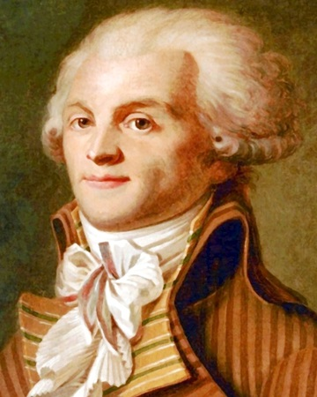 | 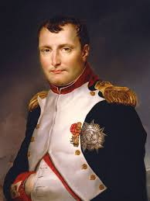
Saladin – Asia – 12th C | Robespierre – Europe – 18th C | Napoleon – Europe – 18/19th C

The Learner Leader profile
Come up with a simple definition of each of these words.
Brief Description
Inquisitive
Communicative
Knowledgeable
Risk-Taking
Principled
Caring
Open-Minded
Well -balanced
Reflective
Creative

