The Growth of Firms

Using pages 203 -204 make some brief notes on measuring the size of firms:

Measuring the size of firms



____________________________________________________________________________________________________________________________________________________________________________________________________________________________________

____________________________________________________________________________________________________________________________________________________________________________________________________________________________________

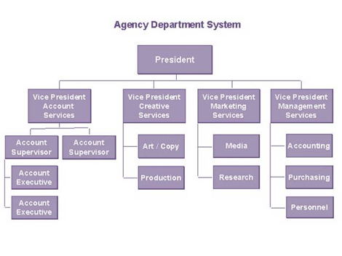

____________________________________________________________________________________________________________________________________________________________________________________________________________________________________

____________________________________________________________________________________________________________________________________________________________________________________________________________________________________

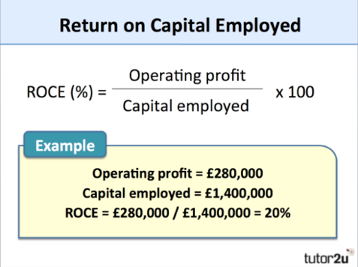

____________________________________________________________________________________________________________________________________________________________________________________________________________________________________

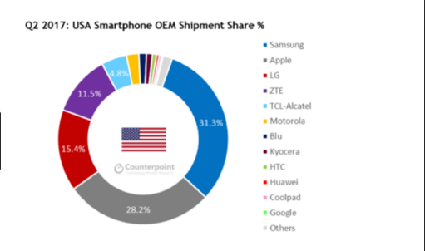

____________________________________________________________________________________________________________________________________________________________________________________________________________________________________

Take notes on motives for growth using pages 206-207, read the advantage and disadvantages of small firms:

Motives for growth:

Survival:

Survival:

____________________________________________________________________________________________________________________________________________________________________________________________________________________________________

____________________________________________________________________________________________________________________________________________________________________________________________________________________________________

____________________________________________________________________________________________________________________________________________________________________________________________________________________________________

[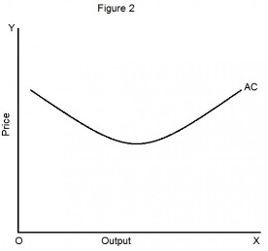](http://www.google.com/url?sa=i&rct=j&q=&esrc=s&source=images&cd=&cad=rja&uact=8&ved=0ahUKEwi6yrzZ6p_LAhUkmoMKHUgSCR0QjRwIBw&url=http://hubpages.com/education/Short-Run-Average-and-Marginal-Cost-Curves&bvm=bv.115339255,d.amc&psig=AFQjCNELR9rJDis-rC_9ie2bTGv6AGgZSA&ust=1456933529760982)[](http://www.google.com/url?sa=i&rct=j&q=&esrc=s&source=images&cd=&cad=rja&uact=8&ved=0ahUKEwjAlej76p_LAhVMnoMKHes6CB0QjRwIBw&url=http://www.kerrypostel.com/increase-profits/&psig=AFQjCNHNl6gXtKGAnpTuhbwRTBNnu3ePyw&ust=1456933657705383)[](http://www.google.com/url?sa=i&rct=j&q=&esrc=s&source=images&cd=&cad=rja&uact=8&ved=0ahUKEwiPlLPG65_LAhXpmoMKHcEwDtYQjRwIBw&url=http://mikemelaragno.com/market-share-or-share-of-the-customer/&bvm=bv.115339255,d.amc&psig=AFQjCNGqKQKSDbAWdOGKYX11Cnx5I57p9w&ust=1456933787884936)

Increased profits:

Average costs are lower:

____________________________________________________________________________________________________________________________________________________________________________________________________________________________________

Increased market share:

Complete the diagram of all of the different methods of growth identified on pages 207-211.

Methods of growth:

Now take notes on these different forms of growth:

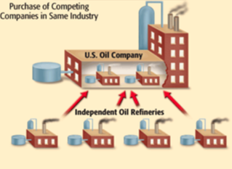Methods of integration:

Lateral integration

____________________________________________________________________________________________________________________________________________________________________________________________________________________________________

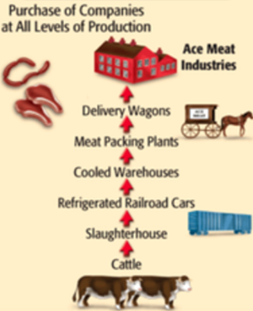 Vertical merger:

____________________________________________________________________________________________________________________________________________________________________________________________________________________________________

Conglomerate merger:

[](http://www.google.com/url?sa=i&rct=j&q=&esrc=s&source=images&cd=&cad=rja&uact=8&ved=0ahUKEwiHiea38J_LAhXCu4MKHZAIAh8QjRwIBw&url=http://carolsanfordinstitute.com/project/procter-gamble/&bvm=bv.115339255,d.amc&psig=AFQjCNHB0BkFxeVeectIU1kfjZ_0pUG4rg&ust=1456935083725596)

____________________________________________________________________________________________________________________________________________________________________________________________________________________________________

Using pages 205 -206 make some brief notes on why most firms remain small:

[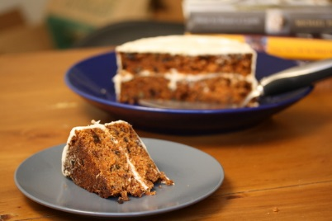](http://www.google.com/url?sa=i&rct=j&q=&esrc=s&source=images&cd=&cad=rja&uact=8&ved=0ahUKEwjW3q-A85_LAhUDvIMKHbDhDyIQjRwIBw&url=http://www.huffingtonpost.com/big-girls-small-kitchen/the-10-best-birthday-cake_b_951459.html&bvm=bv.115339255,d.amc&psig=AFQjCNGw9TSGHr0hu2fuC7yNxcyQ6R_43A&ust=1456935770033051)Limitations to growth:

[](http://www.google.com/url?sa=i&rct=j&q=&esrc=s&source=images&cd=&cad=rja&uact=8&ved=0ahUKEwi5uaWR85_LAhUht4MKHdMhCx0QjRwIBw&url=http://dominikrivinius.empowernetwork.com/blog/the-secret-connection-between-jealousy-and-the-lack-of-money&bvm=bv.115339255,d.amc&psig=AFQjCNHepvpAc0SiAZ1jr4HDPbe0UeFh8g&ust=1456935850987352)[](http://www.google.com/url?sa=i&rct=j&q=&esrc=s&source=images&cd=&cad=rja&uact=8&ved=0ahUKEwj5uab185_LAhWFm4MKHfd2CR4QjRwIBw&url=http://doggiecareresort.com/&psig=AFQjCNE5iKTnT1u3k2jXtxOpVEHWFbtAag&ust=1456936014309614)

Some business owners choose to stay small:

Access to capital is limited: 

The size of their market is small:

__________________________________________________________________________________________________________________

__________________________________________________________________________________________________________________

__________________________________________________________________________________________________________________

__________________________________________________________________________________________________________________