The Economic/Business/ Cycle.

- Economies go through a business cycle. How might one define the business, economic or trade cycle?

- Look at the diagram on the following page and label the following terms :-

Boom
- Recession

Recovery
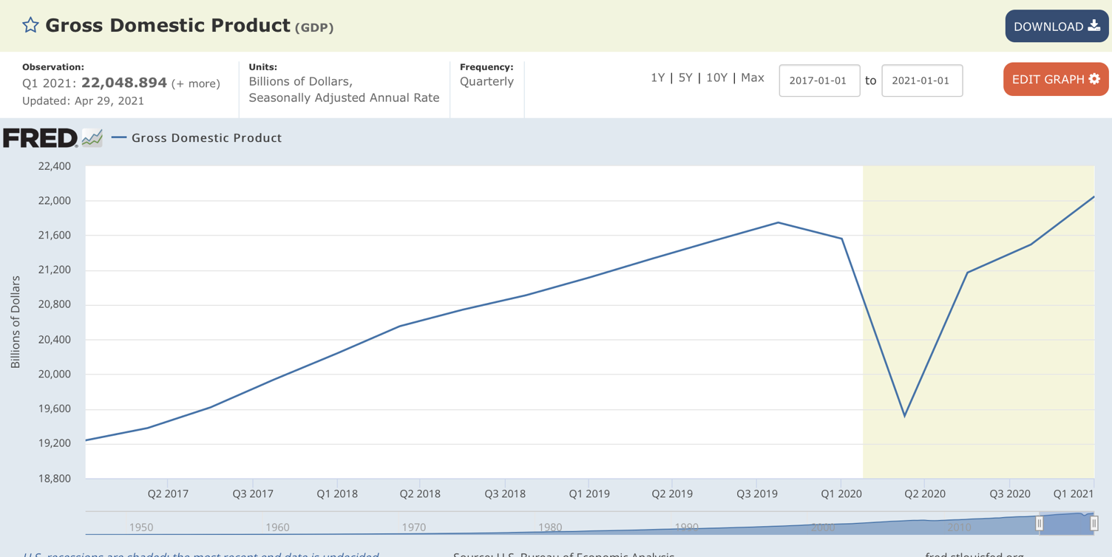

- Define the terms in the table below.

Downturn
Recession
Boom
Recovery

- On the diagram below identify the output gap. Example:

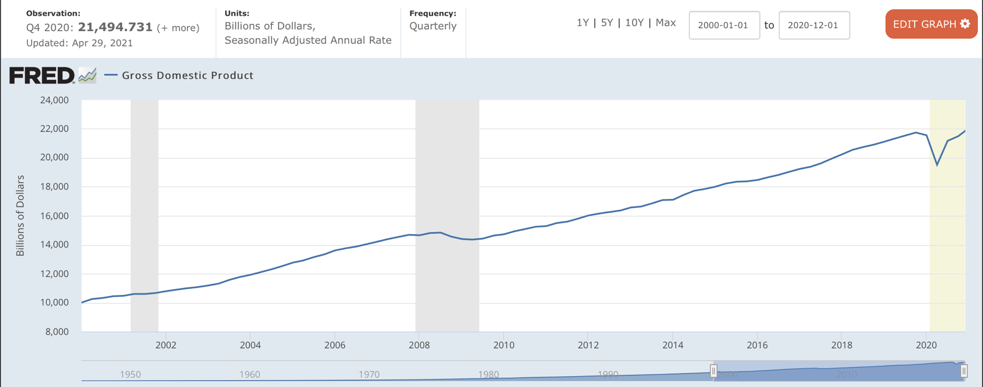

- Define the term output gap.

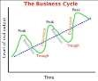
- What is the link between the long-term growth trend in the economy and its productive capacity?

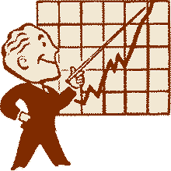
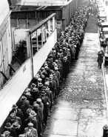
- Sketch two business cycle diagrams for total real GDP over time and real GDP growth over time.

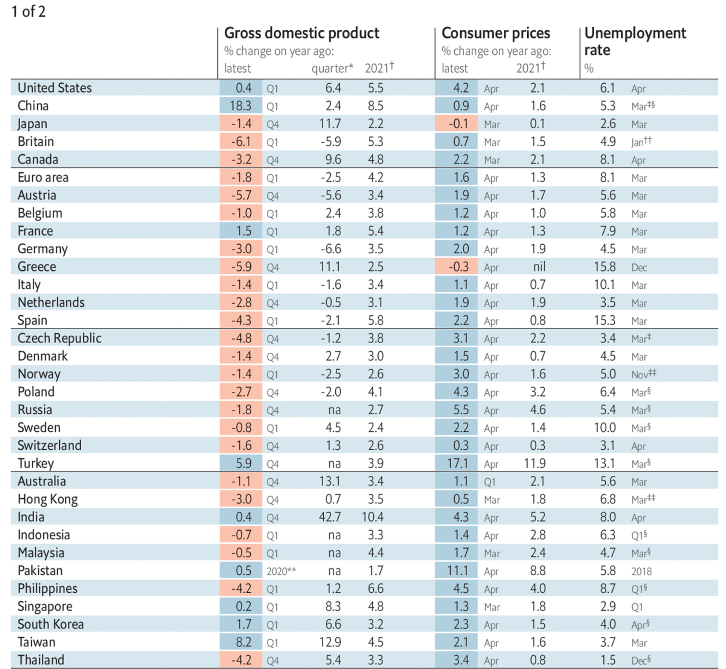

- Identify which countries are experiencing a boom, recovery or recession.

Boom
Recovery
Recession

