Testing for Statistical Significance: Spearman’s Rank for Correlation Coefficient

A type of statistical test you could use is Spearman’s Rank for Correlation Coefficient. This test looks at whether there is a statistically significant relationship between two variables.

Calculate Spearman’s Rank by following this equation: 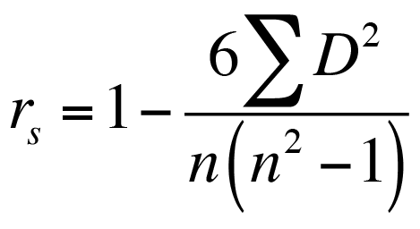

Sites | Variable 1: | Rank | Variable 2: | Rank | Difference | Difference Squared
1. Chevron

2. Cathedral

3. Toyota Centre

4. Discovery Green

5. Minute Maid Park

6. Jail District

7. Chase Tower

8. Green St

9. City Hall

 |  |  |  |  |  | Total of difference squared:

