DP1 Geography Name:______________________________

30 Marks
Unit 1 Test: Population & Economic Development Patterns (60 Minutes)
*Please write all answers on lined paper and use every other line.

- The map below shows Low income countries, middle income countries and high income countries, as classified by the United Nations and the World Bank.

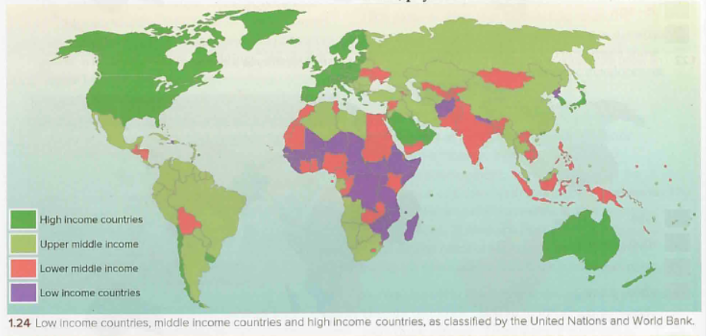

  - Describe the pattern of LICs and HICs on this map. (2 Marks)
  - Identify one anomaly in this pattern. (1 Mark)
  - Why has the World Bank decided not to use the term ‘developing country’? (2 Marks)
  - Account for the distribution of LICs on this map. (3 Marks)
  - What is the difference between external and internal forces that affect economic development? (2 Marks)

- The population pyramids below are from The Economist, with population (shown along top) given in millions.

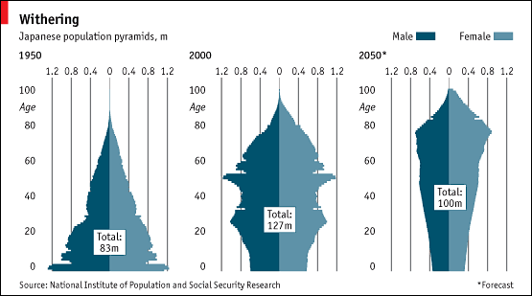

  - Describe the changes in Japan’s population between 1950-2050 as shown in the pyramids above. (3 Marks)
  - What stage of demographic transition was Japan in 1950? (1 Mark)
  - Define dependency ratio. (2 Marks)
  - Outline the challenges associated with an aging population. (3 Marks)
  - Name the type of population policy is Japan implementing to raise fertility rates? (1 Mark)
Answer ONE of the following questions.
Where relevant, answers should refer to case studies or examples and where appropriate include hand drawn maps of diagrams.
- Examine the view that megacities create more opportunities than challenges for individuals and societies. (10 Marks)

- Evaluate the success of a population policy you have studied. (10 Marks)

Marks | Level Descriptor
 | AO1: Knowledge and understanding of specified content  AO2: Application and analysis of knowledge and understanding | AO3: Synthesis and evaluation
0 | The work does not reach a standard described by the descriptors below.
1-2 | The response is too brief, lists unconnected information, is not focused on the question and lacks structure.
 | • The response is very brief or descriptive, listing a series of unconnected comments or largely irrelevant information. The knowledge and understanding presented is very general with large gaps or errors in interpretation. Examples or case studies are not included or only listed.  • There is no evidence of analysis.  • Terminology is missing, not defined, irrelevant or used incorrectly. | • No evidence of evaluation or conclusion is expected at this level.
3-4 | The response is too general, lacks detail, is not focused on the question and is largely unstructured.
 | • The response is very general. The knowledge and understanding presented outlines examples, statistics, and facts that are both relevant and irrelevant. Links to the question are listed.  • The argument or analysis presented is not relevant to the question.  • Basic terminology is defined and used but with errors in understanding or used inconsistently. | • If appropriate to the question, the conclusion is irrelevant.  • There is no evidence of critical evaluation of evidence (examples, statistics and case studies).
5-6 | The response partially addresses the question, but with a narrow argument, an unsubstantiated conclusion, and limited evaluation.
 | • The response describes relevant supporting evidence (information, examples, case studies et cetera), outlining appropriate link(s) to the question.  • The argument or analysis partially addresses the question or elaborates one point repeatedly.  • Relevant terminology is defined and used with only minor errors in understanding or is used inconsistently. | • If appropriate to the question, the conclusions are general, not aligned with the evidence presented and/or based on an incorrect interpretation of the evidence.  • Other perspectives on evidence (examples, statistics and case studies) and/or strengths and weaknesses of evidence are listed.
7-8 | The response addresses the whole question, the analysis is evaluated and the conclusion is relevant but lacks balance.
 | • The response describes relevant supporting evidence correctly (information, examples and case studies) that covers all the main points of the question, describing appropriate links to the question.  • The argument or analysis is clear and relevant to the question but one-sided or unbalanced.  • Complex terminology is defined and used correctly but not consistently. | • If appropriate to the question, the conclusion is relevant to the question, aligned with the evidence but unbalanced.  • Other perspectives on evidence (examples, statistics and case studies) and/or strengths and weaknesses of evidence are described.
9-10 | The response is in-depth and question-specific (topic and command term); analysis and conclusion are justified through well-developed evaluation of evidence and perspectives.
 | • The response explains correct and relevant examples, statistics and details that are integrated in the response, explaining the appropriate link to the question.  • The argument or analysis is balanced, presenting evidence that is discussed, explaining complexity, exceptions and comparisons.  • Complex and relevant terminology is used correctly throughout the response. | • If appropriate to the question, the conclusion is relevant to the question, balanced and aligned with the evidence.  • Evaluation includes a systematic and detailed presentation of ideas, cause and effect relations, other perspectives; strengths and weaknesses of evidence are discussed; (if appropriate) includes justification of the argument and conclusion.

