How Significant was the role of International Protest and Intervention in the Anti-Apartheid Movement?
Source A
The Working Committee of the African National Congress has directed me to place on record our sincere appreciation of the moral and material support which our cause and the Campaign for the Defiance of the Unjust Laws in particular has received from the Negro people of the United States of America.
The African people are presently engaged in a life-and-death struggle against the barbarous policy of racial discrimination pursued by the Malan regime. During the last forty years, my organization has waged a relentless struggle against this policy and has always held the view that a system of government which permits human exploitation and the denial of fundamental human rights to its citizens must be condemned and eradicated from the face of the earth.
The policy of racial tyranny contravenes the Universal Declaration of Human Rights and is a direct threat to world peace. It offends enlightened world opinion and condemns the Malan regime as a group of infamous renegades whose barbarous atrocities perpetrated on the sons and daughters of the soil have shamed humanity. Though we face severe odds, we are confident of our power to halt this brutal onslaught on our civil liberties.
The interest taken by the Negro people in the struggle of the oppressed people both in our country and other parts of the world, their sentimental and historical affiliations to the Continent of Africa, and their contribution in the campaign for world peace and international harmony are factors which make them our comrades-in-arms in spite of the considerable distance and space that separate us.
Message by W.M. Sisulu to the Negro People of the United States of America, 2 September 1952
(Transmitted through the Council on African Affairs)

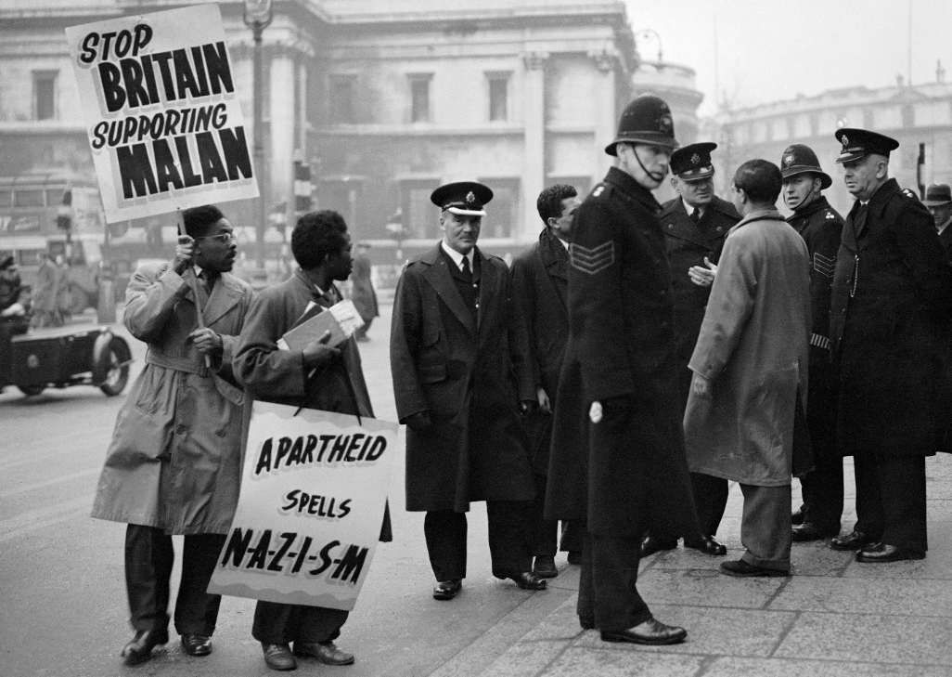
Source B
Demonstration in Trafalgar Square, 19th Jan 1951
Source C
The United Nations: Partner in the Struggle against Apartheid
The elimination of South Africa’s system of legalized racial discrimination known as apartheid (“apart-ness” in the Afrikaans language of the descendants of the first Dutch settlers) was on the agenda of the United Nations from its inception. On 22 June 1946 the Indian government requested that the discriminatory treatment of Indians in the Union of South Africa be included on the agenda of the very first session of the General Assembly.
In the decades that followed the world body would contribute to the global struggle against apartheid by drawing world attention to the inhumanity of the system, legitimizing popular resistance, promoting anti-apartheid actions by governmental and non-governmental organizations, instituting an arms embargo, and supporting an oil embargo and boycotts of apartheid in many fields.
From the UN website, ‘With contribution from Enuga S. Reddy, Former UN Assistant Secretary-General, Principal Secretary, UN Special Committee Against Apartheid Director and UN Centre Against Apartheid’
Source D
However, the South African government ignored UN calls and continued with its apartheid policies. Between 1960 and 1963, the General Assembly adopted many resolutions on apartheid, including Resolutions 1598/1961, 1633/1961 and 1761/1963. Later on, in terms of its Resolution 2202 of 16 December 1966, the General Assembly condemned apartheid as a ‘crime against humanity’.
Between 1948 and 1966, the UN did not act strongly against the South African government because Britain, France and the US opposed such action due to their economic interests. They misused their veto power in blocking the proposed UN Security Council’s actions against South Africa (Souare 2006:78). The attitude of the three Security Council’s permanent members towards South Africa explains why the bulk of the UN work against the apartheid system in South Africa was done by the General Assembly and not by the Security Council. This also explains why apartheid in South Africa lasted for 45 years.
Published on the Website ‘The African Centre for the constructive resolution of disputes’ in 2011 by Dr André Mbata Mangu, Research Professor and Director of Public Law in the University of South Africa, Pretoria.
Questions:
1a. Why, according to Source A, did ‘Negro’ US protestors give support to the Anti-Apartheid Movement?
1b. What message is conveyed by Source B?
2. With reference to its origin, purpose and content, analyse the value and limitations of Source C for a historian studying the significance of the UN to the Anti-Apartheid Movement.
3. Compare and Contrast the views on the extent of the UN’s involvement and impact regarding the Anti-Apartheid Struggle expressed in Source B & Source C.
4. ‘International Protest and Intervention was vital regarding the success of the Anti-Apartheid Movement.’ Using the sources and your own knowledge, explain to what extent you agree with this statement.

