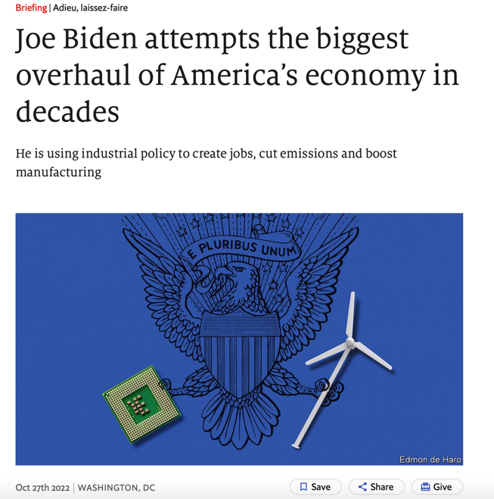
On October 20th Mr Biden returned to the site of the accident. Reconstruction would normally take at least two years. But thanks in part to a $1.2trn investment in infrastructure that he signed into law, Mr Biden could boast that this time the bridge would be back up by Christmas. “For too long, we talked about building the best economy in the world,” he said. “We didn’t do it, but we’re finally getting to it. We’re getting it done.”
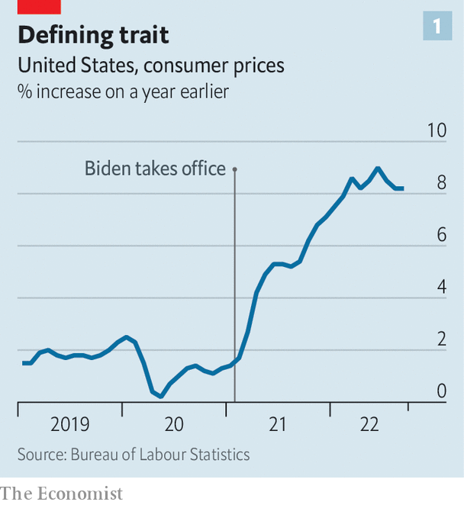
That is most assuredly not the public’s view. As the midterm elections draw near, negative perceptions about the economy may be the decisive factor in shifting control of Congress from Democratic to Republican hands. Poll after poll shows that the state of the economy is voters’ number-one concern. The recent surge in inflation, or “Bidenflation”, as some attack ads have dubbed it, shows no sign of dissipating (see chart). Meanwhile, much of Mr Biden’s agenda has fallen by the wayside: promises of universal pre-kindergarten, fatter family subsidies and an overhaul of health insurance have been undone by congressional gridlock.

Bidenomics can be seen as an attempt to mimic darpa’s approach in fields other than defence, especially clean energy. The Biden administration has doubled funding for research, created institutions to demonstrate how novel technologies work and started to exploit its procurement power in order to gin up demand for them. In short, it is working to foster a chain from innovation to adoption for cutting-edge products.
The various subsidies and incentives will be integral to getting American businesses and consumers to opt for cleaner sources of power. Before the iraand the infrastructure law were enacted, America’s emissions of greenhouse gases were on course to fall by 30% from the level of 2005 by 2030. Now, the Department of Energy estimates and independent researchers concur, they will drop by about 40%. The increment is equivalent to about two years’ worth of emissions from Britain.
If the Democrats (and economists) had their way, America would have imposed a price of some sort on carbon—a much more efficient way to achieve the same goal. But they failed repeatedly to get such a measure through Congress and paid an electoral price for trying, as Republicans painted them as anti-growth. The lavish spending on clean energy is a more politically palatable alternative. It so happens that the two states adding the most new-energy jobs carry political weight. One is Michigan, a perennial battleground; the other is Texas, a Republican bastion that Democrats dream of flipping.
By the same token, Bidenomics’s industrial policy can be seen as a way of counteracting the decades-long erosion of well-paid, blue-collar jobs that has been a source of dismay for Democrats, in particular. For manufacturers to obtain tax credits in full, they will have both to pay workers well and to provide apprenticeship programmes. The ira, for instance, requires apprentices to do at least 15% of the work on construction sites it funds by 2024.
Democrats believe that these requirements will help generate both a bigger pool of skilled workers and a bigger supply of well-paid jobs. Even if the change is only marginal, a few high-profile investments in the rustbelt offer voters a glimmer of hope. Ohio is getting electric-vehicle battery factories; West Virginia wind farms and Pennsylvania robotics manufacturers.

