Leisure in different geographical and developmental contexts

What is the relationship between GNI (gross national income per person) and the percentage of employees working 50 hours or more per week?

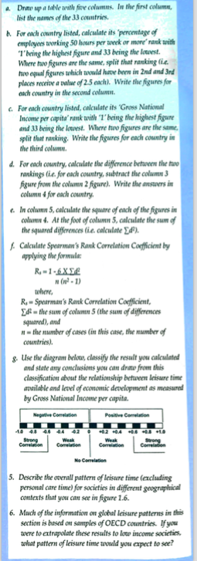
- Draw a scatter graph of the data above. GNI per capita should be on the vertical axis and employees working 50 hours or more on the horizontal axis. Try to draw a line of best fit through the scatter points.
- Describe the relationship you have found in the graph.
- Calculate a more statistically precise analysis of the data by performing a Spearman’s Rank statistical test. Instructions for how to do this are above.
- Describe the findings of your statistical analysis.
Spearman’s Rank
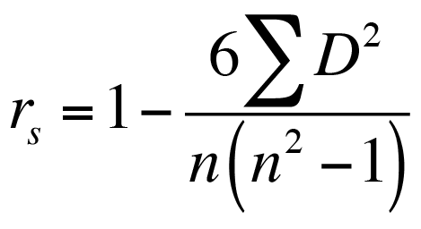

COUNTRY | GNI per capita | Rank GNI | % working 50 hrs or more per week | % work rank | Difference (between the ranks) | Difference squared
 |  |  |  |  |  | TOTAL:

R = Spearman’s Rank Correlation Coefficient
D = Difference between the ranks
= sum of the differences squared
n= the number of cases (in this case the number of countries = 33)

