Economic policies - Theory
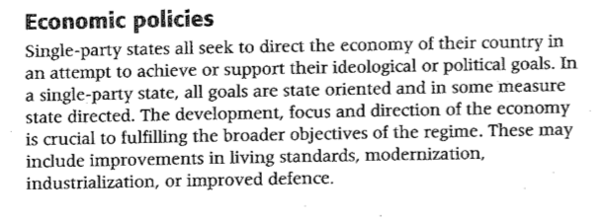
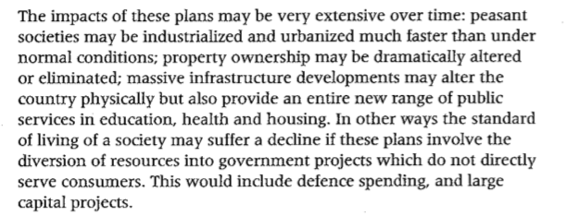
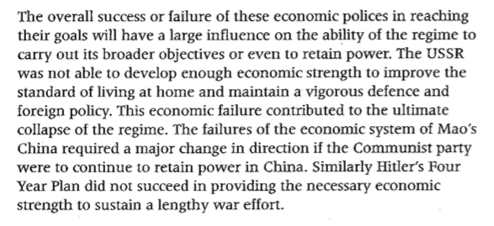

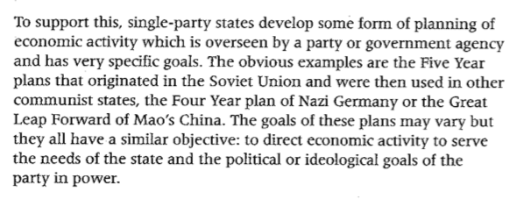

Theory - Economy | Hitler | Castro
Seek to direct the economy to achieve ideological or political goals

Why control the economy?.

States develop economic plans - directing economic activity to serve the needs of the state.

What? What did they do?
Impacts may be extensive over time. They can be positive or negative.

Analysis of impact
The success and failure of economic policies will have an influence on the ability of regime to carry out objectives or retain power.

Evaluation of success

Communication of the ideology - Education Policies

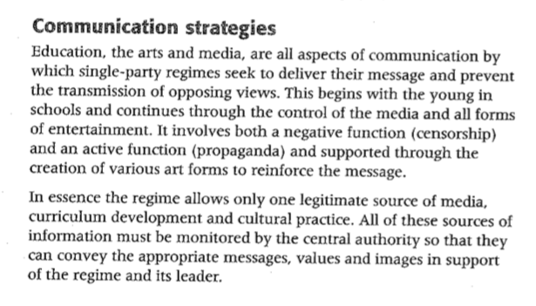
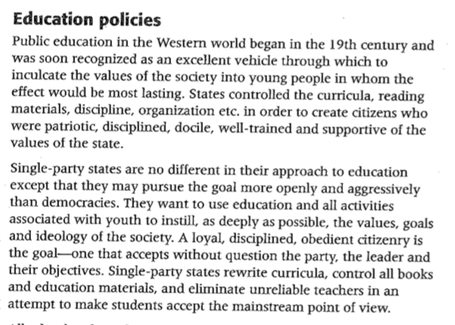
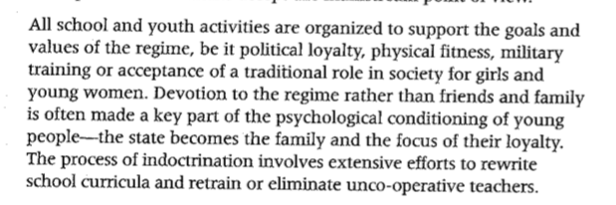

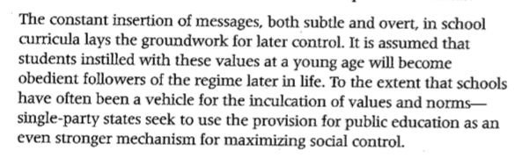

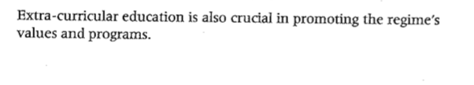

Theory - Education | Hitler | Castro
Education - Aims: A vehicle to inculcate the values of society. Used to instill the values, goals and ideology of society.
State controls curricular, reading materials, discipline, teachers and organization to create citizens who are patriotic, disciplined, docile, well trained and supportive of the vision.
School and youth activities are used to support the values and goals of the state.
Political loyalty
Physical fitness
Military training
Traditional role of Women

Loyalty to the regime over family and friends is often made a key part of the psychological conditioning of the young.

