Specialisation and the Division of Labour

INTRODUCTION: Humans have accumulated great wealth since the beginning of early civilisations. The single largest factor that explains this is ‘Specialisation and the Division of Labour’. In this lesson you will consider what this is and why it matters. The British Economist Adam Smith was the first to identify the mathematical benefits 250 years ago and a simple example given in a later video you will watch will be sufficient to explain why:

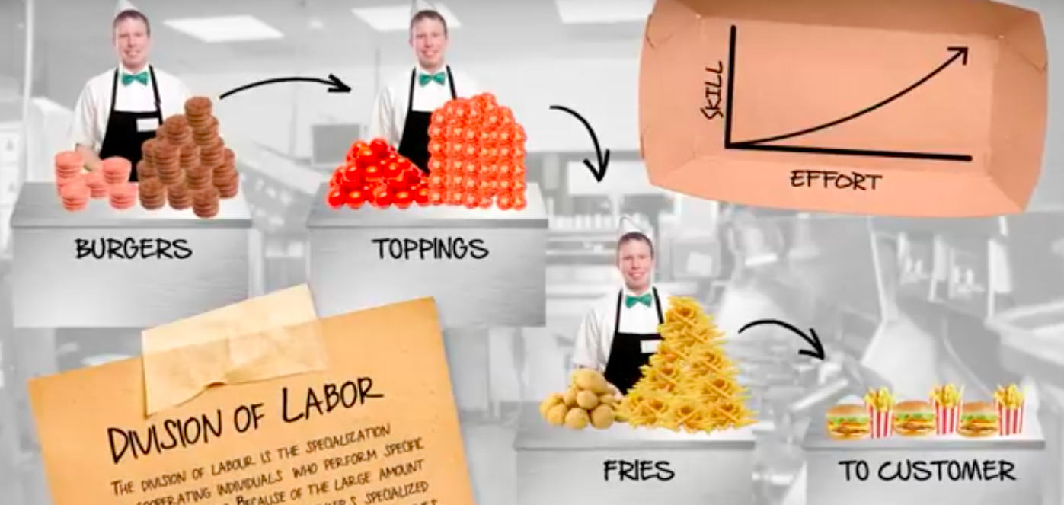
Burgers/Toppings/Fries | Burgers | Toppings | Fries
100 | 400 | 400 | 400

Example: Imagine a small Burger restaurant of 3 workers. The workers think about how to divide the task of making burgers each day. On the first day they decide to make the burger from beginning to end individually at the end of the day each worker produced 100 burgers or 300 burgers in total. Labour productivity we would say was 300 burgers divided by 3 workers or 100 units per worker. Now let’s imagine that they use their head and think about making the production process more efficient by adopting specialisation and the division of labour. They now divide up the task of making the burger with one worker focusing on cooking the burgers, the second worker preparing and adding the toppings (tomatoes, salad etc) and the third worker prepping and cooking fries. At the end of the day they notice that they made 400 burgers together! So 400 burgers was the total output produced by 3 workers, this gives average labour productivity of 400 output divided by 3 workers or Average Labour Productivity of 400/3=133 burger. This gives a 33 burger improvement in labour productivity per worker over the previous day. But what explains this increase and how can the benefits of specialisation and the division of labour be exploited even more to increase average labour productivity? What are the benefits to the economy generally and are there any downsides? Watch the videos on specialisation and the division of labour on:

http://www.bishoustonhumanities.net/33-workers.html

ACTIVITY: Complete the Following Tasks as you watch each video:

Division of Labour: Burgers and Ships
Make notes on…
How does Division of labour work…?

What are its benefits….

Why does it produce more…?

How can workers become even more specialised?

Given the examples of containerisation in the global transport market how did this allow for greater specialization and the division of labour (take some general notes).

How the Division of Knowledge saved my son’s life…
Make notes on…
What has tended to happen to specialisation in most professions over time…

Give some examples of this from the field of science and medicine…

What have been the gains made from this…

How did specialisation and the division of labour benefit the Economist Don Boudreux (the presenter) personally.

Comparative advantage and the Tragedy of Tasmania:
Make notes on…

Once specialization and the division of labour have been achieved why does it lead to increased overall consumption? (the bananas and oranges example)

How is the idea of opportunity cost relevant to division of labour?

Why do we tend to specialise in those activities/jobs in which we have a lower opportunity cost?

Extension: Can you create an example of Division of Labour in a daily task that you complete (could you enlist other family members to demonstrate how the task can be broken up and made more efficient). Did it make the everyday task more efficient; if so why if not; why not? What are the limits of using more capital per worker, what are the downsides to specialisation and the division of labour? You could either create a short film of this or write a reflection and post it in the forum.

