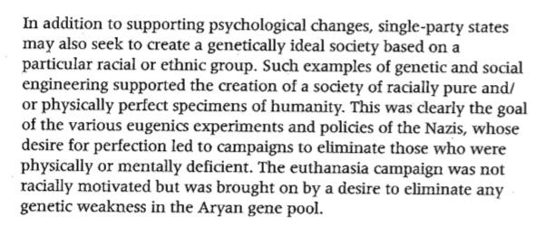
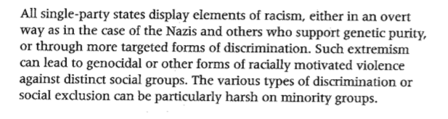
Social Policies – General Theory: https://drive.google.com/file/d/1i40wukLgKWRpd8JADyfn0akMYkKK74c9/view?pli=1
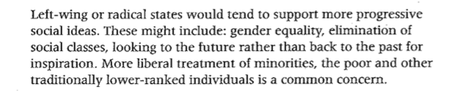
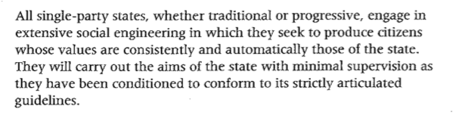

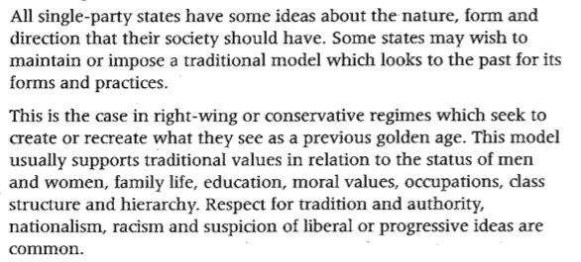

Policies – Women
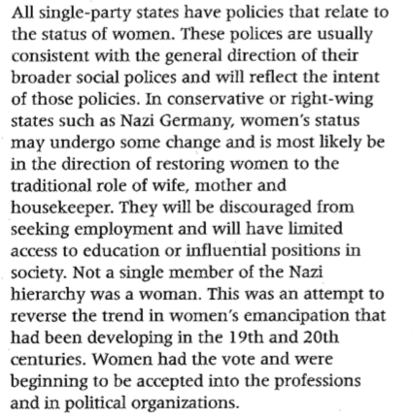
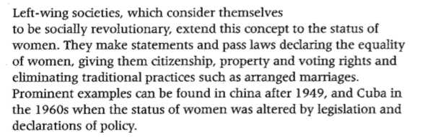

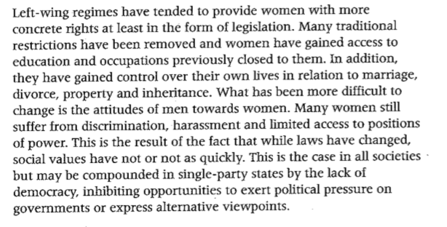

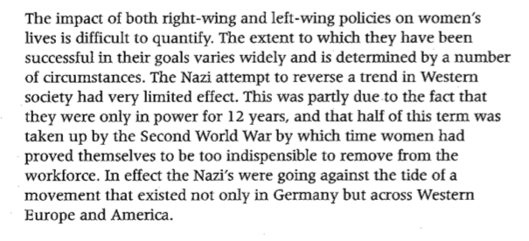

Policies – Women Theory | Hitler | Castro
The aim for women is in line with the broad aims of the Party.
Policies will aim to support this aim.
Success of these policies is hard to define.

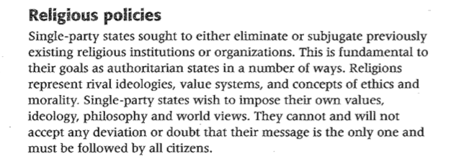
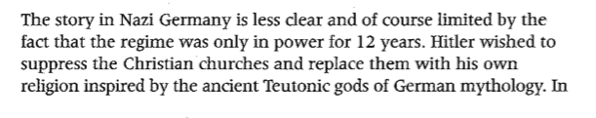
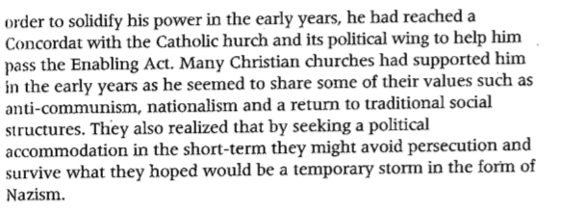
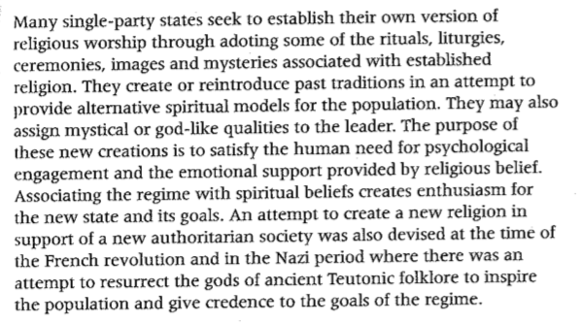
Policies - Religion
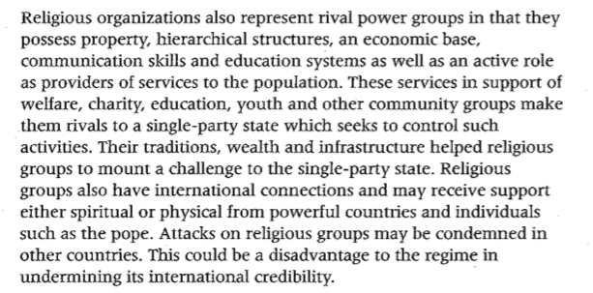
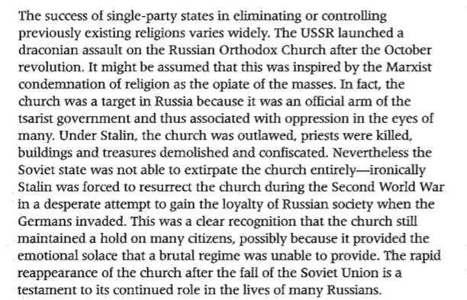
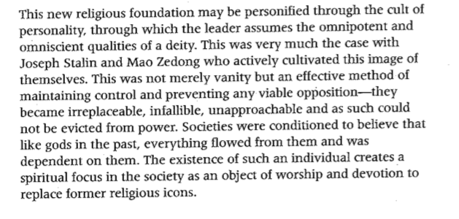

Policies – Religion Theory | Hitler | Castro
Religious Institutions are usually rival ideologies and hold a power base that can be an opposition.

why were they considered opposition?

SPS seek to control these institutions.

How did they control these institutions?
Were they successful?
Some SPS establish their own quasi-religious worship that supports the development of the cult of personality.

How were they established?
did they succeed?
What were the consequences and effects?

Policies – Propaganda and the Arts

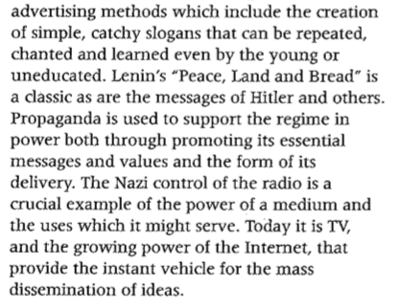
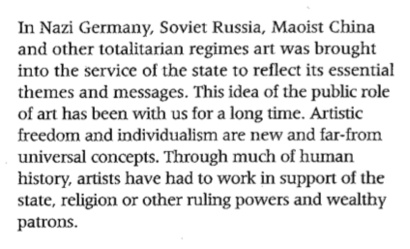
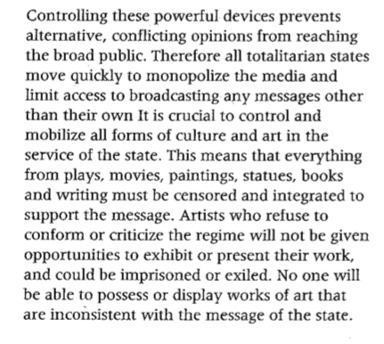

Policies – Propaganda and the Arts Theory | Hitler | Castro
Propaganda is valuable and used widely.
SPS monopolise media outlets and communication institutions.
Art and culture is controlled/censored to ensure that the message is embedded in society.

Policies – Minorities
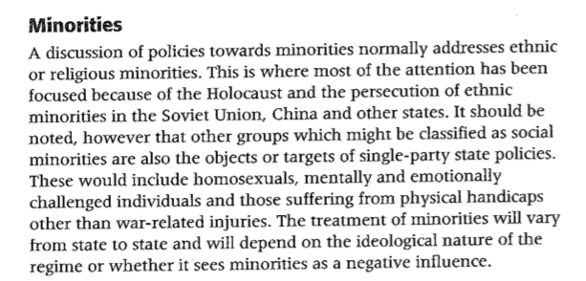

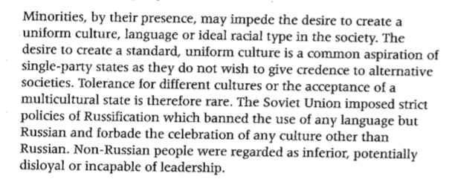

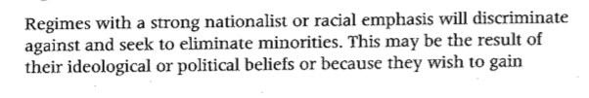
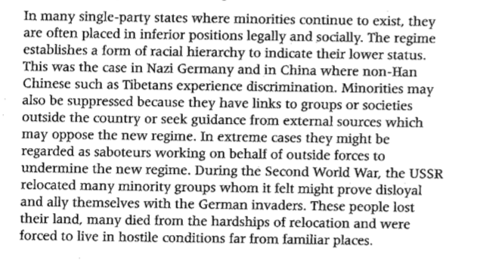

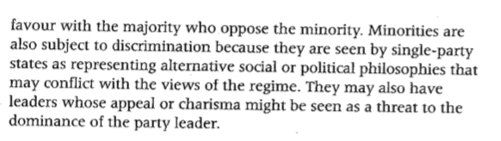

Policies – Minorities Theory | Hitler | Castro
SPS identify minorities within society who are opposed to or a target in the broad aims of the party.

Why?
They can be ethnic or religious but also other minority groups such as homosexuals or the disabled.

Who?
Policies are used to limit, target or impact the role of such minorities in society.

Impact?

