Queen Mary’s Peak Volcano (Example of a Shield Volcano)

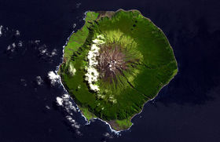
Queen Mary’s Peak is the name of the summit (top) of volcano on the island of Tristan da Cunha. The island is located in the South Atlantic Ocean. The Queen Mary’s Peak volcano is over 300m wide which is very wide for the top of a volcano. Volcanoes like this tend to have a broad or wide peak. The volcano is on a constructive plate boundary. This is where the South American plate and African plate are moving in the opposite direction. Queen Mary last erupted in 1961. No one was killed or injured by the eruption. The lava just seeped out gently and ran down the long slopes of the volcano. The volcano erupted runny lava that quickly spread down the gentle slopes of the volcano. Volcanoes like the Queen Mary tend to release runny lava that is not viscous (sticky) and form long slopes. Because the lava is runny it spreads over a longer distance so volcanoes like Queen Mary can be very wide and cover a large area. Many people think that the cone of Queen Mary looks like a shield.
Satellite Image of Queen Mary’s Peak

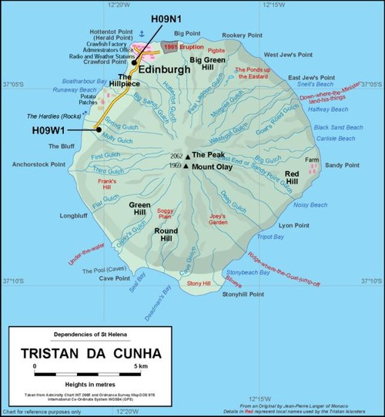

Map showing the location of Queen Mary’s Peak

Mt. Pinatubo (Example of a Composite volcano)

Mt. Pinatubo is located on the island of Luzon in the Philippines. The Philippines is in SE Asia. Mt. Pinatubo erupted last in 1991. Thousands had to be evacuated because of the eruption. Mt Pinatubo released lava flows, ash and poisonous gases like nitrogen oxide. The eruption killed 847 people. The 1991 eruption of Mt Pinatubo released 10 million tons of magma and the volcano caused global temperatures to drop by 0.5°C. The eruption was so powerful it destroyed a part of the volcano’s cone. Mt. Pinatubo had a volcanic explosivity index (VEI) of 6. VEI is a measure of the explosiveness of a volcanic eruption. The volcanic explosivity index goes from 0 to 8. Zero (0) is non-explosive while 8 is the most explosive. Mt. Pinatubo was 6.

Mt. Pinatubo is located on a destructive plate boundary. This is where the Pacific (oceanic) plate is sliding under the Philippines (continental) plate. The result is a volcano over 1400m high with steep slopes. When the volcano erupted it release viscous (sticky) lava that ran down the slope of the volcano. Volcanoes like Pinatubo usually have viscous (sticky) lava. Often the viscous (sticky) lava blocks up the vent. Overtime pressure builds up and eventually the top of the volcano is blown off in a large explosion. Mt. Pinatubo also ejected large plumes of ash which fell on top of the lava. As a result a close look at Mt. Pinatubo will show layers of lava then ash then lava again and so on. Several layers of lava and ash from previous eruptions are easily seen on volcanoes like Mt. Pinatubo.

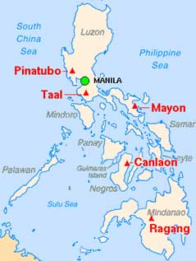
Map showing the location of Mt. Pinatubo in the Philippines

