Sherpa Religion
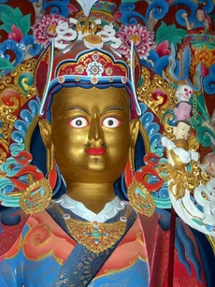
The Sherpa religion is a mixture of Buddhist tradition and animistic faith (in its basic form the belief all living things are spirits and they are all equal) which have evolved from centuries of myths, legends and the strong influence of religion. Nyingmapa Buddhism attempts to cover the full potential of a person’s conscious mind through meditation, study and work.
(Right) The great 8th century Guru Rinpoche, who was instrumental in introducing Buddhism into Tibet during the reign of King Trisong Detsen

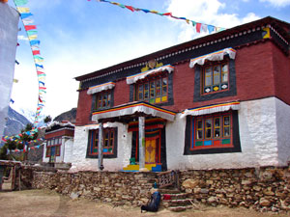
As more people settled in the area, traditions began which helped unite the villages. Daily life began, and continues, to revolve around the village gompa (temple) and their Buddhist beliefs are present in their daily activities of farming, herding and trading.
(Left) Village Gompa - Also a place for meetings and festivals

It wasn’t until contact with Westerners was made that Sherpa’s ventured into the high peaks of the mountains as they revere the mountains as dwelling places of the gods and goddesses. Mount Everest, or Chomolungma, means ‘Goddess Mother Of The Land ‘in Tibetan.
Although Everest now sees many human footprints, the Sherpa’s still regard it as a holy place and before all modern day expeditions begin a Puja ceremony is conducted. Here the Sherpa’s and other team members leave offerings of food and drink and pay homage to the gods of the mountains, hoping to remain in their graces during their climb
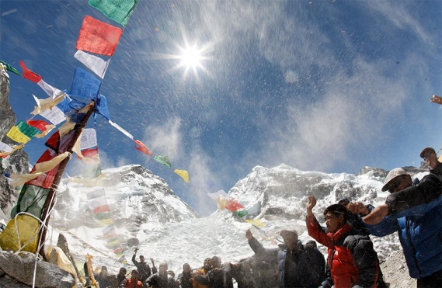
During the ceremony pray flags are raised. Each flag is a different color representing the elements: Blue – Space White – Water Red – Fire Green – Air Yellow – Earth It is believed when the wind blows it send the prayer out across the world. These prayers are selfless and for all
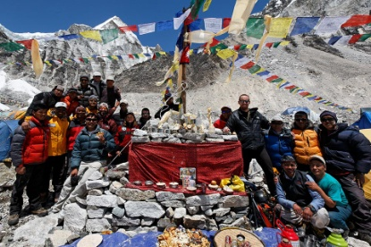
The effects of tourism on religious traditions suggest that many Sherpa’s have managed to adapt to tourism successfully without ant great loss of culture. Since the expeditions to Mount Everest, Sherpa’s have become a ‘celebrated people’ and receive a great deal of international fame. The Sherpa’s themselves are aware of the fascination with their culture and have been able to direct this interest towards the building and repair of local monasteries.

