Sherpa Language
The Sherpa language is only a spoken language; however in recent years there have been attempts to introduce a written form based on Tibetan script. This is not an easy undertaking as the Sherpa language originates from the old Tibetan religious books and goes back to Tibetan dialect spoken in eastern provinces in the 15th century, but it has developed its own way in the last 500 years or so. So, it must be regarded as a language in its own right separate from modern Tibetan. Even within the Sherpa regions there are lots of regional differences as well as a significant influence from other languages such as Newar, Nepali, Tamang and English.
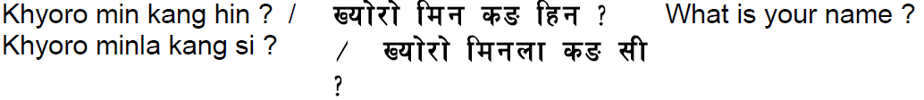
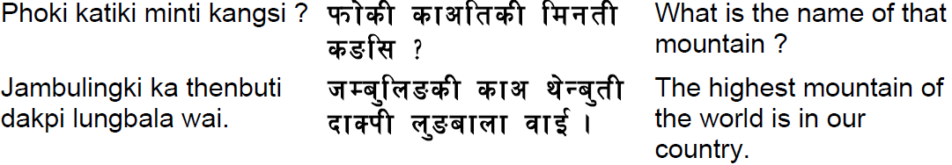
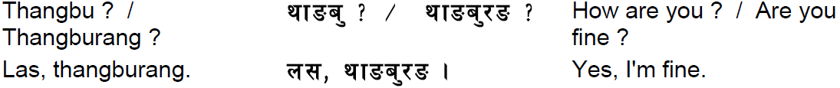
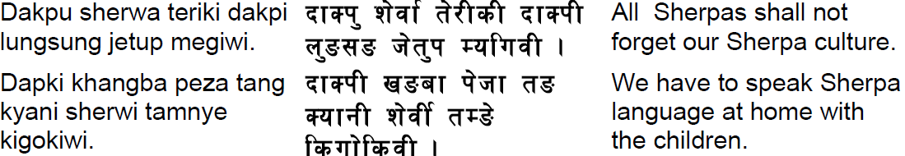
In many cultures people share the same common names, but Sherpa’s have especially similar names as many are name after the day of the week they are born on: Sunday – Nima Monday – Dawa Tuesday – Mingma Wednesday – Lhakpa Thursday – Phurba Friday – Pasang Saturday - Pemba

