Sherpa History
Sherpa translates to mean ‘easterner’. The name was created when 600 years ago people began to migrate from Tibet to the mountains in Nepal. This was a time of great unrest in Tibet and many lamas (Tibetan priests of Lamaism), their families and their followers left their homes looking for new places to live. Many eventually settled in the mountains of northern Nepal.
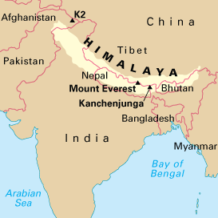
Sherpa’s are among the world’s most famous Nepalese people and being the world’s highest living population this has made them born mountaineers. It was their fantastic mountaineering prowess and their hardiness which brought them to the attention of early European climbers.
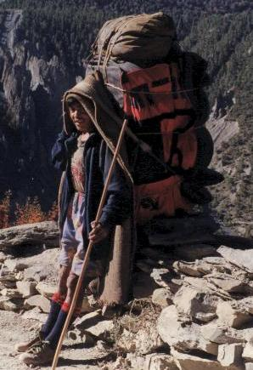
Approximately 30,000 Sherpa’s lie in Nepal today and since the 1950s, tourism has become the dominant source of employment and income in the area

