Sherpa Culture
Most Sherpa’s now live in North-Eastern Nepal’s near Mount Everest. They live in clans and are completely unfamiliar with our society’s hierarchal systems. Sherpa’s are extremely hard workers and where many of their villages are located farming is incredibly difficult. Although they live on the higher grounds their crops are usually on the lower planes, with their most productive season being in the summer monsoon, and the least from June to September.
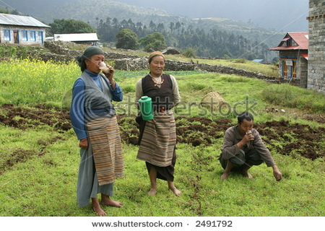
When it comes to division of labor, trading and wage labor are predominantly male activities, with plowing being assigned exclusively to men. Other agricultural and pastoral labor is shared by both sexes, and often women do the major share while the men are trekking.
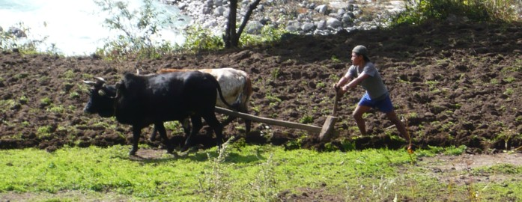
The Sherpa people follow the Buddhist religion and while this and many other traditional practices haven’t changed the arrival of Westerners have changed parts of their lifestyle forever. This is primarily the shift from regarding climbing the mountains as blasphemous, to regarding it as a source of economic opportunity and pride. This radical change from traditional farmers and tradesmen has brought the Sherpa’s worldwide fame and has become the mainstay of their economy and made their lives easier.
The first notable and successful Sherpa climber was Tangzing Norgay who climbed Everest a number of times but none more notable then when he reached the top with Sir Edmund Hillary in 1953. Ever since Sherpa’s have embraced mountaineering and after many years as only being recorded in the footnotes in history they are finally being given full credit.
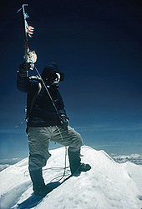
Norgay on the summit of Mount Everest, 29 May 1953. Photo taken by Edmund Hillary

